|  |
| --- |
|  |
| |  |  |  | | --- | --- | --- | | 75 | Date: | February 2015 | |
| ADL and AML Non-normative Examples    Version: 1.0  **OMG Document Number: health/2015-04-10**  **Standard document URL: http://www.omg.org/spec/AML/1.0**  Original File: N/A |

# AML and ADL Examples

The following section gives examples of AML and their ADL equivalents to illustrate the relationship between ADL and AML. These are valid OpenEHR ADL archetypes that have been converted into AML.

## AOM Structures Basic Examples

### Mixed AOM Node Types v1 Example

Test various AOM C_OBJECT types together, to ensure co-existence within the same object structure.

#### Mixed AOM Node Types v1 ADL

archetype (adl_version=2.0.5; rm_release=1.0.2)

openEHR-EHR-EVALUATION.mixed_aom_node_types.v1.0.0

language

original_language = <[ISO_639-1::en]>

description

original_author = <

["name"] = <"Thomas Beale">

["email"] = <"thomas.beale@openEHR.org">

["organisation"] = <"openEHR Foundation <http://www.openEHR.org>">

["date"] = <"2004-05-01">

>

details = <

["en"] = <

language = <[ISO_639-1::en]>

purpose = <"Test various AOM C_OBJECT types together, to ensure co-existence within the same object structure.">

keywords = <"ADL", "test">

>

>

lifecycle_state = <"published">

other_details = <

["regression"] = <"PASS">

>

copyright = <"copyright © 2010 openEHR Foundation <http://www.openEHR.org>">

licence = <"Creative Commons CC-BY-SA <https://creativecommons.org/licenses/by-sa/3.0/>">

definition

EVALUATION[id1] matches { -- Evaluation

data matches {

ITEM_TREE[id14] matches {

items matches {

CLUSTER[id2] matches { -- cluster

items matches {

use_node ELEMENT[id10] /data[id14]/items[id11]/items[id13] -- /data[id14]/items[cluster]/items[element]

allow_archetype CLUSTER[id4] matches { -- element

include

archetype_id/value matches {/.*/}

}

ELEMENT[id3] -- element

}

}

CLUSTER[id11] matches { -- cluster

items matches {

ELEMENT[id13] -- element

}

}

}

}

}

}

terminology

term_definitions = <

["en"] = <

["id1"] = <

text = <"Evaluation">

description = <"Evaluation">

>

["id2"] = <

text = <"cluster">

description = <"cluster">

>

["id3"] = <

text = <"element">

description = <"element">

>

["id11"] = <

text = <"cluster">

description = <"cluster">

>

["id13"] = <

text = <"element">

description = <"element">

>

["id4"] = <

text = <"element">

description = <"element">

>

["id10"] = <

text = <"use_node element">

description = <"use_node element">

>

>

>

#### Mixed AOM Node Types v1 ADL Diagram

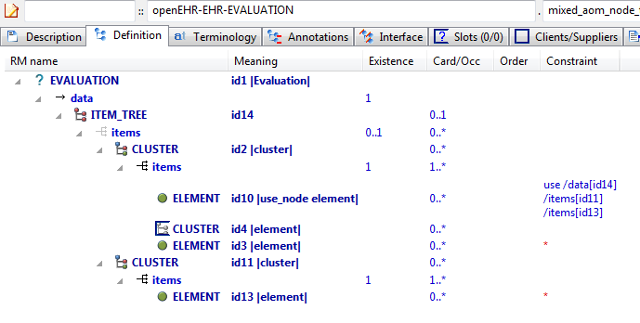

#### Mixed AOM Node Types v1 AML Diagram

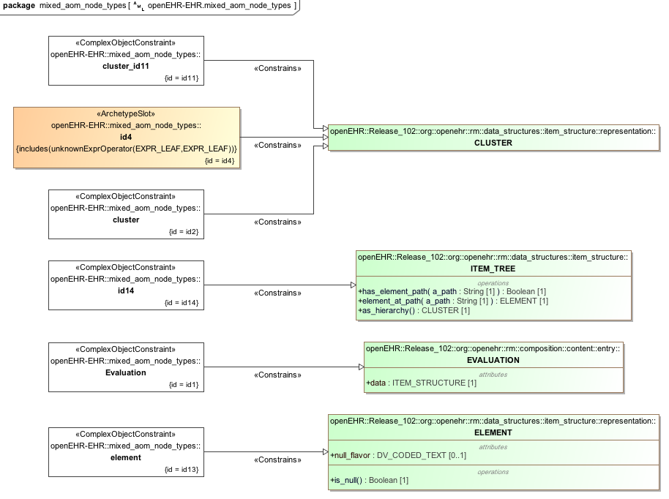

#### Mixed AOM Node Types v1 AML Associations Diagram

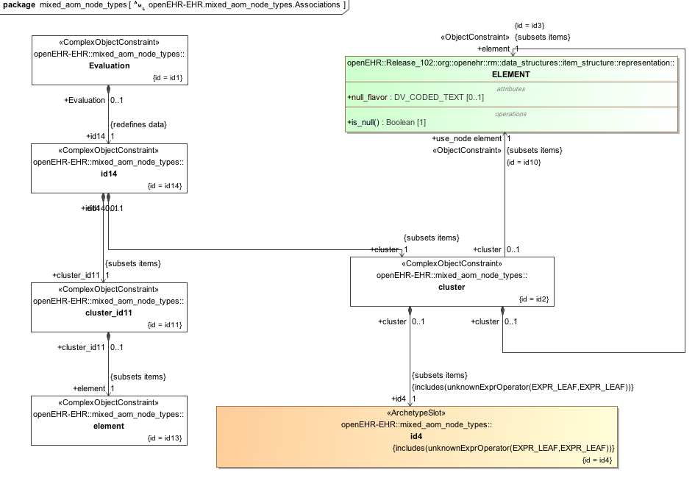

### Structure Test1 v1 Example

Demonstrate simple RM structure hierarchy in an archetype.

#### Structure Test1 v1 ADL

archetype (adl_version=2.0.5; rm_release=1.0.2)

openehr-TEST_PKG-BOOK.structure_test1.v1.0.0

language

original_language = <[ISO_639-1::en]>

description

original_author = <

["name"] = <"Thomas Beale">

["organisation"] = <"openEHR Foundation <http://www.openEHR.org>">

["email"] = <"thomas.beale@openEHR.org">

["date"] = <"2004-05-01">

>

details = <

["en"] = <

language = <[ISO_639-1::en]>

purpose = <"Demonstrate simple RM structure hierarchy in an archetype.">

keywords = <"ADL", "structure", "test">

>

>

lifecycle_state = <"published">

other_details = <

["regression"] = <"PASS">

>

copyright = <"copyright © 2004 openEHR Foundation <http://www.openEHR.org>">

licence = <"Creative Commons CC-BY-SA <https://creativecommons.org/licenses/by-sa/3.0/>">

definition

BOOK[id1] matches { -- Work of fiction

title matches {"Devils"}

author matches {"Fyodor Dostoyevsky"}

chapters matches {

CHAPTER[id2] matches { -- 1st chapter of the book

title matches {"By way of introduction"}

}

CHAPTER[id3] matches { -- 2nd chapter of the book

title matches {"Prince Harry, matchmaking"}

}

CHAPTER[id4] matches { -- 3rd chapter of the book

title matches {"Another man's sins"}

}

}

}

terminology

term_definitions = <

["en"] = <

["id1"] = <

text = <"Work of fiction">

description = <"Novel">

>

["id2"] = <

text = <"1st chapter of the book">

description = <"Chapter 1">

>

["id3"] = <

text = <"2nd chapter of the book">

description = <"Chapter 2">

>

["id4"] = <

text = <"3rd chapter of the book">

description = <"Chapter 3">

>

>

>

#### Structure Test1 v1 ADL Diagram

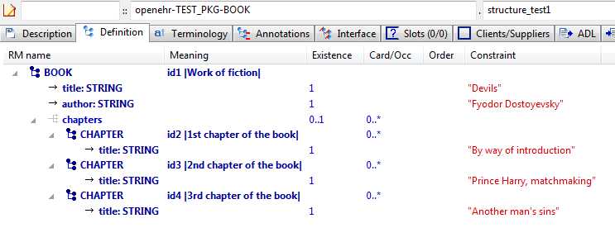

#### Structure Test1 v1 AML Diagram

#### Structure Test1 v1 AML Associations Diagram

### Assumed Values Example

Test constraints on primitive types that have added 'assumed values' as defined by the AOM.

#### Assumed Values ADL

archetype (adl_version=2.0.5; rm_release=1.0.2)

openehr-TEST_PKG-WHOLE.assumed_values.v1.0.0

language

original_language = <[ISO_639-1::en]>

description

original_author = <

["name"] = <"Thomas Beale">

["email"] = <"thomas.beale@openEHR.org">

["organisation"] = <"openEHR Foundation <http://www.openEHR.org>">

["date"] = <"2004-05-01">

>

details = <

["en"] = <

language = <[ISO_639-1::en]>

purpose = <"Test constraints on primitive types that have added 'assumed values' as defined by the AOM.">

keywords = <"ADL", "assumed types", "test">

>

>

lifecycle_state = <"published">

other_details = <

["regression"] = <"PASS">

>

copyright = <"copyright © 2004 openEHR Foundation <http://www.openEHR.org>">

licence = <"Creative Commons CC-BY-SA <https://creativecommons.org/licenses/by-sa/3.0/>">

definition

WHOLE[id1] matches { -- test entry

string_attr1 matches {"something", "something else"; "something else"}

string_attr2 matches {/this|that|something else/; "this"}

string_attr3 matches {/cardio.*/; "cardiology examination"}

boolean_attr1 matches {True}

boolean_attr2 matches {False}

boolean_attr3 matches {True, False; True}

integer_attr1 matches {55}

integer_attr2 matches {10, 20, 30; 10}

integer_attr3 matches {|0..100|; 10}

integer_attr4 matches {|>10|; 11}

integer_attr5 matches {|<10|; 9}

integer_attr6 matches {|>=10|; 10}

integer_attr7 matches {|<=10|; 5}

integer_attr8 matches {|-10..-5|; -8}

integer_attr9 matches {10}

real_attr1 matches {100.0}

real_attr2 matches {10.0, 20.0, 30.0; 20.0}

real_attr3 matches {|0.0..100.0|; 20.4}

real_attr4 matches {|>=10.0|; 20.0}

real_attr5 matches {|<=10.0|; 9.5}

real_attr6 matches {|>=10.0|; 20.3}

real_attr7 matches {|<=10.0|; 8.0}

real_attr8 matches {|-10.0..-5.0|; -9.8}

real_attr9 matches {10.0}

date_attr1 matches {yyyy-mm-dd; 1995-03-17}

date_attr2 matches {yyyy-??-??; 1995-03-17}

date_attr3 matches {yyyy-mm-??; 1995-03-17}

date_attr4 matches {yyyy-??-XX; 1995-03}

date_attr5 matches {1983-12-25}

date_attr6 matches {2000-01-01}

time_attr1 matches {hh:mm:ss; 12:01:30}

time_attr2 matches {hh:mm:XX; 12:01}

time_attr3 matches {hh:??:XX; 12:00}

time_attr4 matches {hh:??:??; 12:00}

time_attr5 matches {22:00:05,0}

time_attr6 matches {00:00:59,0}

time_attr7 matches {00:00:59,0}

date_time_attr1 matches {yyyy-mm-ddThh:mm:ss; 1995-03-17T12:01:30}

date_time_attr2 matches {yyyy-mm-ddThh:mm:??; 1995-03-17T12:01}

date_time_attr3 matches {yyyy-mm-ddThh:mm:XX; 1995-03-17T12:01}

date_time_attr4 matches {yyyy-mm-ddThh:??:XX; 1995-03-17T12:01}

date_time_attr5 matches {yyyy-??-??T??:??:??; 1995-03-17T12:01}

date_time_attr6 matches {1983-12-25T22:00:05,0}

date_time_attr7 matches {2000-01-01T00:00:59,0}

date_time_attr8 matches {2000-01-01T00:00:59,0}

duration_attr1 matches {PT0S}

duration_attr2 matches {P1D}

duration_attr3 matches {PT2H5M}

duration_attr4 matches {PT1H55M}

duration_attr5 matches {|<=PT1H|; PT30M}

duration_attr6 matches {PT1H30M}

}

terminology

term_definitions = <

["en"] = <

["id1"] = <

text = <"test entry">

description = <"test entry">

>

>

>

#### Assumed Values ADL Diagram

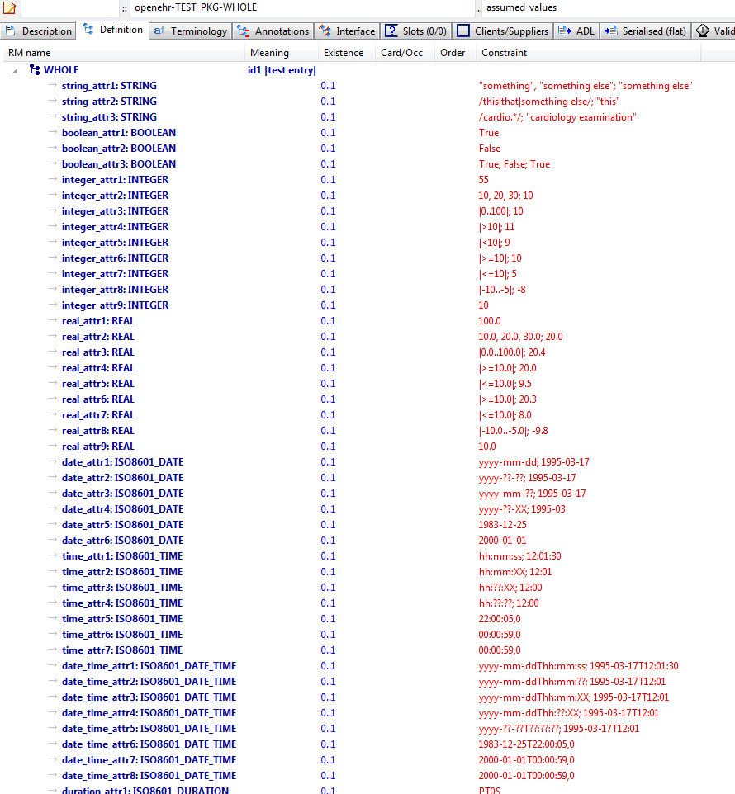

#### Assumed Values AML Diagram

#### Assumed Values AML Associations Diagram

### Primitive Types Example

Test constraints on built-in types assumed by ADL / AOM. These types include:

#### Primitive Types ADL

archetype (adl_version=2.0.5; rm_release=1.0.2)

openehr-TEST_PKG-WHOLE.primitive_types.v1.0.0

language

original_language = <[ISO_639-1::en]>

description

original_author = <

["name"] = <"Thomas Beale">

["email"] = <"thomas.beale@openEHR.org">

["organisation"] = <"openEHR Foundation <http://www.openEHR.org>">

["date"] = <"2004-05-01">

>

details = <

["en"] = <

language = <[ISO_639-1::en]>

purpose = <"Test constraints on built-in types assumed by ADL / AOM. These types include:

Integer, Real, Boolean, String (including regular expressions, delimited with //),

Date, DateTime, Time, Duration,

Interval ranges of ordered types above,

Lists of all atomic types above.

">

keywords = <"ADL", "test">

>

>

lifecycle_state = <"published">

other_details = <

["regression"] = <"PASS">

>

copyright = <"copyright © 2004 openEHR Foundation <http://www.openEHR.org>">

licence = <"Creative Commons CC-BY-SA <https://creativecommons.org/licenses/by-sa/3.0/>">

definition

WHOLE[id1] matches { -- test entry

string_attr1 matches {"something"}

string_attr2 matches {/this|that|something else/}

string_attr3 matches {/cardio.*/}

string_attr4

string_attr5 matches {"and", "something", "else"}

boolean_attr1 matches {True}

boolean_attr2 matches {False}

boolean_attr3 matches {True, False}

boolean_attr4

integer_attr1 matches {55}

integer_attr2 matches {10, 20, 30}

integer_attr3 matches {|0..100|}

integer_attr4 matches {|>0..100|}

integer_attr5 matches {|0..<100|}

integer_attr6 matches {|>0..<100|}

integer_attr7 matches {|>10|}

integer_attr8 matches {|<10|}

integer_attr9 matches {|>=10|}

integer_attr10 matches {|<=10|}

integer_attr11 matches {|-10..-5|}

integer_attr12 matches {10}

integer_attr13

real_attr1 matches {100.0}

real_attr2 matches {10.0, 20.0, 30.0}

real_attr3 matches {|0.0..100.0|}

real_attr4 matches {|>0.0..100.0|}

real_attr5 matches {|0.0..<100.0|}

real_attr6 matches {|>0.0..<100.0|}

real_attr7 matches {|>=10.0|}

real_attr8 matches {|<=10.0|}

real_attr9 matches {|>=10.0|}

real_attr10 matches {|<=10.0|}

real_attr11 matches {|-10.0..-5.0|}

real_attr12 matches {10.0}

real_attr13

date_attr1 matches {yyyy-mm-dd}

date_attr2 matches {yyyy-??-??}

date_attr3 matches {yyyy-mm-??}

date_attr4 matches {yyyy-??-XX}

date_attr5 matches {1983-12-25}

date_attr6 matches {2000-01-01}

date_attr7 matches {2000-01-01}

date_attr8 matches {|2000-01-01..2000-02-01|}

date_attr9 matches {|>2000-01-01..2000-02-01|}

date_attr10 matches {|2000-01-01..<2000-02-01|}

date_attr11 matches {|>2000-01-01..<2000-02-01|}

time_attr1 matches {hh:mm:ss}

time_attr2 matches {hh:mm:??}

time_attr3 matches {hh:mm:XX}

time_attr4 matches {hh:??:??}

time_attr5 matches {hh:??:XX}

time_attr6 matches {22:00:05,0}

time_attr7 matches {00:00:59,0}

time_attr8 matches {00:00:59,0}

time_attr9 matches {|01:00:00..02:00:00|}

time_attr10 matches {|>01:00:00..02:00:00|}

time_attr11 matches {|01:00:00..<02:00:00|}

time_attr12 matches {|>01:00:00..<02:00:00|}

date_time_attr1 matches {yyyy-mm-ddThh:mm:ss}

date_time_attr2 matches {yyyy-mm-ddThh:mm:??}

date_time_attr3 matches {yyyy-mm-ddThh:mm:XX}

date_time_attr4 matches {yyyy-mm-ddThh:??:??}

date_time_attr5 matches {yyyy-mm-ddThh:??:XX}

date_time_attr6 matches {yyyy-??-??T??:??:??}

date_time_attr7 matches {1983-12-25T22:00:05,0}

date_time_attr8 matches {2000-01-01T00:00:59,0}

date_time_attr9 matches {2000-01-01T00:00:59,0}

date_time_attr10 matches {|2000-01-01T01:00:00..2000-01-01T02:00:00|}

date_time_attr11 matches {|>2000-01-01T01:00:00..2000-01-01T02:00:00|}

date_time_attr12 matches {|2000-01-01T01:00:00..<2000-01-01T02:00:00|}

date_time_attr13 matches {|>2000-01-01T01:00:00..<2000-01-01T02:00:00|}

duration_attr1 matches {Pw}

duration_attr2 matches {Pmw}

duration_attr3 matches {PWD}

duration_attr4 matches {PD}

duration_attr5 matches {Pym}

duration_attr6 matches {PdThms}

duration_attr7 matches {PTs}

duration_attr8 matches {PThm}

duration_attr9 matches {PT0S}

duration_attr10 matches {PT0S}

duration_attr11 matches {P1D}

duration_attr12 matches {|P38W..P39W4D|}

duration_attr13 matches {|>P38W..P39W4D|}

duration_attr14 matches {|P38W..<P39W4D|}

duration_attr15 matches {|>P38W..<P39W4D|}

duration_attr16 matches {PT2H5M}

duration_attr17 matches {PT1H55M}

duration_attr18 matches {|<=PT1H|}

duration_attr19 matches {PT1H30M}

duration_attr20 matches {Pw/PT0S}

duration_attr21 matches {Pmw/PT0S}

duration_attr22 matches {PWD/PT0S}

duration_attr23 matches {PD/PT0S}

duration_attr24 matches {Pym/PT0S}

duration_attr25 matches {PdThms/PT0S}

duration_attr26 matches {PTs/PT0S}

duration_attr27 matches {PThm/PT0S}

duration_attr28 matches {Pw/|P38W..P39W4D|}

duration_attr29 matches {Pmw/|P38W..P39W4D|}

duration_attr30 matches {PWD/|P38W..P39W4D|}

duration_attr31 matches {PD/|P38W..P39W4D|}

duration_attr32 matches {Pym/|P38W..P39W4D|}

duration_attr33 matches {PdThms/|P38W..P39W4D|}

duration_attr34 matches {PTs/|P38W..P39W4D|}

duration_attr35 matches {PThm/|P38W..P39W4D|}

duration_attr36 matches {|>=PT0S|}

}

terminology

term_definitions = <

["en"] = <

["id1"] = <

text = <"test entry">

description = <"test entry">

>

>

>

#### Primitive Types ADL Diagram

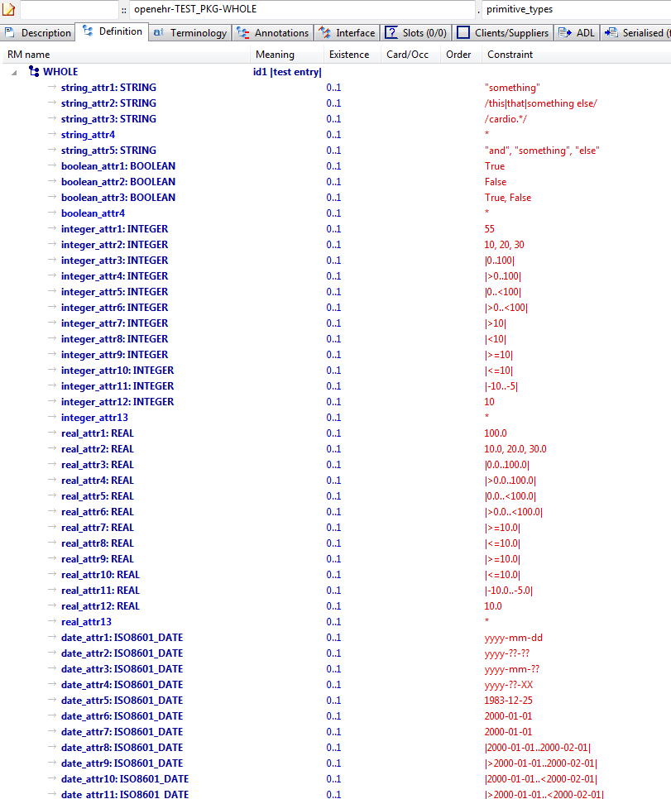

#### Primitive Types AML Diagram

#### Primitive Types AML Associations Diagram

## AOM Structures C_attribute_alternatives Examples

### Quantity Alternatives Example

Demonstrate multiple alternative Quantity expressions.

#### Quantity Alternatives ADL

archetype (adl_version=2.0.5; rm_release=1.0.2; generated)

openEHR-EHR-CLUSTER.quantity_altenatives.v1.0.0

language

original_language = <[ISO_639-1::en]>

description

custodian_namespace = <"org.openehr">

custodian_organisation = <"openEHR Foundation <http://www.openEHR.org>">

original_author = <

["name"] = <"Thomas Beale">

["email"] = <"thomas.beale@openEHR.org">

["organisation"] = <"openEHR Foundation <http://www.openEHR.org>">

["date"] = <"2009-06-08">

>

details = <

["en"] = <

language = <[ISO_639-1::en]>

purpose = <"Demonstrate multiple alternative Quantity expressions.">

keywords = <"ADL", "test", "breathing", "oxygen">

>

>

lifecycle_state = <"published">

other_details = <

["regression"] = <"PASS">

>

copyright = <"Copyright © 2009 openEHR Foundation <http://www.openEHR.org>">

licence = <"Creative Commons CC-BY-SA <https://creativecommons.org/licenses/by-sa/3.0/>">

definition

CLUSTER[id1] matches { -- Ambient oxygen

items matches {

ELEMENT[id52] occurrences matches {0..1} matches { -- Oxygen flow rate

value matches {

DV_QUANTITY[id55] matches {

property matches {[at1]}

[magnitude, units, precision] matches {

[{|0.0..50.0|}, {"l/m"}, {1}],

[{|0.0..50000.0|}, {"ml/min"}, {1}]

}

}

}

}

ELEMENT[id54] occurrences matches {0..1} matches { -- un

value matches {

DV_PROPORTION[id56] matches {

numerator matches {|0.0..1.0|; 0.21}

is_integral matches {False}

type matches {1}

}

DV_PROPORTION[id57] matches {

numerator matches {|0.0..100.0|; 21.0}

is_integral matches {False}

type matches {2}

}

}

}

ELEMENT[id55] occurrences matches {0..1} matches { -- un

value matches {

DV_PROPORTION[id58] matches {

[numerator, is_integral, type] matches

{[{|0.0..1.0|; 0.21}, {False}, {1}],

[{|0.0..100.0|; 21.0}, {False}, {2}]}

}

}

}

}

}

terminology

term_definitions = <

["en"] = <

["id1"] = <

text = <"Ambient oxygen">

description = <"The amount of oxygen being delivered to the subject at the time of observation. Assumed values of 21% O2, Fi02 of 0.21 and Oxygen flow rate of zero.">

>

["id52"] = <

text = <"Oxygen flow rate">

description = <"Flow rate of inspired oxygen.">

>

["id54"] = <

text = <"Inspired O2 level [NON-CO-VARYING ALTERNATIVES]">

description = <"Inspired oxygen.">

>

["id55"] = <

text = <"Inspired O2 level [CO-VARYING ALTERNATIVES]">

description = <"Inspired oxygen.">

>

["id56"] = <

text = <"FiO2">

description = <"Fraction of inspired oxygen.">

>

["id57"] = <

text = <"Percent O2">

description = <"Percentage of inspired oxygen.">

>

["at1"] = <

text = <"Flow rate, volume">

description = <"Flow rate, volume">

>

>

>

term_bindings = <

["openehr"] = <

["at1"] = <http://openehr.org/id/126>

>

>

#### Quantity Alternatives ADL Diagram

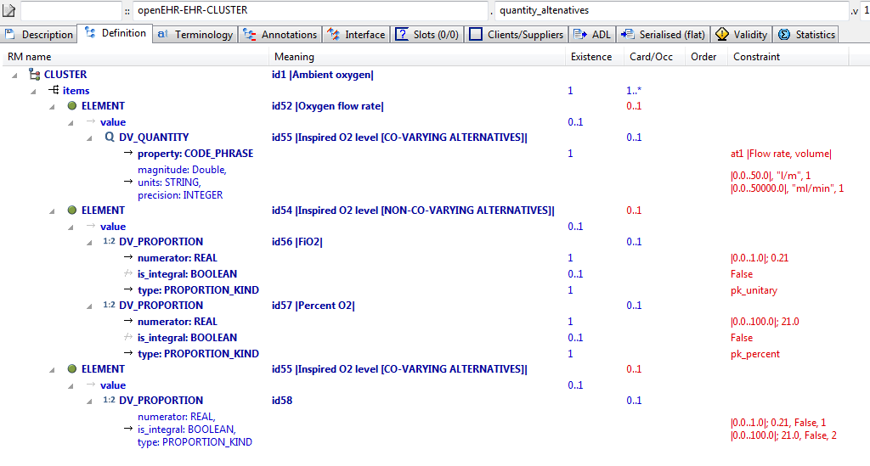

#### Quantity Alternatives AML Diagram

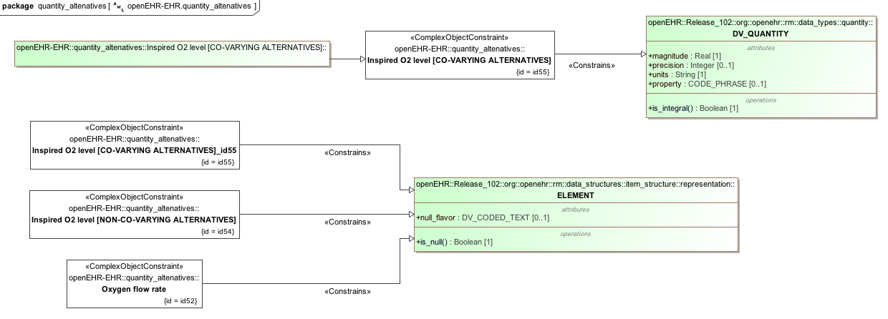

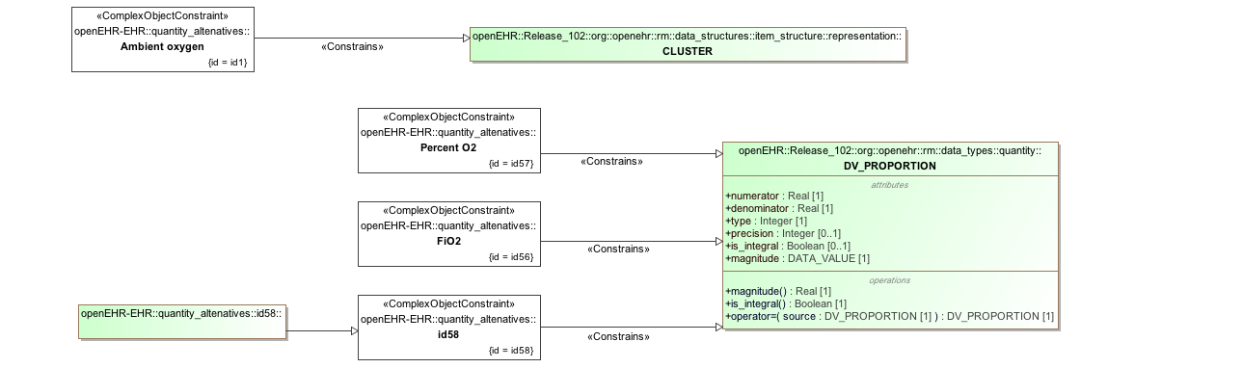

#### Quantity Alternatives AML Associations Diagram

### Multiple Alternatives Example

Test multiple alternative nodes of single-valued attribute; view in flat mode to see result.

#### Multiple Alternatives ADL

archetype (adl_version=2.0.5; rm_release=1.0.2)

openEHR-EHR-OBSERVATION.multiple_alternatives.v1.0.0

language

original_language = <[ISO_639-1::en]>

description

custodian_namespace = <"org.openehr">

custodian_organisation = <"openEHR Foundation <http://www.openEHR.org>">

original_author = <

["name"] = <"Thomas Beale">

["email"] = <"thomas.beale@openEHR.org">

["organisation"] = <"openEHR Foundation <http://www.openEHR.org>">

["date"] = <"2008-08-11">

>

details = <

["en"] = <

language = <[ISO_639-1::en]>

purpose = <"Test multiple alternative nodes of single-valued attribute; view in flat mode to see result.">

>

>

lifecycle_state = <"published">

other_details = <

["regression"] = <"PASS">

>

copyright = <"Copyright © 2008 openEHR Foundation <http://www.openEHR.org>">

licence = <"Creative Commons CC-BY-SA <https://creativecommons.org/licenses/by-sa/3.0/>">

definition

OBSERVATION[id1] matches { -- top-level archetype

protocol matches {

ITEM_TREE[id2] -- protocol #1

ITEM_TREE[id3] -- protocol #2

}

}

terminology

term_definitions = <

["en"] = <

["id1"] = <

text = <"top-level archetype">

description = <"top level test archetype for specialisation lineage">

>

["id2"] = <

text = <"protocol #1">

description = <"protocol #1">

>

["id3"] = <

text = <"protocol #2">

description = <"protocol #2">

>

>

>

#### Multiple Alternatives ADL Diagram

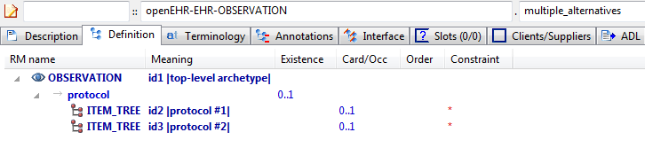

#### Multiple Alternatives AML Diagram

#### Multiple Alternatives AML Associations Diagram

## AOM Structures Rules Examples

### Rules Formulae v1 Example

Illustrate rules that define formulae based on archetype data points. This example defines two rules based on well known blood pressure formulae, viz 'mean arterial pressure' and 'pulse pressure'.

#### Rules Formulae v1 ADL

archetype (adl_version=2.0.5; rm_release=1.0.2)

openEHR-EHR-OBSERVATION.rules_formulae.v1.0.0

language

original_language = <[ISO_639-1::en]>

description

custodian_namespace = <"org.openehr">

custodian_organisation = <"openEHR Foundation <http://www.openEHR.org>">

original_author = <

["name"] = <"Thomas Beale">

["email"] = <"thomas.beale@openEHR.org">

["organisation"] = <"openEHR Foundation <http://www.openEHR.org>">

["date"] = <"2014-01-22">

>

details = <

["en"] = <

language = <[ISO_639-1::en]>

purpose = <"Illustrate rules that define formulae based on archetype data points. This example defines two rules based on well known blood pressure formulae, viz 'mean arterial pressure' and 'pulse pressure'.">

keywords = <"ADL", "test", "rules">

>

>

lifecycle_state = <"published">

other_details = <

["regression"] = <"PASS">

>

copyright = <"Copyright © 2014 openEHR Foundation <http://www.openEHR.org>">

licence = <"Creative Commons CC-BY-SA <https://creativecommons.org/licenses/by-sa/3.0/>">

definition

OBSERVATION[id1] matches { -- Blood Pressure

data matches {

HISTORY[id2] matches { -- history

events cardinality matches {1..*; unordered} matches {

EVENT[id7] occurrences matches {0..*} matches { -- any event

data matches {

ITEM_TREE[id4] matches {

items matches {

ELEMENT[id5] occurrences matches {0..1} matches { -- Systolic

value matches {

DV_QUANTITY[id1054] matches {

property matches {[at1055]}

magnitude matches {|0.0..<1000.0|}

units matches {"mm[Hg]"}

precision matches {0}

}

}

}

ELEMENT[id6] occurrences matches {0..1} matches { -- Diastolic

value matches {

DV_QUANTITY[id1055] matches {

property matches {[at1055]}

magnitude matches {|0.0..<1000.0|}

units matches {"mm[Hg]"}

precision matches {0}

}

}

}

ELEMENT[id1007] occurrences matches {0..1} matches { -- Mean Arterial Pressure

value matches {

DV_QUANTITY[id1056] matches {

property matches {[at1055]}

magnitude matches {|0.0..<1000.0|}

units matches {"mm[Hg]"}

precision matches {0}

}

}

}

ELEMENT[id1008] occurrences matches {0..1} matches { -- Pulse Pressure

value matches {

DV_QUANTITY[id1057] matches {

property matches {[at1055]}

magnitude matches {|0.0..<1000.0|}

units matches {"mm[Hg]"}

precision matches {0}

}

}

}

ELEMENT[id34] occurrences matches {0..1} matches { -- Comment

value matches {

DV_TEXT[id1058]

}

}

}

}

}

state matches {

ITEM_TREE[id8] matches {

items matches {

ELEMENT[id9] occurrences matches {0..1} matches { -- Position

value matches {

DV_CODED_TEXT[id1059] matches {

defining_code matches {[ac1; at1002]} -- Position

}

}

}

ELEMENT[id1053] occurrences matches {0..1} matches { -- Confounding factors

value matches {

DV_TEXT[id1060]

}

}

allow_archetype CLUSTER[id1031] occurrences matches {0..1} matches { -- Exertion

include

archetype_id/value matches {/openEHR-EHR-CLUSTER\.level_of_exertion(-a-zA-Z0-9_]+)*\.v1/}

}

ELEMENT[id1044] occurrences matches {0..1} matches { -- Sleep status

value matches {

DV_CODED_TEXT[id1061] matches {

defining_code matches {[ac2; at1045]} -- Sleep status

}

}

}

ELEMENT[id1006] occurrences matches {0..1} matches { -- Tilt

value matches {

DV_QUANTITY[id1062] matches {

property matches {[at1059]}

magnitude matches {|-90.0..90.0|}

units matches {"°"}

precision matches {0}

}

}

}

}

}

}

}

INTERVAL_EVENT[id1043] occurrences matches {0..1} matches { -- 24 hour average

math_function matches {

DV_CODED_TEXT[id1063] matches {

defining_code matches {[at1060]}

}

}

width matches {

DV_DURATION[id1064] matches {

value matches {PT24H}

}

}

data matches {

use_node ITEM_TREE[id1065] /data[id2]/events[id7]/data[id4] -- /data[history]/events[any event]/data[id4]

}

state matches {

use_node ITEM_TREE[id1066] /data[id2]/events[id7]/state[id8] -- /data[history]/events[any event]/state[id8]

}

}

}

}

}

protocol matches {

ITEM_TREE[id12] matches { -- list structure

items matches {

ELEMENT[id14] occurrences matches {0..1} matches { -- Cuff size

value matches {

DV_CODED_TEXT[id1067] matches {

defining_code matches {[ac3]} -- Cuff size

}

}

}

CLUSTER[id1034] occurrences matches {0..1} matches { -- Location

items matches {

ELEMENT[id15] occurrences matches {0..1} matches { -- Location of measurement

value matches {

DV_CODED_TEXT[id1068] matches {

defining_code matches {[ac4]} -- Location of measurement

}

}

}

ELEMENT[id1035] occurrences matches {0..1} matches { -- Specific location

value matches {

DV_TEXT[id1069]

}

}

}

}

ELEMENT[id1036] occurrences matches {0..1} matches { -- Method

value matches {

DV_CODED_TEXT[id1070] matches {

defining_code matches {[ac5]} -- Method

}

}

}

ELEMENT[id1039] occurrences matches {0..1} matches { -- Mean Arterial Pressure Formula

value matches {

DV_TEXT[id1071]

}

}

ELEMENT[id1011] occurrences matches {0..1} matches { -- Diastolic endpoint

value matches {

DV_CODED_TEXT[id1072] matches {

defining_code matches {[ac6]} -- Diastolic endpoint

}

}

}

allow_archetype CLUSTER[id1026] occurrences matches {0..1} matches { -- Device

include

archetype_id/value matches {/openEHR-EHR-CLUSTER\.device([a-zA-Z0-9_]+)*\.v1/}

}

}

}

}

}

rules

mean_arterial_pressure: /data[id2]/events[id7]/data[id4]/items[id1007]/value/magnitude = /data[id2]/events[id7]/data[id4]/items[id6]/value/magnitude + 0.33 * (/data[id2]/events[id7]/data[id4]/items[id5]/value/magnitude - /data[id2]/events[id7]/data[id4]/items[id6]/value/magnitude)

pulse_pressure: /data[id2]/events[id7]/data[id4]/items[id1008]/value/magnitude = /data[id2]/events[id7]/data[id4]/items[id5]/value/magnitude - /data[id2]/events[id7]/data[id4]/items[id6]/value/magnitude

terminology

term_definitions = <

["en"] = <

["id1"] = <

text = <"Blood Pressure">

description = <"The local measurement of arterial blood pressure which is a surrogate for arterial. pressure in the systemic circulation. Most commonly, use of the term 'blood pressure' refers to measurement of brachial artery pressure in the upper arm.">

>

["id2"] = <

text = <"history">

description = <"history Structural node">

>

["id5"] = <

text = <"Systolic">

description = <"Peak systemic arterial blood pressure - measured in systolic or contraction phase of the heart cycle.">

>

["id6"] = <

text = <"Diastolic">

description = <"Minimum systemic arterial blood pressure - measured in the diastolic or relaxation phase of the heart cycle.">

>

["id7"] = <

text = <"any event">

description = <"Default event">

>

["id9"] = <

text = <"Position">

description = <"The position of the subject at the time of measurement.">

>

["id12"] = <

text = <"list structure">

description = <"list structure">

>

["id14"] = <

text = <"Cuff size">

description = <"The size of the cuff used for blood pressure measurement. ">

>

["id15"] = <

text = <"Location of measurement">

description = <"Common body sites where blood pressure is recorded.">

>

["at16"] = <

text = <"Adult Thigh">

description = <"A cuff used for an adult thigh - bladder approx 20cm x 42cm.">

>

["at17"] = <

text = <"Large Adult">

description = <"A cuff for adults with larger arms - bladder approx 16cm x 38cm.">

>

["at18"] = <

text = <"Adult">

description = <"A cuff that is standard for an adult - bladder approx 13cm x 30cm.">

>

["at26"] = <

text = <"Right arm">

description = <"The right arm of the person.">

>

["at27"] = <

text = <"Left arm">

description = <"The left arm of the person.">

>

["at28"] = <

text = <"Right thigh">

description = <"The right thigh of the person.">

>

["at29"] = <

text = <"Left thigh">

description = <"The left thigh of the person.">

>

["id34"] = <

text = <"Comment">

description = <"Comment on blood pressure measurement.">

>

["at1001"] = <

text = <"Standing">

description = <"Standing at the time of blood pressure measurement.">

>

["at1002"] = <

text = <"Sitting">

description = <"Sitting (for example on bed or chair) at the time of blood pressure measurement.">

>

["at1003"] = <

text = <"Reclining">

description = <"Reclining at the time of blood pressure measurement.">

>

["at1004"] = <

text = <"Lying">

description = <"Lying flat at the time of blood pressure measurement.">

>

["id1006"] = <

text = <"Tilt">

description = <"The craniocaudal tilt of the surface on which the person is lying at the time of measurement.">

>

["id1007"] = <

text = <"Mean Arterial Pressure">

description = <"The average arterial pressure that occurs over the entire course of the heart contraction and relaxation cycle.">

>

["id1008"] = <

text = <"Pulse Pressure">

description = <"The difference between the systolic and diastolic pressure.">

>

["at1009"] = <

text = <"Small Adult">

description = <"A cuff used for a small adult - bladder approx 10cm x 24cm.">

>

["at1010"] = <

text = <"Paediatric/Child">

description = <"A cuff that is appropriate for a child or adult with a thin arm - bladder approx 8cm x 21cm.">

>

["id1011"] = <

text = <"Diastolic endpoint">

description = <"Record which Korotkoff sound is used for determining diastolic pressure using auscultative method.">

>

["at1012"] = <

text = <"Phase IV">

description = <"The fourth Korotkoff sound is identified as an abrupt muffling of sounds.">

>

["at1013"] = <

text = <"Phase V">

description = <"The fifth Korotkoff sound is identified by absence of sounds as the cuff pressure drops below the diastolic blood pressure.">

>

["at1015"] = <

text = <"Lying with tilt to left">

description = <"Lying flat with some lateral tilt, usually angled towards the left side. Commonly required in the last trimester of pregnancy to relieve aortocaval compression.">

>

["at1019"] = <

text = <"Infant">

description = <"A cuff used for infants - bladder approx 5cm x 15cm.">

>

["at1020"] = <

text = <"Neonatal">

description = <"A cuff used for a neonate, assuming cuff is the appropriate size for maturity and birthweight of the neonate.">

>

["at1021"] = <

text = <"Right wrist">

description = <"The right wrist of the subject.">

>

["at1022"] = <

text = <"Left wrist">

description = <"The left wrist of the subject.">

>

["id1026"] = <

text = <"Device">

description = <"Details about sphygmomanometer or other device used to measure the blood pressure.">

>

["at1027"] = <

text = <"Right ankle">

description = <"The right ankle of the subject.">

>

["id1031"] = <

text = <"Exertion ">

description = <"Details about physical activity undertaken at the time of blood pressure.measurement.">

>

["at1032"] = <

text = <"Left ankle">

description = <"The left ankle of the subject.">

>

["at1033"] = <

text = <"Finger">

description = <"A finger of the subject. Identification of the finger can be recorded in 'Specific Location' data element, if required.">

>

["id1034"] = <

text = <"Location">

description = <"Body location where blood pressure is measured. Use 'Location of measurement' to select from common sites. Use 'Specific location' to record more specific details or a site that is not in the common set or to refer to an external terminology.">

>

["id1035"] = <

text = <"Specific location">

description = <"Specific details about the body site where blood pressure is recorded.">

>

["id1036"] = <

text = <"Method">

description = <"Method of measurement of blood pressure.">

>

["at1037"] = <

text = <"Auscultation">

description = <"Method of measuring blood pressure externally, using a stethoscope and Korotkoff sounds.">

>

["at1038"] = <

text = <"Palpation">

description = <"Method of measuring blood pressure externally, using palpation (usually of the brachial or radial arteries).">

>

["id1039"] = <

text = <"Mean Arterial Pressure Formula">

description = <"Formula used to calculate the MAP (if recorded in data).">

>

["at1040"] = <

text = <"Machine">

description = <"Method of measuring blood pressure externally, using a blood pressure machine.">

>

["at1041"] = <

text = <"Invasive">

description = <"Method of measuring blood pressure internally ie involving penetration of the skin and measuring inside blood vessels.">

>

["id1043"] = <

text = <"24 hour average ">

description = <"Estimate of the average blood pressure over a 24 hour period.">

>

["id1044"] = <

text = <"Sleep status">

description = <"Sleep status - supports interpretation of 24 hour ambulatory blood pressure records. ">

>

["at1045"] = <

text = <"Alert & awake">

description = <"Subject is fully conscious.">

>

["at1046"] = <

text = <"Sleeping">

description = <"Subject is in the natural state of bodily rest.">

>

["at1052"] = <

text = <"Toe">

description = <"A toe of the subject. Identification of the toe can be recorded in 'Specific Location' data element, if required.">

>

["id1053"] = <

text = <"Confounding factors">

description = <"Comment on and record other incidental factors that may be contributing to the blood pressure measurement. For example, level of anxiety or 'white coat syndrome'; pain or fever; changes in atmospheric pressure etc.">

>

["at1054"] = <

text = <"Intra-arterial">

description = <"Invasive measurement via transducer access line within an artery. Location of the transducer can be recorded in 'Specific Location' data element, if required.">

>

["ac1"] = <

text = <"Position">

description = <"The position of the subject at the time of measurement.">

>

["ac2"] = <

text = <"Sleep status">

description = <"Sleep status - supports interpretation of 24 hour ambulatory blood pressure records. ">

>

["ac3"] = <

text = <"Cuff size">

description = <"The size of the cuff used for blood pressure measurement. ">

>

["ac4"] = <

text = <"Location of measurement">

description = <"Common body sites where blood pressure is recorded.">

>

["ac5"] = <

text = <"Method">

description = <"Method of measurement of blood pressure.">

>

["ac6"] = <

text = <"Diastolic endpoint">

description = <"Record which Korotkoff sound is used for determining diastolic pressure using auscultative method.">

>

["at1055"] = <

text = <"pressure">

description = <"pressure">

>

["at1058"] = <

text = <"(added by post-parse processor)">

description = <"(added by post-parse processor)">

>

["at1059"] = <

text = <"(added by post-parse processor)">

description = <"(added by post-parse processor)">

>

["at1060"] = <

text = <"(added by post-parse processor)">

description = <"(added by post-parse processor)">

>

>

>

term_bindings = <

["SNOMED-CT"] = <

["id1"] = <http://snomedct.info/id/163020007>

["id5"] = <http://snomedct.info/id/163030003>

["id6"] = <http://snomedct.info/id/163031004>

["id14"] = <http://snomedct.info/id/246153002>

>

["openehr"] = <

["at1055"] = <http://openehr.org/id/125>

["at1059"] = <http://openehr.org/id/497>

["at1060"] = <http://openehr.org/id/146>

>

>

value_sets = <

["ac1"] = <

id = <"ac1">

members = <"at1001", "at1002", "at1003", "at1004", "at1015">

>

["ac2"] = <

id = <"ac2">

members = <"at1045", "at1046">

>

["ac3"] = <

id = <"ac3">

members = <"at16", "at17", "at18", "at1009", "at1010", "at1019", "at1020">

>

["ac4"] = <

id = <"ac4">

members = <"at26", "at27", "at28", "at29", "at1021", "at1022", "at1027", "at1032", "at1033", "at1052", "at1054">

>

["ac5"] = <

id = <"ac5">

members = <"at1037", "at1038", "at1040", "at1041">

>

["ac6"] = <

id = <"ac6">

members = <"at1012", "at1013">

>

>

#### Rules Formulae v1 ADL Diagram

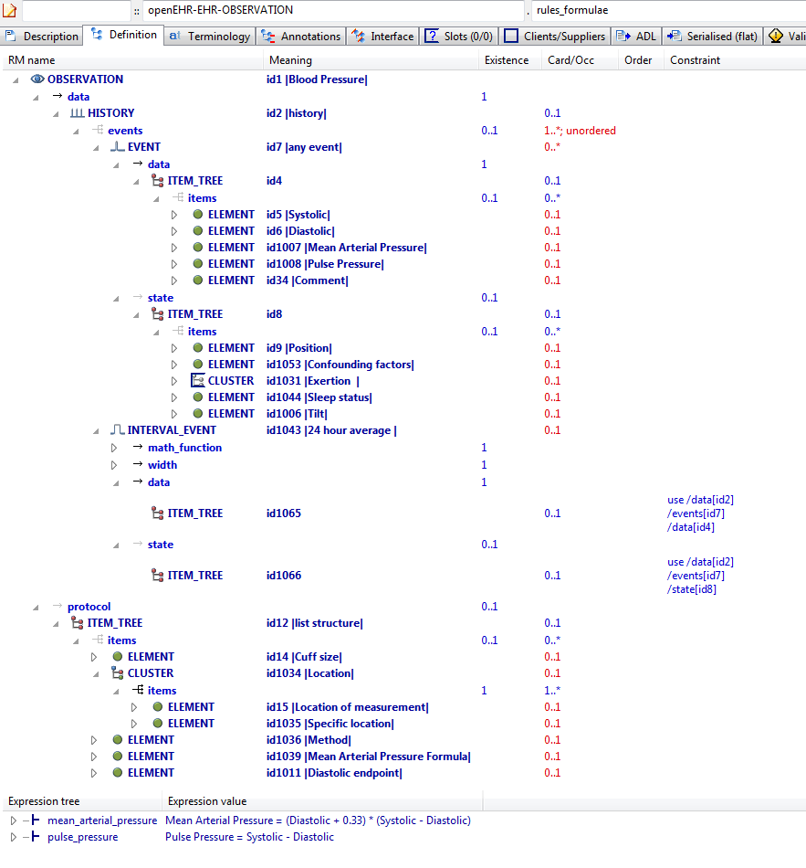

#### Rules Formulae v1 AML Diagram

#### Rules Formulae v1 AML Associations Diagram

## AOM Structures Slots Examples

### Slot Include Any Exclude Empty v1 Example

Demonstrate 'open' slot.

#### Slot Include Any Exclude Empty v1 ADL

archetype (adl_version=2.0.5; rm_release=1.0.2)

openEHR-EHR-SECTION.slot_include_any_exclude_empty.v1.0.0

language

original_language = <[ISO_639-1::en]>

description

custodian_namespace = <"org.openehr">

custodian_organisation = <"openEHR Foundation <http://www.openEHR.org>">

original_author = <

["name"] = <"Thomas Beale">

["email"] = <"thomas.beale@openEHR.org">

["organisation"] = <"openEHR Foundation <http://www.openEHR.org>">

["date"] = <"2010-03-14">

>

details = <

["en"] = <

language = <[ISO_639-1::en]>

purpose = <"Demonstrate 'open' slot.">

keywords = <"ADL", "test", "slots">

>

>

lifecycle_state = <"published">

other_details = <

["regression"] = <"PASS">

>

copyright = <"Copyright © 2010 openEHR Foundation <http://www.openEHR.org>">

licence = <"Creative Commons CC-BY-SA <https://creativecommons.org/licenses/by-sa/3.0/>">

definition

SECTION[id1] matches { -- Slot section

items cardinality matches {1..*; unordered} matches {

allow_archetype OBSERVATION[id2] occurrences matches {0..1} matches { -- Vital signs

include

archetype_id/value matches {/.*/}

}

}

}

terminology

term_definitions = <

["en"] = <

["id1"] = <

text = <"Slot section">

description = <"Slot section">

>

["id2"] = <

text = <"Vital signs">

description = <"Vital signs observations.">

>

>

>

#### Slot Include Any Exclude Empty v1 ADL Diagram

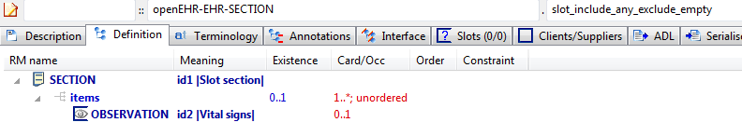

#### Slot Include Any Exclude Empty v1 AML Diagram

#### Slot Include Any Exclude Empty v1 AML Associations Diagram

### Slot Include Any Exclude Non Any v1 Example

Test slot with any include and non-any exclude, which corresponds to 'hard' exclusion.

#### Slot Include Any Exclude Non Any v1 ADL

archetype (adl_version=2.0.5; rm_release=1.0.2)

openEHR-EHR-SECTION.slot_include_any_exclude_non_any.v1.0.0

language

original_language = <[ISO_639-1::en]>

description

custodian_namespace = <"org.openehr">

custodian_organisation = <"openEHR Foundation <http://www.openEHR.org>">

original_author = <

["name"] = <"Thomas Beale">

["organisation"] = <"Ocean Informatics">

["email"] = <"thomas.beale@oceaninformatics.com">

["date"] = <"2010-03-14">

>

details = <

["en"] = <

language = <[ISO_639-1::en]>

purpose = <"Test slot with any include and non-any exclude, which corresponds to 'hard' exclusion.">

keywords = <"ADL", "test", "slots">

>

>

lifecycle_state = <"published">

other_details = <

["regression"] = <"PASS">

>

copyright = <"Copyright © 2010 openEHR Foundation <http://www.openEHR.org>">

licence = <"Creative Commons CC-BY-SA <https://creativecommons.org/licenses/by-sa/3.0/>">

definition

SECTION[id1] matches { -- Slot section

items cardinality matches {1..*; unordered} matches {

allow_archetype OBSERVATION[id2] occurrences matches {0..1} matches { -- Vital signs

include

archetype_id/value matches {/.*/}

exclude

archetype_id/value matches {/openEHR-EHR-OBSERVATION\.blood_pressure([a-zA-Z0-9_]+)*\.v1/}

}

}

}

terminology

term_definitions = <

["en"] = <

["id1"] = <

text = <"Slot section">

description = <"Slot section">

>

["id2"] = <

text = <"Vital signs">

description = <"Vital signs observations.">

>

>

>

#### Slot Include Any Exclude Non Any v1 ADL Diagram

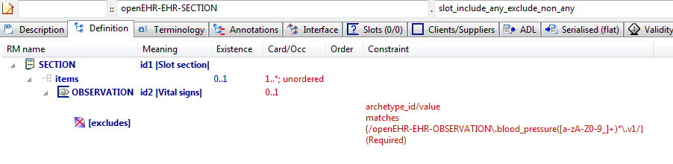

#### Slot Include Any Exclude Non Any v1 AML Diagram

#### Slot Include Any Exclude Non Any v1 AML Associations Diagram

### Slot Include Empty Exclude Any v1 Example

Test slot with no include and exclude = any.

#### Slot Include Empty Exclude Any v1 ADL

archetype (adl_version=2.0.5; rm_release=1.0.2)

openEHR-EHR-SECTION.slot_include_empty_exclude_any.v1.0.0

language

original_language = <[ISO_639-1::en]>

description

custodian_namespace = <"org.openehr">

custodian_organisation = <"openEHR Foundation <http://www.openEHR.org>">

original_author = <

["name"] = <"Thomas Beale">

["email"] = <"thomas.beale@openEHR.org">

["organisation"] = <"openEHR Foundation <http://www.openEHR.org>">

["date"] = <"2010-03-14">

>

details = <

["en"] = <

language = <[ISO_639-1::en]>

purpose = <"Test slot with no include and exclude = any.">

keywords = <"ADL", "test", "slots">

>

>

lifecycle_state = <"published">

other_details = <

["regression"] = <"PASS">

>

copyright = <"Copyright © 2014 openEHR Foundation <http://www.openEHR.org>">

licence = <"Creative Commons CC-BY-SA <https://creativecommons.org/licenses/by-sa/3.0/>">

definition

SECTION[id1] matches { -- Slot section

items cardinality matches {1..*; unordered} matches {

allow_archetype OBSERVATION[id2] occurrences matches {0..1} matches { -- Vital signs

exclude

archetype_id/value matches {/.*/}

}

}

}

terminology

term_definitions = <

["en"] = <

["id1"] = <

text = <"Slot section">

description = <"Slot section">

>

["id2"] = <

text = <"Vital signs">

description = <"Vital signs observations.">

>

>

>

#### Slot Include Empty Exclude Any v1 ADL Diagram

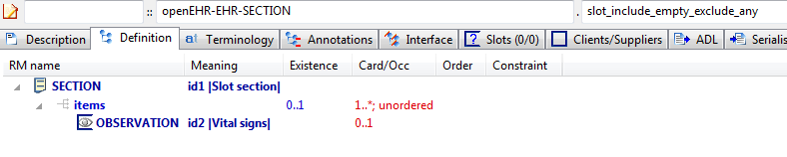

#### Slot Include Empty Exclude Any v1 AML Diagram

#### Slot Include Empty Exclude Any v1 AML Associations Diagram

### Slot Include Empty Exclude Empty v1 Example

Test slot with no include or exclude.

#### Slot Include Empty Exclude Empty v1 ADL

archetype (adl_version=2.0.5; rm_release=1.0.2)

openEHR-EHR-SECTION.slot_include_empty_exclude_empty.v1.0.0

language

original_language = <[ISO_639-1::en]>

description

custodian_namespace = <"org.openehr">

custodian_organisation = <"openEHR Foundation <http://www.openEHR.org>">

original_author = <

["name"] = <"Thomas Beale">

["email"] = <"thomas.beale@openEHR.org">

["organisation"] = <"openEHR Foundation <http://www.openEHR.org>">

["date"] = <"2010-03-14">

>

details = <

["en"] = <

language = <[ISO_639-1::en]>

purpose = <"Test slot with no include or exclude.">

keywords = <"ADL", "test", "slots">

>

>

lifecycle_state = <"published">

other_details = <

["regression"] = <"PASS">

>

copyright = <"Copyright © 2010 openEHR Foundation <http://www.openEHR.org>">

licence = <"Creative Commons CC-BY-SA <https://creativecommons.org/licenses/by-sa/3.0/>">

definition

SECTION[id1] matches { -- Slot section

items cardinality matches {1..*; unordered} matches {

allow_archetype OBSERVATION[id2] occurrences matches {0..1} -- Vital signs

}

}

terminology

term_definitions = <

["en"] = <

["id1"] = <

text = <"Slot section">

description = <"Slot section">

>

["id2"] = <

text = <"Vital signs">

description = <"Vital signs observations.">

>

>

>

#### Slot Include Empty Exclude Empty v1 ADL Diagram

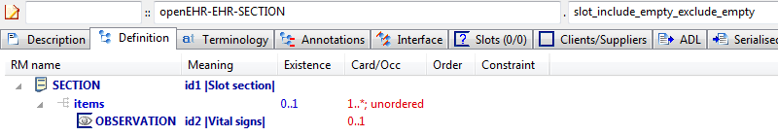

#### Slot Include Empty Exclude Empty v1 AML Diagram

#### Slot Include Empty Exclude Empty v1 AML Associations Diagram

### Slot Include Empty Exclude Non Any v1 Example

Test slot with no include and non-any exclude, which defines a recommendation to exclude.

#### Slot Include Empty Exclude Non Any v1 ADL

archetype (adl_version=2.0.5; rm_release=1.0.2)

openEHR-EHR-SECTION.slot_include_empty_exclude_non_any.v1.0.0

language

original_language = <[ISO_639-1::en]>

description

custodian_namespace = <"org.openehr">

custodian_organisation = <"openEHR Foundation <http://www.openEHR.org>">

original_author = <

["name"] = <"Thomas Beale">

["email"] = <"thomas.beale@openEHR.org">

["organisation"] = <"openEHR Foundation <http://www.openEHR.org>">

["date"] = <"2010-03-14">

>

details = <

["en"] = <

language = <[ISO_639-1::en]>

purpose = <"Test slot with no include and non-any exclude, which defines a recommendation to exclude.">

keywords = <"ADL", "test", "slots">

>

>

lifecycle_state = <"published">

other_details = <

["regression"] = <"PASS">

>

copyright = <"Copyright © 2010 openEHR Foundation <http://www.openEHR.org>">

licence = <"Creative Commons CC-BY-SA <https://creativecommons.org/licenses/by-sa/3.0/>">

definition

SECTION[id1] matches { -- Slot section

items cardinality matches {1..*; unordered} matches {

allow_archetype OBSERVATION[id2] occurrences matches {0..1} matches { -- Vital signs

exclude

archetype_id/value matches {/openEHR-EHR-OBSERVATION\.blood_pressure([a-zA-Z0-9_]+)*\.v1/}

}

}

}

terminology

term_definitions = <

["en"] = <

["id1"] = <

text = <"Slot section">

description = <"Slot section">

>

["id2"] = <

text = <"Vital signs">

description = <"Vital signs observations.">

>

>

>

#### Slot Include Empty Exclude Non Any v1 ADL Diagram

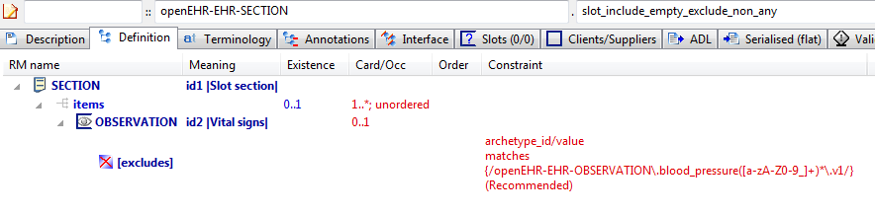

#### Slot Include Empty Exclude Non Any v1 AML Diagram

#### Slot Include Empty Exclude Non Any v1 AML Associations Diagram

### Slot Include Non Any Exclude Any v1 Example

Test slot archetype with non-any include and exclude = any, which corresponds to 'hard' includes.

#### Slot Include Non Any Exclude Any v1 ADL

archetype (adl_version=2.0.5; rm_release=1.0.2)

openEHR-EHR-SECTION.slot_include_non_any_exclude_any.v1.0.0

language

original_language = <[ISO_639-1::en]>

description

custodian_namespace = <"org.openehr">

custodian_organisation = <"openEHR Foundation <http://www.openEHR.org>">

original_author = <

["name"] = <"Thomas Beale">

["email"] = <"thomas.beale@openEHR.org">

["organisation"] = <"openEHR Foundation <http://www.openEHR.org>">

["date"] = <"2010-03-14">

>

details = <

["en"] = <

language = <[ISO_639-1::en]>

purpose = <"Test slot archetype with non-any include and exclude = any, which corresponds to 'hard' includes.">

>

>

lifecycle_state = <"published">

other_details = <

["regression"] = <"PASS">

>

copyright = <"Copyright © 2010 openEHR Foundation <http://www.openEHR.org>">

licence = <"Creative Commons CC-BY-SA <https://creativecommons.org/licenses/by-sa/3.0/>">

definition

SECTION[id1] matches { -- Slot section

items cardinality matches {1..*; unordered} matches {

allow_archetype OBSERVATION[id2] occurrences matches {0..1} matches { -- Vital signs

include

archetype_id/value matches {/openEHR-EHR-OBSERVATION\.blood_pressure([a-zA-Z0-9_]+)*\.v1/}

exclude

archetype_id/value matches {/.*/}

}

}

}

terminology

term_definitions = <

["en"] = <

["id1"] = <

text = <"Slot section">

description = <"Slot section">

>

["id2"] = <

text = <"Vital signs">

description = <"Vital signs observations.">

>

>

>

#### Slot Include Non Any Exclude Any v1 ADL Diagram

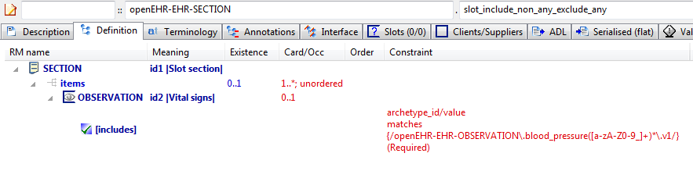

#### Slot Include Non Any Exclude Any v1 AML Diagram

#### Slot Include Non Any Exclude Any v1 AML Associations Diagram

### Slot Include Non Any Exclude Empty v1 Example

Test slot archetype with non-any include and no excludes, which means the includes are taken as recommendations.

#### Slot Include Non Any Exclude Empty v1 ADL

archetype (adl_version=2.0.5; rm_release=1.0.2)

openEHR-EHR-SECTION.slot_include_non_any_exclude_empty.v1.0.0

language

original_language = <[ISO_639-1::en]>

description

custodian_namespace = <"org.openehr">

custodian_organisation = <"openEHR Foundation <http://www.openEHR.org>">

original_author = <

["name"] = <"Thomas Beale">

["email"] = <"thomas.beale@openEHR.org">

["organisation"] = <"openEHR Foundation <http://www.openEHR.org>">

["date"] = <"2010-03-14">

>

details = <

["en"] = <

language = <[ISO_639-1::en]>

purpose = <"Test slot archetype with non-any include and no excludes, which means the includes are taken as recommendations.">

keywords = <"ADL", "test", "slots">

>

>

lifecycle_state = <"published">

other_details = <

["regression"] = <"PASS">

>

copyright = <"Copyright © 2010 openEHR Foundation <http://www.openEHR.org>">

licence = <"Creative Commons CC-BY-SA <https://creativecommons.org/licenses/by-sa/3.0/>">

definition

SECTION[id1] matches { -- Slot section

items cardinality matches {1..*; unordered} matches {

allow_archetype OBSERVATION[id2] occurrences matches {0..1} matches { -- Vital signs

include

archetype_id/value matches {/openEHR-EHR-OBSERVATION\.blood_pressure([a-zA-Z0-9_]+)*\.v1|openEHR-EHR-OBSERVATION\.body_temperature([a-zA-Z0-9_]+)*\.v1|openEHR-EHR-OBSERVATION\.heart_rate([a-zA-Z0-9_]+)*\.v1|openEHR-EHR-OBSERVATION\.indirect_oximetry([a-zA-Z0-9_]+)*\.v1|openEHR-EHR-OBSERVATION\.respiration([a-zA-Z0-9_]+)*\.v1/}

}

}

}

terminology

term_definitions = <

["en"] = <

["id1"] = <

text = <"Slot section">

description = <"Slot section">

>

["id2"] = <

text = <"Vital signs">

description = <"Vital signs observations.">

>

>

>

#### Slot Include Non Any Exclude Empty v1 ADL Diagram

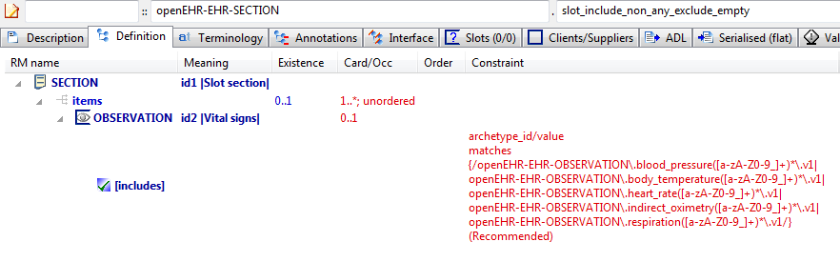

#### Slot Include Non Any Exclude Empty v1 AML Diagram

#### Slot Include Non Any Exclude Empty v1 AML Associations Diagram

## AOM Structures Tuples Examples

### Real Ordinal v1.0.0 Example

Test integer ordinal values for an RM that has ORDINAL.value defined as Real; constraints should silently be promoted to Reals.

#### Real Ordinal v1.0.0 ADL

archetype (adl_version=2.0.5; rm_release=2.0.2)

CIMI-CORE-ITEM_GROUP.real_ordinal.v1.0.0

language

original_language = <[ISO_639-1::en]>

description

lifecycle_state = <"unmanaged">

original_author = <

["name"] = <"Thomas Beale">

["organisation"] = <"openEHR Foundation">

["email"] = <"thomas.beale@OceanInformatics.com">

["date"] = <"2014-10-10">

>

custodian_namespace = <"org.openehr">

custodian_organisation = <"openEHR Foundation <http://www.openEHR.org>">

copyright = <"Copyright © 2014 openEHR Foundation <http://www.openEHR.org>">

licence = <"Creative Commons CC-BY-SA <https://creativecommons.org/licenses/by-sa/3.0/>">

details = <

["en"] = <

language = <[ISO_639-1::en]>

purpose = <"Test integer ordinal values for an RM that has ORDINAL.value defined as Real; constraints should silently be promoted to Reals.">

keywords = <"ADL", "test", "tuples">

>

>

other_details = <

["regression"] = <"PASS">

>

definition

ITEM_GROUP[id1] matches { -- Laboratory test ordinal

item matches {

ELEMENT[id2] matches { -- Result value

value matches {

ORDINAL[id3] matches {

[symbol, value] matches {

[{[at1]}, {0.0}],

[{[at2]}, {1.0}],

[{[at3]}, {2.0}]

}

}

}

}

}

}

terminology

term_definitions = <

["en"] = <

["id1"] = <

text = <"Laboratory test ordinal">

>

["id2"] = <

text = <"Result value">

>

["at1"] = <

text = <"min">

>

["at2"] = <

text = <"med">

>

["at3"] = <

text = <"max">

>

>

>

#### Real Ordinal v1.0.0 ADL Diagram

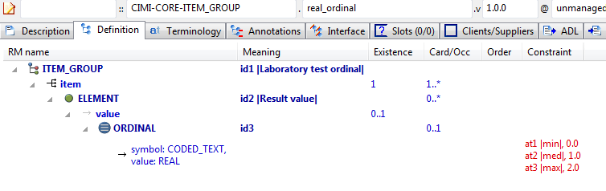

#### Real Ordinal v1.0.0 AML Diagram

#### Real Ordinal v1.0.0 AML Associations Diagram

### Ordinal Tuple v1 Example

Example of a tuple used to model an 'ordinal' reference model concept. The latter is one in which there is logically a 2-column list of {value, symbol} pairs (the value is typically an Integer). The tuple constraint provides a nice way to model this, by limiting the possible pairs (mostly meaningless) to just those that make sense in the domain.

#### Ordinal Tuple v1 ADL

archetype (adl_version=2.0.5; rm_release=1.0.2)

openEHR-EHR-OBSERVATION.ordinal_tuple.v1.0.0

language

original_language = <[ISO_639-1::en]>

description

custodian_namespace = <"org.openehr">

custodian_organisation = <"openEHR Foundation <http://www.openEHR.org>">

original_author = <

["name"] = <"Thomas Beale">

["email"] = <"thomas.beale@openEHR.org">

["organisation"] = <"openEHR Foundation <http://www.openEHR.org>">

["date"] = <"2013-08-14">

>

details = <

["en"] = <

language = <[ISO_639-1::en]>

purpose = <"Example of a tuple used to model an 'ordinal' reference model concept. The latter is one in which there is logically a 2-column list of {value, symbol} pairs (the value is typically an Integer). The tuple constraint provides a nice way to model this, by limiting the possible pairs (mostly meaningless) to just those that make sense in the domain.">

keywords = <"ADL", "test", "tuples", "ordinals">

>

>

lifecycle_state = <"published">

other_details = <

["regression"] = <"PASS">

>

copyright = <"Copyright © 2013 openEHR Foundation <http://www.openEHR.org>">

licence = <"Creative Commons CC-BY-SA <https://creativecommons.org/licenses/by-sa/3.0/>">

definition

OBSERVATION[id1] matches { -- Apgar score

data matches {

HISTORY[id3] matches {

events cardinality matches {1..*; unordered} matches {

POINT_EVENT[id4] occurrences matches {0..1} matches { -- 1 minute

data matches {

ITEM_LIST[id2] matches {

items cardinality matches {1..6; ordered} matches {

ELEMENT[id10] occurrences matches {0..1} matches { -- Respiratory effort

value matches {

DV_ORDINAL[id11] matches {

[value, symbol] matches {

[{0}, {[at11]}],

[{1}, {[at12]}],

[{2}, {[at13]}]

}

}

}

}

}

}

}

}

}

}

}

}

terminology

term_definitions = <

["en"] = <

["id1"] = <

text = <"Apgar score">

description = <"Clinical score derived from assessment of respiratory effort, heart rate, reflex irritability, muscle tone and skin colour.">

>

["id4"] = <

text = <"1 minute">

description = <"Apgar score 1 minute after birth.">

>

["id10"] = <

text = <"Respiratory effort">

description = <"Observation of the infant's respiratory effort.">

>

["at11"] = <

text = <"Absent">

description = <"No effort to breath.">

>

["at12"] = <

text = <"Weak or irregular">

description = <"Some effort to breath, moving chest.">

>

["at13"] = <

text = <"Normal">

description = <"Breathing normally or crying.">

>

["ac1"] = <

text = <"Respiratory effort">

description = <"Observation of the infant's respiratory effort.">

>

>

>

value_sets = <

["ac1"] = <

id = <"ac1">

members = <"at11", "at12", "at13">

>

>

#### Ordinal Tuple v1 ADL Diagram

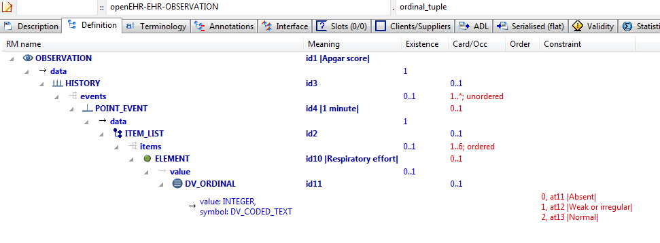

#### Ordinal Tuple v1 AML Diagram

#### Ordinal Tuple v1 AML Associations Diagram

### Dv Ordinals v1 Example

Example showing openEHR DV_ORDINAL modelled with and without tuples.

#### Dv Ordinals v1 ADL

archetype (adl_version=2.0.5; rm_release=1.0.2)

openehr-TEST_PKG-SOME_TYPE.dv_ordinals.v1.0.0

language

original_language = <[ISO_639-1::en]>

description

custodian_namespace = <"org.openehr">

custodian_organisation = <"openEHR Foundation <http://www.openEHR.org>">

original_author = <

["name"] = <"Thomas Beale">

["email"] = <"thomas.beale@openEHR.org">

["organisation"] = <"openEHR Foundation <http://www.openEHR.org>">

["date"] = <"2004-06-01">

>

details = <

["en"] = <

language = <[ISO_639-1::en]>

purpose = <"Example showing openEHR DV_ORDINAL modelled with and without tuples.">

keywords = <"ADL", "ordinal", "test">

>

>

lifecycle_state = <"published">

other_details = <

["regression"] = <"PASS">

>

copyright = <"Copyright © 2004 openEHR Foundation <http://www.openEHR.org>">

licence = <"Creative Commons CC-BY-SA <https://creativecommons.org/licenses/by-sa/3.0/>">

definition

SOME_TYPE[id1] matches { -- root item

standard_ordinal_attr matches {

DV_ORDINAL[id5] matches { -- ordinal 1

value matches {0}

symbol matches {

DV_CODED_TEXT[id8] matches {

defining_code matches {[at2]}

}

}

}

DV_ORDINAL[id6] matches { -- ordinal 2

value matches {1}

symbol matches {

DV_CODED_TEXT[id9] matches {

defining_code matches {[at3]}

}

}

}

DV_ORDINAL[id7] matches { -- ordinal 3

value matches {2}

symbol matches {

DV_CODED_TEXT[id10] matches {

defining_code matches {[at4]}

}

}

}

}

clinical_ordinal_attr_1 matches {

DV_ORDINAL[id11] matches {

[value, symbol] matches {

[{0}, {[at2]}],

[{1}, {[at3]}],

[{2}, {[at4]}]

}

}

}

}

terminology

term_definitions = <

["en"] = <

["id1"] = <

text = <"root item">

description = <"xxxx">

>

["at2"] = <

text = <"+">

description = <"mild">

>

["at3"] = <

text = <"++">

description = <"medium">

>

["at4"] = <

text = <"+++">

description = <"severe">

>

["id5"] = <

text = <"ordinal 1">

description = <"ordinal 1">

>

["id6"] = <

text = <"ordinal 2">

description = <"ordinal 2">

>

["id7"] = <

text = <"ordinal 3">

description = <"ordinal 3">

>

["ac1"] = <

text = <"root item">

description = <"xxxx">

>

>

>

value_sets = <

["ac1"] = <

id = <"ac1">

members = <"at2", "at3", "at4">

>

>

#### Dv Ordinals v1 ADL Diagram

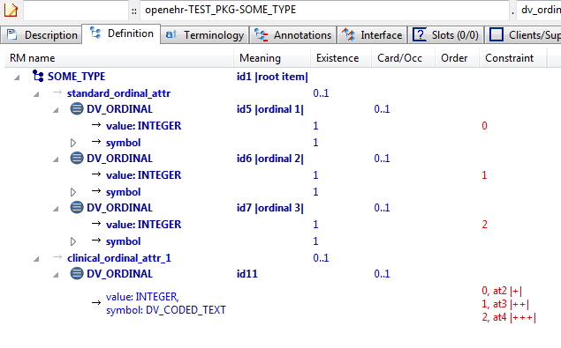

#### Dv Ordinals v1 AML Diagram

#### Dv Ordinals v1 AML Associations Diagram

### Dv Quantity Tuple v1 Example

Illustrates DV_QUANTITY tuple constraints

#### Dv Quantity Tuple v1 ADL

archetype (adl_version=2.0.5; rm_release=1.0.2)

openehr-TEST_PKG-SOME_TYPE.dv_quantity_tuple.v1.0.0

language

original_language = <[ISO_639-1::en]>

description

custodian_namespace = <"org.openehr">

custodian_organisation = <"openEHR Foundation <http://www.openEHR.org>">

original_author = <

["name"] = <"Thomas Beale">

["email"] = <"thomas.beale@openEHR.org">

["organisation"] = <"openEHR Foundation <http://www.openEHR.org>">

["date"] = <"2013-06-01">

>

details = <

["en"] = <

language = <[ISO_639-1::en]>

purpose = <"Illustrates DV_QUANTITY tuple constraints">

keywords = <"ADL", "test", "tuples", "quantities">

>

>

lifecycle_state = <"published">

other_details = <

["regression"] = <"PASS">

>

copyright = <"Copyright © 2013 openEHR Foundation <http://www.openEHR.org>">

licence = <"Creative Commons CC-BY-SA <https://creativecommons.org/licenses/by-sa/3.0/>">

definition

SOME_TYPE[id1] matches { -- root item

clinical_quantity_attr_1 matches {

DV_QUANTITY[id2] matches {

property matches {[at1]}

[units, magnitude] matches {

[{"C"}, {|>=4.0|}],

[{"F"}, {|>=40.0|}]

}

}

}

}

terminology

term_definitions = <

["en"] = <

["id1"] = <

text = <"root item">

description = <"xxxx">

>

["at1"] = <

text = <"Temperature">

description = <"Temperature">

>

>

>

term_bindings = <

["openehr"] = <

["at1"] = <http://openehr.org/id/127>

>

>

#### Dv Quantity Tuple v1 ADL Diagram

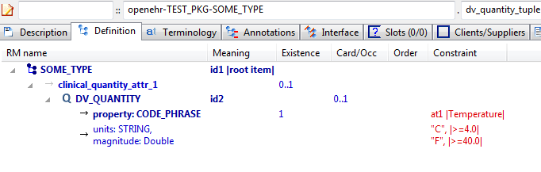

#### Dv Quantity Tuple v1 AML Diagram

#### Dv Quantity Tuple v1 AML Associations Diagram

## AOM Structures Use_archetype Examples

### Ext Ref v1 Example

Example of an external reference, expressed using the 'use_archetype' keyword. This defines a direct association between the archetypes, without the need for a slot, and a corresponding association (which may be an aggregation or composition) of Reference Model structures. The constraint below says concretely that the COMPOSITION object contains SECTION and OBSERVATION objects under its content attribute.

#### Ext Ref v1 ADL

archetype (adl_version=2.0.5; rm_release=1.0.2)

openEHR-EHR-COMPOSITION.ext_ref.v1.0.0

language

original_language = <[ISO_639-1::en]>

description

custodian_namespace = <"org.openehr">

custodian_organisation = <"openEHR Foundation <http://www.openEHR.org>">

original_author = <

["name"] = <"Thomas Beale">

["email"] = <"thomas.beale@openEHR.org">

["organisation"] = <"openEHR Foundation <http://www.openEHR.org>">

["date"] = <"2011-06-01">

>

details = <

["en"] = <

language = <[ISO_639-1::en]>

purpose = <"Example of an external reference, expressed using the 'use_archetype' keyword. This defines a direct association between the archetypes, without the need for a slot, and a corresponding association (which may be an aggregation or composition) of Reference Model structures. The constraint below says concretely that the COMPOSITION object contains SECTION and OBSERVATION objects under its content attribute.">

keywords = <"ADL", "test", "external reference">

>

>

lifecycle_state = <"published">

other_details = <

["regression"] = <"PASS">

>

copyright = <"Copyright © 2011 openEHR Foundation <http://www.openEHR.org>">

licence = <"Creative Commons CC-BY-SA <https://creativecommons.org/licenses/by-sa/3.0/>">

definition

COMPOSITION[id1] matches { -- Composition

content matches {

use_archetype SECTION[id2, openEHR-EHR-SECTION.section_parent.v1] occurrences matches {0..1}

use_archetype OBSERVATION[id3, openEHR-EHR-OBSERVATION.spec_test_obs.v1] occurrences matches {1}

}

}

terminology

term_definitions = <

["en"] = <

["id1"] = <

text = <"Composition">

description = <"Composition">

>

["id2"] = <

text = <"Section">

description = <"Section">

>

["id3"] = <

text = <"Observation">

description = <"Observation">

>

>

>

#### Ext Ref v1 ADL Diagram

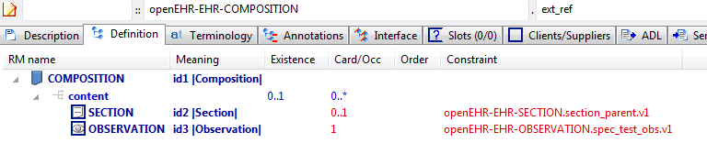

#### Ext Ref v1 AML Diagram

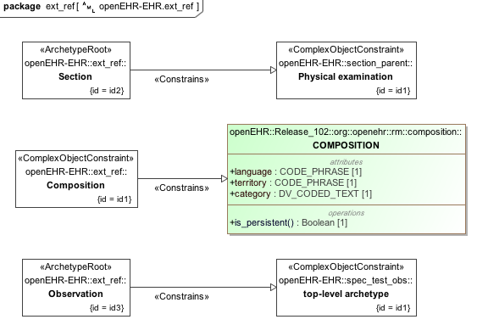

#### Ext Ref v1 AML Associations Diagram

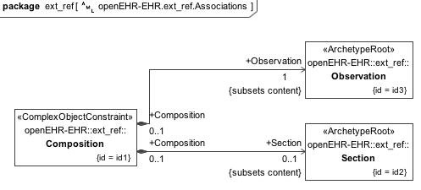

## AOM Structures Use_node Examples

### Use Node Occurrences v1 Example

Example showing override of occurrences at source end of use_node. With no occurrences stated on a use_node node, the occurrences at target of the reference are used. This can be overridden as in this example with an occurrences at the source end.

#### Use Node Occurrences v1 ADL

archetype (adl_version=2.0.5; rm_release=1.0.2)

openEHR-DEMOGRAPHIC-PERSON.use_node_occurrences.v1.0.0

language

original_language = <[ISO_639-1::en]>

description

custodian_namespace = <"org.openehr">

custodian_organisation = <"openEHR Foundation <http://www.openEHR.org>">

original_author = <

["name"] = <"Thomas Beale">

["email"] = <"thomas.beale@openEHR.org">

["organisation"] = <"openEHR Foundation <http://www.openEHR.org>">

["date"] = <"2004-06-01">

>

details = <

["en"] = <

language = <[ISO_639-1::en]>

purpose = <"Example showing override of occurrences at source end of use_node. With no occurrences stated on a use_node node, the occurrences at target of the reference are used. This can be overridden as in this example with an occurrences at the source end.">

keywords = <"ADL", "test", "use_node", "occurrences">

>

>

lifecycle_state = <"published">

other_details = <

["regression"] = <"PASS">

>

copyright = <"Copyright © 2004 openEHR Foundation <http://www.openEHR.org>">

licence = <"Creative Commons CC-BY-SA <https://creativecommons.org/licenses/by-sa/3.0/>">

definition

PERSON[id1] matches { -- person demographics

contacts matches {

CONTACT[id6] matches { -- home contact

addresses matches {

ADDRESS[id7] occurrences matches {0..1} -- home phone number

ADDRESS[id8] occurrences matches {0..2} -- home fax number

ADDRESS[id9] -- home email address

}

}

CONTACT[id10] matches { -- work contact

addresses matches {

use_node ADDRESS[id11] /contacts[id6]/addresses[id7] -- /contacts[home contact]/addresses[home phone number]

use_node ADDRESS[id12] /contacts[id6]/addresses[id8] -- /contacts[home contact]/addresses[home fax number]

use_node ADDRESS[id13] occurrences matches {1..3} /contacts[id6]/addresses[id9] -- /contacts[home contact]/addresses[home email address]

}

}

}

}

terminology

term_definitions = <

["en"] = <

["id1"] = <

text = <"person demographics">

description = <"demographic person details">

>

["id6"] = <

text = <"home contact">

description = <"person's home contact details">

>

["id7"] = <

text = <"home phone number">

description = <"person's home phone number">

>

["id8"] = <

text = <"home fax number">

description = <"person's home fax number">

>

["id9"] = <

text = <"home email address">

description = <"person's home email address">

>

["id10"] = <

text = <"work contact">

description = <"person's home contact details">

>

["id11"] = <

text = <"work fax number">

description = <"person's work fax number">

>

["id12"] = <

text = <"work email address">

description = <"person's work email address">

>

["id13"] = <

text = <"work contact">

description = <"person's work contact details">

>

>

>

#### Use Node Occurrences v1 ADL Diagram

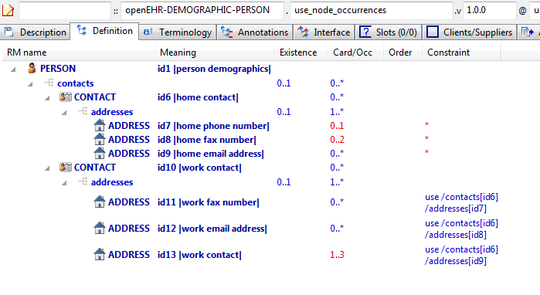

#### Use Node Occurrences v1 AML Diagram

#### Use Node Occurrences v1 AML Associations Diagram

### Path Analysis Use Nodes v1 Example

Illustrate path set created by multiple use_node references. Three paths should be visible that end in [id14] in the path analysis.

#### Path Analysis Use Nodes v1 ADL

archetype (adl_version=2.0.5; rm_release=1.0.2)

openEHR-EHR-OBSERVATION.path_analysis_use_nodes.v1.0.0

language

original_language = <[ISO_639-1::en]>

description

custodian_namespace = <"org.openehr">

custodian_organisation = <"openEHR Foundation <http://www.openEHR.org>">

original_author = <

["name"] = <"Thomas Beale">

["email"] = <"thomas.beale@openEHR.org">

["organisation"] = <"openEHR Foundation <http://www.openEHR.org>">

["date"] = <"2004-06-01">

>

details = <

["en"] = <

language = <[ISO_639-1::en]>

purpose = <"Illustrate path set created by multiple use_node references. Three paths should be visible that end in [id14] in the path analysis.">

keywords = <"ADL", "test", "internal references">

>

>

lifecycle_state = <"published">

other_details = <

["regression"] = <"PASS">

>

copyright = <"Copyright © 2004 openEHR Foundation <http://www.openEHR.org>">

licence = <"Creative Commons CC-BY-SA <https://creativecommons.org/licenses/by-sa/3.0/>">

definition

OBSERVATION[id1] matches { -- Laboratory result

data matches {

HISTORY[id2] matches {

events cardinality matches {1..*; unordered} matches {

EVENT[id3] occurrences matches {0..*} matches { -- Any event

data matches {

ITEM_TREE[id4] matches {

items matches {

CLUSTER[id12] matches { -- level 1

name matches {

DV_CODED_TEXT[id23] matches {

defining_code matches {[ac1]} -- =LOINC::Battery_name

}

}

items matches {

CLUSTER[id13] matches { -- level 2

name matches {

DV_CODED_TEXT[id24] matches {

defining_code matches {[ac2]} -- =LOINC::Battery_name

}

}

items matches {

use_node ELEMENT[id21] /data[id2]/events[id3]/data[id4]/items[id14] -- /data[id2]/events[Any event]/data[id4]/items[Any result]

}

}

use_node ELEMENT[id22] /data[id2]/events[id3]/data[id4]/items[id14] -- /data[id2]/events[Any event]/data[id4]/items[Any result]

}

}

ELEMENT[id14] -- Any result

}

}

}

}

}

}

}

}

terminology

term_definitions = <

["en"] = <

["id1"] = <

text = <"Laboratory result">

description = <"Generic laboratory result archetype to allow terminology driven results on a generic framework">

>

["id3"] = <

text = <"Any event">

description = <"Any event in a time series">

>

["id12"] = <

text = <"level 1">

description = <"A cluster to enable level one battery labels">

>

["id13"] = <

text = <"level 2">

description = <"A cluster to enable level 2 battery labels">

>

["id14"] = <

text = <"Any result">

description = <"Generic result - data type is not set">

>

["id21"] = <

text = <"ref 1">

description = <"Use node ref #1">

>

["id22"] = <

text = <"ref 2">

description = <"Use node ref #2">

>

["ac1"] = <

text = <"=LOINC::Battery_name">

description = <"Any name for a set of tests from the LOINC set of battery names">

>

["ac2"] = <

text = <"=LOINC::Battery_name">

description = <"Any name for a set of tests from the LOINC set of battery names">

>

>

>

#### Path Analysis Use Nodes v1 ADL Diagram

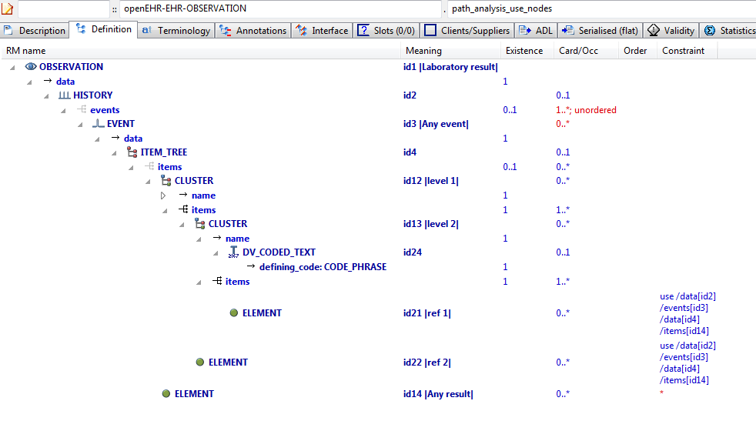

#### Path Analysis Use Nodes v1 AML Diagram

#### Path Analysis Use Nodes v1 AML Associations Diagram

### Use Node Multiple v1 Example

This example, based on the openEHR Apgar archetype, shows the use of internal references (keyword 'use_node') to re-use a subtree constraint structure repeatedly elsewhere in the archetype.

#### Use Node Multiple v1 ADL

archetype (adl_version=2.0.5; rm_release=1.0.2)

openEHR-EHR-OBSERVATION.apgar.v1.0.0

language

original_language = <[ISO_639-1::en]>

description

custodian_namespace = <"org.openehr">

custodian_organisation = <"openEHR Foundation <http://www.openEHR.org>">

original_author = <

["name"] = <"Thomas Beale">

["email"] = <"thomas.beale@openEHR.org">

["organisation"] = <"openEHR Foundation <http://www.openEHR.org>">

["date"] = <"2004-06-01">

>

details = <

["en"] = <

language = <[ISO_639-1::en]>

purpose = <"This example, based on the openEHR Apgar archetype, shows the use of internal references (keyword 'use_node') to re-use a subtree constraint structure repeatedly elsewhere in the archetype.">

keywords = <"ADL", "test", "internal references">

>

>

lifecycle_state = <"published">

other_details = <

["regression"] = <"PASS">

>

copyright = <"Copyright © 2004 openEHR Foundation <http://www.openEHR.org>">

licence = <"Creative Commons CC-BY-SA <https://creativecommons.org/licenses/by-sa/3.0/>">

definition

OBSERVATION[id1] matches { -- Apgar score

data matches {

HISTORY[id3] matches {

events cardinality matches {1..*; unordered} matches {

POINT_EVENT[id4] occurrences matches {0..1} matches { -- 1 minute

offset matches {

DV_DURATION[id46] matches {

value matches {PT1M}

}

}

data matches {

ITEM_LIST[id2] matches {

items cardinality matches {1..6; ordered} matches {

ELEMENT[id10] occurrences matches {0..1} matches { -- Respiratory effort

value matches {

DV_ORDINAL[id47] matches {

[value, symbol] matches {

[{0}, {[at11]}],

[{1}, {[at12]}],

[{2}, {[at13]}]

}

}

}

}

ELEMENT[id6] occurrences matches {0..1} matches { -- Heart Rate

value matches {

DV_ORDINAL[id48] matches {

[value, symbol] matches {

[{0}, {[at7]}],

[{1}, {[at8]}],

[{2}, {[at9]}]

}

}

}

}

ELEMENT[id14] occurrences matches {0..1} matches { -- Muscle tone

value matches {

DV_ORDINAL[id49] matches {

[value, symbol] matches {

[{0}, {[at15]}],

[{1}, {[at16]}],

[{2}, {[at17]}]

}

}

}

}

ELEMENT[id18] occurrences matches {0..1} matches { -- Reflex irritability

value matches {

DV_ORDINAL[id50] matches {

[value, symbol] matches {

[{0}, {[at19]}],

[{1}, {[at20]}],

[{2}, {[at21]}]

}

}

}

}

ELEMENT[id22] occurrences matches {0..1} matches { -- Skin colour

value matches {

DV_ORDINAL[id51] matches {

[value, symbol] matches {

[{0}, {[at23]}],

[{1}, {[at24]}],

[{2}, {[at25]}]

}

}

}

}

ELEMENT[id26] occurrences matches {0..1} matches { -- Total

value matches {

DV_COUNT[id52] matches {

magnitude matches {|0..10|}

}

}

}

}

}

}

}

POINT_EVENT[id27] occurrences matches {0..1} matches { -- 2 minute

offset matches {

DV_DURATION[id53] matches {

value matches {PT2M}

}

}

data matches {

use_node ITEM_LIST[id41] /data[id3]/events[id4]/data[id2] -- /data[id3]/events[1 minute]/data[id2]

}

}

POINT_EVENT[id28] occurrences matches {0..1} matches { -- 3 minute

offset matches {

DV_DURATION[id54] matches {

value matches {PT3M}

}

}

data matches {

use_node ITEM_LIST[id42] /data[id3]/events[id4]/data[id2] -- /data[id3]/events[1 minute]/data[id2]

}

}

POINT_EVENT[id29] occurrences matches {0..1} matches { -- 5 minute

offset matches {

DV_DURATION[id55] matches {

value matches {PT5M}

}

}

data matches {

use_node ITEM_LIST[id43] /data[id3]/events[id4]/data[id2] -- /data[id3]/events[1 minute]/data[id2]

}

}

POINT_EVENT[id32] occurrences matches {0..1} matches { -- 10 minute

offset matches {

DV_DURATION[id56] matches {

value matches {PT10M}

}

}

data matches {

use_node ITEM_LIST[id44] /data[id3]/events[id4]/data[id2] -- /data[id3]/events[1 minute]/data[id2]

}

}

EVENT[id38] occurrences matches {0..*} matches { -- Any event

data matches {

use_node ITEM_LIST[id45] /data[id3]/events[id4]/data[id2] -- /data[id3]/events[1 minute]/data[id2]

}

}

}

}

}

protocol matches {

ITEM_LIST[id30] matches {

items matches {

ELEMENT[id31] occurrences matches {0..1} matches { -- Notes on measurement

value matches {

DV_TEXT[id57]

}

}

}

}

}

}

terminology

term_definitions = <

["en"] = <

["id1"] = <

text = <"Apgar score">

description = <"Clinical score derived from assessment of respiratory effort, heart rate, reflex irritability, muscle tone and skin colour.">

>

["id4"] = <

text = <"1 minute">

description = <"Apgar score 1 minute after birth.">

>

["id6"] = <

text = <"Heart Rate">

description = <"Recording of the infant's heart rate.">

>

["at7"] = <

text = <"Absent">

description = <"No heart beat is seen, felt or heard.">

>

["at8"] = <

text = <"<100 beats per minute">

description = <"Heart rate less than 100 beats per minute.">

>

["at9"] = <

text = <"≥100 beats per minute">

description = <"Heart rate greater than or equal to 100 beats per minute.">

>

["id10"] = <

text = <"Respiratory effort">

description = <"Observation of the infant's respiratory effort.">

>

["at11"] = <

text = <"Absent">

description = <"No effort to breath.">

>

["at12"] = <

text = <"Weak or irregular">

description = <"Some effort to breath, moving chest.">

>

["at13"] = <

text = <"Normal">

description = <"Breathing normally or crying.">

>

["id14"] = <

text = <"Muscle tone">

description = <"Observation of the infant's muscle tone.">

>

["at15"] = <

text = <"Limp or flaccid">

description = <"No spontaneous movement.">

>

["at16"] = <

text = <"Reduced tone">

description = <"Some flexion of extremities.">

>

["at17"] = <

text = <"Normal tone">

description = <"Normal, vigorous movements.">

>

["id18"] = <

text = <"Reflex irritability">

description = <"Observation of the response of the infant to an irritant stimulation, for example, suctioning the oropharynx and nares with a soft rubber catheter.">

>

["at19"] = <

text = <"No response">

description = <"No response to stimulation.">

>

["at20"] = <

text = <"Reduced response">

description = <"Grimace or feeble cry when stimulated.">

>

["at21"] = <

text = <"Normal response">

description = <"Grimace, sneeze, cough or pulls away when stimulated.">

>

["id22"] = <

text = <"Skin colour">

description = <"Observation of the skin colour of the infant.">

>

["at23"] = <

text = <"Completely blue">

description = <"Body and extremities are blue.">

>

["at24"] = <

text = <"Body pink; extremities blue">

description = <"Body is pink; extremities are blue.">

>

["at25"] = <

text = <"Completely pink">

description = <"Body and extremities are pink; no cyanosis.">

>

["id26"] = <

text = <"Total">

description = <"The sum of the 5 ordinal scores for each component parameter.">

>

["id27"] = <

text = <"2 minute">

description = <"Apgar score 2 minutes after birth.">

>

["id28"] = <

text = <"3 minute">

description = <"Apgar score 3 minutes after birth.">

>

["id29"] = <

text = <"5 minute">

description = <"Apgar score 5 minutes after birth.">

>

["id31"] = <

text = <"Notes on measurement">

description = <"Notes on measurement of the Apgar score.">

>

["id32"] = <

text = <"10 minute">

description = <"Apgar score 10 minutes after birth.">

>

["id38"] = <

text = <"Any event">

description = <"Apgar score at any additional time, as required.">

>

["ac1"] = <

text = <"Respiratory effort (synthesised)">

description = <"Observation of the infant's respiratory effort. (synthesised)">

>

["ac2"] = <

text = <"Heart Rate (synthesised)">

description = <"Recording of the infant's heart rate. (synthesised)">

>

["ac3"] = <

text = <"Muscle tone (synthesised)">

description = <"Observation of the infant's muscle tone. (synthesised)">

>

["ac4"] = <

text = <"Reflex irritability (synthesised)">

description = <"Observation of the response of the infant to an irritant stimulation, for example, suctioning the oropharynx and nares with a soft rubber catheter. (synthesised)">

>

["ac5"] = <

text = <"Skin colour (synthesised)">

description = <"Observation of the skin colour of the infant. (synthesised)">

>

>

>

value_sets = <

["ac1"] = <

id = <"ac1">

members = <"at11", "at12", "at13">

>

["ac2"] = <

id = <"ac2">

members = <"at7", "at8", "at9">

>

["ac3"] = <

id = <"ac3">

members = <"at15", "at16", "at17">

>

["ac4"] = <

id = <"ac4">

members = <"at19", "at20", "at21">

>

["ac5"] = <

id = <"ac5">

members = <"at23", "at24", "at25">

>

>

#### Use Node Multiple v1 ADL Diagram

#### Use Node Multiple v1 AML Diagram

#### Use Node Multiple v1 AML Associations Diagram

## Description Annotations Examples

### Annotations Rm Path v1 Example

Demonstrate annotations on pure Reference Model paths, i.e. paths that must be valid, but have not been archetyped. They are thus still valid for annotations.

#### Annotations Rm Path v1 ADL

archetype (adl_version=2.0.5; rm_release=1.0.2)

openEHR-EHR-COMPOSITION.annotations_rm_path.v1.0.0

language

original_language = <[ISO_639-1::en]>

description

original_author = <

["name"] = <"Thomas Beale">

["email"] = <"thomas.beale@openEHR.org">

["organisation"] = <"openEHR Foundation <http://www.openEHR.org>">

["date"] = <"2010-11-09">

>

details = <

["en"] = <

language = <[ISO_639-1::en]>

purpose = <"Demonstrate annotations on pure Reference Model paths, i.e. paths that must be valid, but have not been archetyped. They are thus still valid for annotations.">

use = <"The typical use is to add design notes about RM data items that are not archetyped (i.e. don't specifically need to be constrained) but whose meaning is specific to the archetype.">

keywords = <"ADL", "test">

>

>

lifecycle_state = <"published">

other_details = <

["regression"] = <"PASS">

>

copyright = <"Copyright © 2010 openEHR Foundation <http://www.openEHR.org>">

licence = <"Creative Commons CC-BY-SA <https://creativecommons.org/licenses/by-sa/3.0/>">

definition

COMPOSITION[id1] matches { -- Prescription

category matches {

DV_CODED_TEXT[id10] matches {

defining_code matches {[at1]}

}

}

context matches {

EVENT_CONTEXT[id11] matches {

other_context matches {

ITEM_TREE[id2] matches {

items matches {

CLUSTER[id3] occurrences matches {0..*} matches { -- Qualification

items matches {

ELEMENT[id4] occurrences matches {0..1} matches { -- OrderID

value matches {

DV_EHR_URI[id12]

DV_IDENTIFIER[id13]

}

}

ELEMENT[id5] occurrences matches {0..*} matches { -- Endorsement

value matches {

DV_TEXT[id14]

}

}

ELEMENT[id6] occurrences matches {0..*} matches { -- AuthorisationID

value matches {

DV_IDENTIFIER[id15]

}

}

ELEMENT[id7] occurrences matches {0..*} matches { -- Comment

value matches {

DV_TEXT[id16]

}

}

}

}

}

}

}

}

}

content cardinality matches {1..*; unordered} matches {

allow_archetype INSTRUCTION[id8] occurrences matches {1..*} matches { -- Medication instruction

include

archetype_id/value matches {/openEHR-EHR-INSTRUCTION\.medication\.v1/}

}

allow_archetype ENTRY[id9] occurrences matches {0..*} matches { -- Other data

include

archetype_id/value matches {/.*/}

}

}

}

terminology

term_definitions = <

["en"] = <

["id1"] = <

text = <"Prescription">

description = <"A document authorising supply and administration of one or more medicines, vaccines or other therapeutic goods (as a collection of medication instrations) to be communicated to a dispensing or administration provider.">

>

["id3"] = <

text = <"Qualification">

description = <"Qualifications on any medication order included in the prescription.">

>

["id4"] = <

text = <"OrderID">

description = <"The path or ID of the order referenced. If there is no OrderID then the endorsement relates to the entire prescription.">

>

["id5"] = <

text = <"Endorsement">

description = <"Asserting that a special condition applies such as approval for enhanced subsidy or concurrent supply. Australian examples include Regulation 24 (PBS), Hardship Conditions (RPBS) or CTG for 'close the gap'.">

>

["id6"] = <

text = <"AuthorisationID">

description = <"An identifier authorising prescription, dispensing or reimbursement for this medication order.">

>

["id7"] = <

text = <"Comment">

description = <"Comment on any qualification.">

>

["id8"] = <

text = <"Medication instruction">

description = <"Contains one or more medication instructions to be supplied.">

>

["id9"] = <

text = <"Other data">

description = <"Other observational or relevant data.">

>

["at1"] = <

text = <"event">

description = <"event">

>

>

>

term_bindings = <

["openehr"] = <

["at1"] = <http://openehr.org/id/433>

>

>

annotations

items = <

["en"] = <

["/context/start_time"] = <

["test"] = <"XXXX">

["local_name"] = <"consultation start time">

>

["/context/location"] = <

["design note"] = <"Note on use of the non-archteyped context/location RM element in this data">

>

["/context/health_care_facility/name"] = <

["design note"] = <"Note on use of non-archteyped context/health_care_facility/name RM element in this data">

>

>

>

#### Annotations Rm Path v1 ADL Diagram

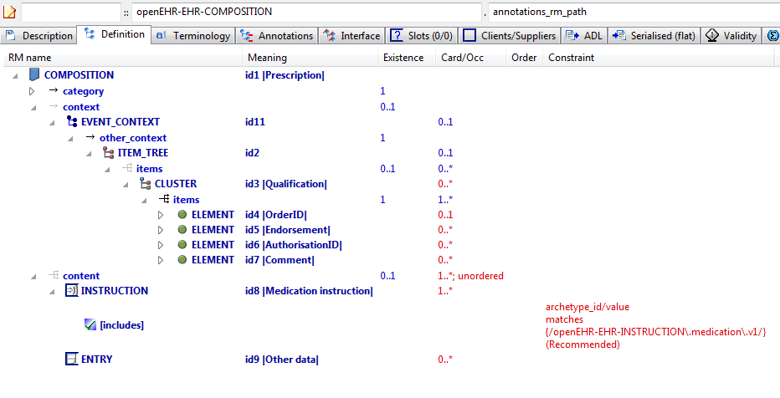

#### Annotations Rm Path v1 AML Diagram

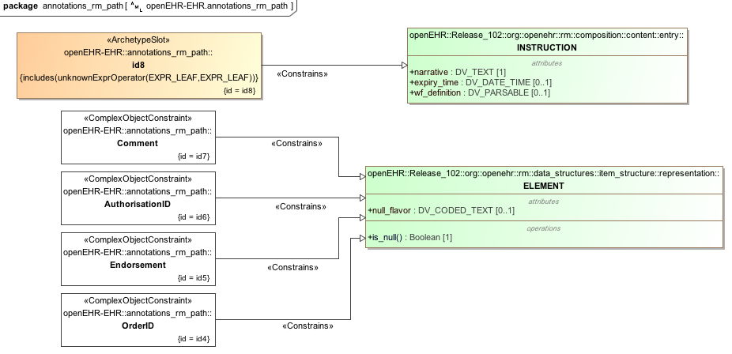

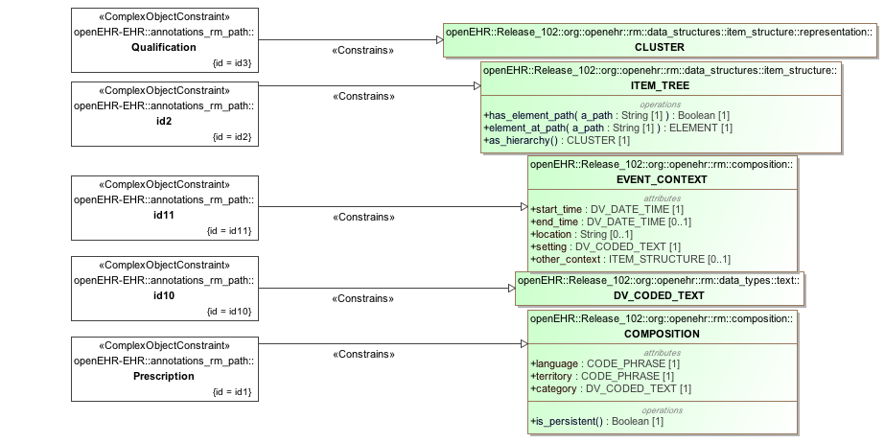

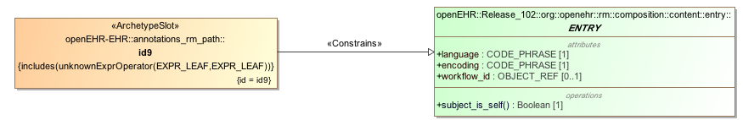

#### Annotations Rm Path v1 AML Associations Diagram

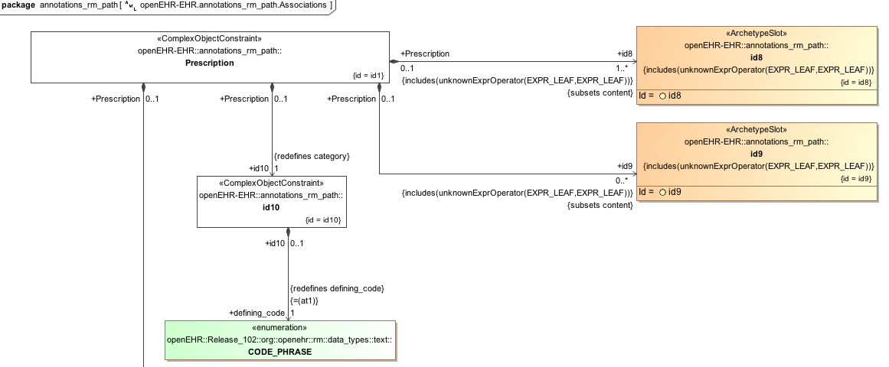

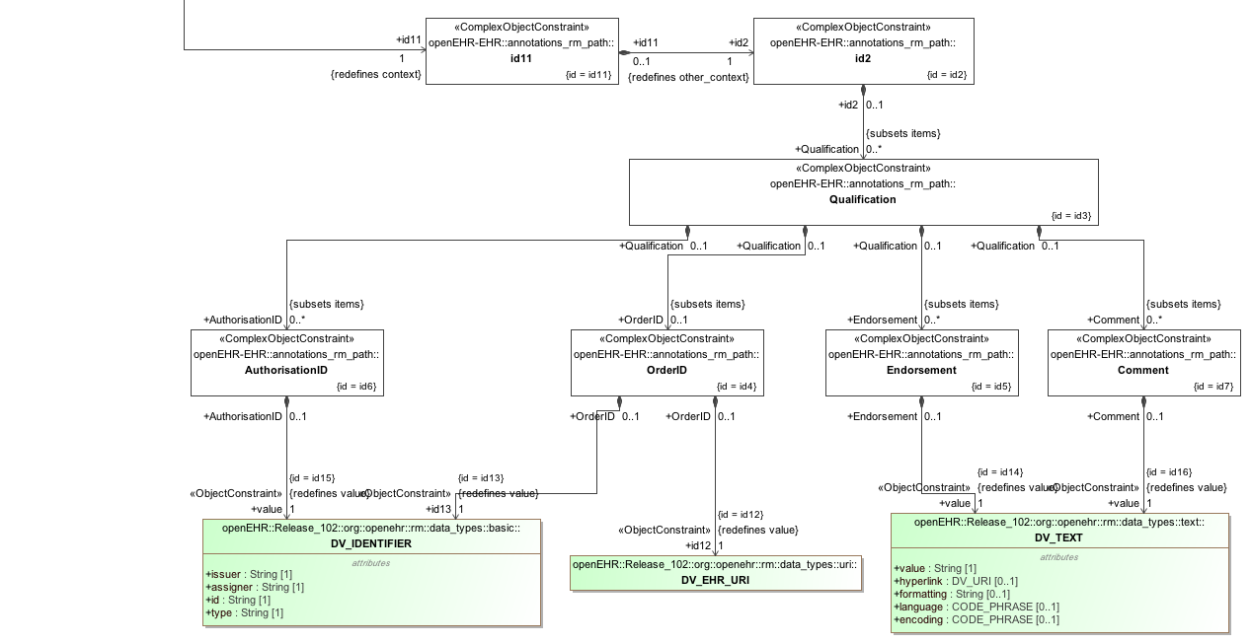

### Annotations 1st Child v1 Example

Test use of annotations in a specialised archetype, on specialised paths.

#### Annotations 1st Child v1 ADL

archetype (adl_version=2.0.5; rm_release=1.0.2)

openEHR-EHR-EVALUATION.annotations_1st_child.v1.0.0

specialize

openEHR-EHR-EVALUATION.annotations_parent.v1

language

original_language = <[ISO_639-1::en]>

description

original_author = <

["name"] = <"Thomas Beale">

["email"] = <"thomas.beale@openEHR.org">

["organisation"] = <"openEHR Foundation <http://www.openEHR.org>">

["date"] = <"2010-12-12">

>

details = <

["en"] = <

language = <[ISO_639-1::en]>

purpose = <"Test use of annotations in a specialised archetype, on specialised paths.">

keywords = <"ADL", "test">

>

>

lifecycle_state = <"published">

other_details = <

["regression"] = <"PASS">

>

copyright = <"Copyright © 2010 openEHR Foundation <http://www.openEHR.org>">

licence = <"Creative Commons CC-BY-SA <https://creativecommons.org/licenses/by-sa/3.0/>">

definition

EVALUATION[id1.1] matches { -- Exclusion statement - Adverse Reaction

/data[id2]/items matches {

ELEMENT[id0.7] occurrences matches {0..1} matches { -- No known adverse reaction to

value matches {

DV_TEXT[id0.5]

}

}

ELEMENT[id0.8] occurrences matches {0..1} matches { -- No known allergic reaction to

value matches {

DV_TEXT[id0.6]

}

}

ELEMENT[id0.9] occurrences matches {0..1} matches { -- No known hypersensitivity reaction to

value matches {

DV_TEXT[id0.7] -- No known adverse reaction to

}

}

ELEMENT[id0.10] occurrences matches {0..1} matches { -- No known intolerance to

value matches {

DV_TEXT[id0.8] -- No known allergic reaction to

}

}

}

}

terminology

term_definitions = <

["en"] = <

["id1.1"] = <

text = <"Exclusion statement - Adverse Reaction">

description = <"Statements about Adverse Reactions that need to be positively recorded as absent or excluded.">

>

["id0.10"] = <

text = <"No known intolerance to">

description = <"Positive statement about intolerances to substances that are explicitly known to have not been identified at the time of recording.">

>

["id0.7"] = <

text = <"No known adverse reaction to">

description = <"Positive statement about adverse reactions to substances that are explicitly known to have not been identified at the time of recording.">

>

["id0.8"] = <

text = <"No known allergic reaction to">

description = <"Positive statement about allergic reactions to substances that are explicitly known to have not been identified at the time of recording.">

>

["id0.9"] = <

text = <"No known hypersensitivity reaction to">

description = <"Positive statement about hypersensitivity reactions to substances that are explicitly known to have not been identified at the time of recording.">

>

>

>

annotations

items = <

["en"] = <

["/data[id2]/items[id0.8]"] = <

["design note"] = <"this is a design note on allergic reaction">

["requirements note"] = <"this is a requirements note on allergic reaction">

["medline ref"] = <"this is a medline ref on allergic reaction">

>

["/data[id2]/items[id0.10]"] = <

["design note"] = <"this is a design note on intelerance">

["requirements note"] = <"this is a requirements note on intolerance">

["national data dictionary"] = <"NDD ref for intolerance">

>

["/data[id2]/items[id3]"] = <

["design note"] = <"this is a SPECIALISED design note on Statement">

["NEW TAG"] = <"this is a SPECIALISED design note on Statement">

>

>

>

#### Annotations 1st Child v1 ADL Diagram

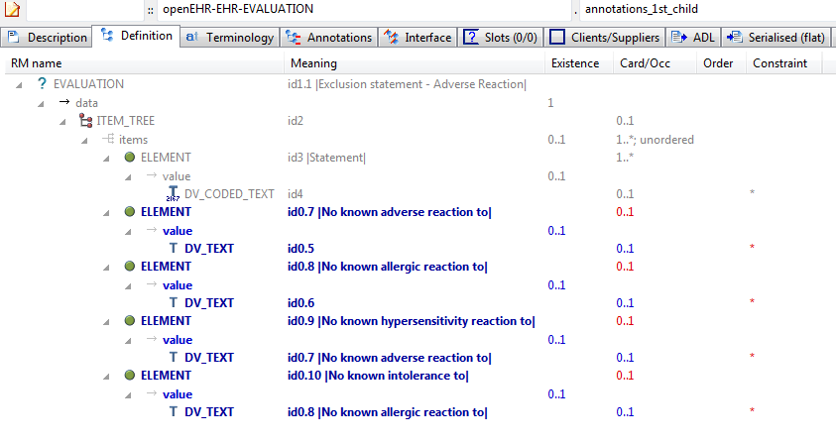

#### Annotations 1st Child v1 AML Diagram

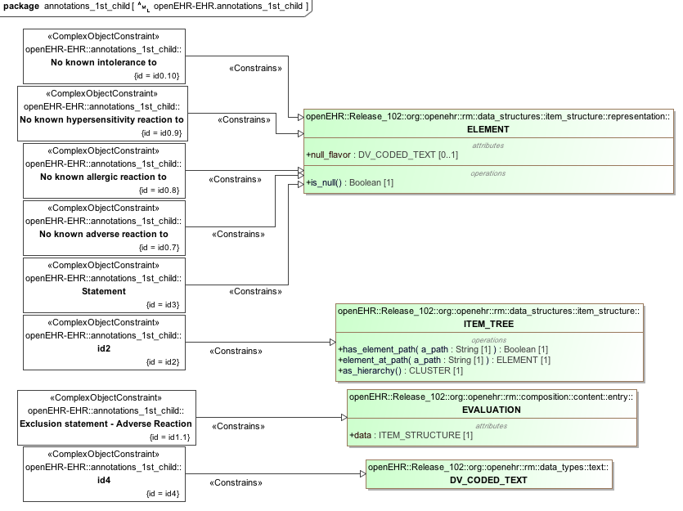

#### Annotations 1st Child v1 AML Associations Diagram

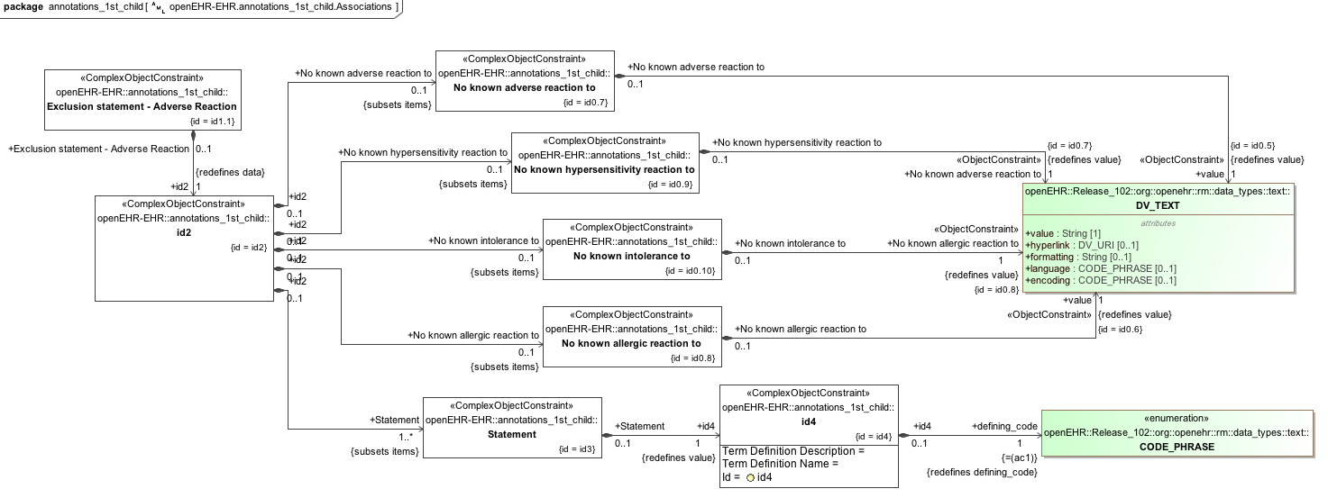

### Annotations Only Child v1 Example

Test use of specialisation that adds only annotations, i.e. no other changes.

#### Annotations Only Child v1 ADL

archetype (adl_version=2.0.5; rm_release=1.0.2)

openEHR-EHR-EVALUATION.annotations_only_child.v1.0.0

specialize

openEHR-EHR-EVALUATION.annotations_parent.v1

language

original_language = <[ISO_639-1::en]>

description

original_author = <

["name"] = <"Thomas Beale">

["email"] = <"thomas.beale@openEHR.org">

["organisation"] = <"openEHR Foundation <http://www.openEHR.org>">

["date"] = <"2010-12-12">

>

details = <

["en"] = <

language = <[ISO_639-1::en]>

purpose = <"Test use of specialisation that adds only annotations, i.e. no other changes.">

keywords = <"ADL", "test">

>

>

lifecycle_state = <"published">

other_details = <

["regression"] = <"PASS">

>

copyright = <"Copyright © 2010 openEHR Foundation <http://www.openEHR.org>">

licence = <"Creative Commons CC-BY-SA <https://creativecommons.org/licenses/by-sa/3.0/>">

definition

EVALUATION[id1.1] -- Annotations specialisation

terminology

term_definitions = <

["en"] = <

["id1.1"] = <

text = <"Annotations specialisation">

description = <"Annotations specialisation">

>

>

>

annotations

items = <

["en"] = <

["/data[id2]/items[id3]"] = <

["design note"] = <"this is a SPECIALISED design note on Statement">

["NEW TAG"] = <"this is a SPECIALISED design note on Statement">

>

>

>

#### Annotations Only Child v1 ADL Diagram

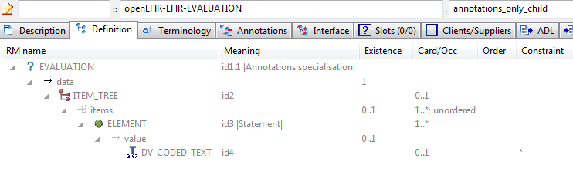

#### Annotations Only Child v1 AML Diagram

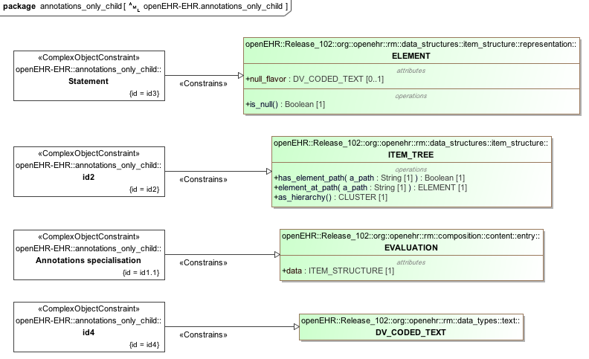

#### Annotations Only Child v1 AML Associations Diagram

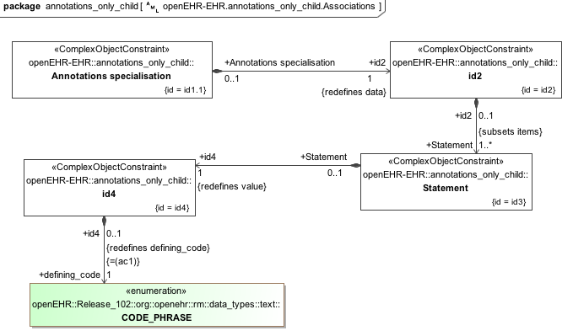

### Annotations Parent v1 Example

Archetype containing various kinds of annotation, including notes, requirements and UI processing hints.

#### Annotations Parent v1 ADL

archetype (adl_version=2.0.5; rm_release=1.0.2)

openEHR-EHR-EVALUATION.annotations_parent.v1.0.0

language

original_language = <[ISO_639-1::en]>

description

original_author = <

["name"] = <"Thomas Beale">

["email"] = <"thomas.beale@openEHR.org">

["organisation"] = <"openEHR Foundation <http://www.openEHR.org>">

["date"] = <"2010-12-20">

>

details = <

["en"] = <

language = <[ISO_639-1::en]>

purpose = <"Archetype containing various kinds of annotation, including notes, requirements and UI processing hints.">

keywords = <"ADL", "test">

>

>

lifecycle_state = <"published">

other_details = <

["regression"] = <"PASS">

>

copyright = <"Copyright © 2004 openEHR Foundation <http://www.openEHR.org>">

licence = <"Creative Commons CC-BY-SA <https://creativecommons.org/licenses/by-sa/3.0/>">

definition

EVALUATION[id1] matches { -- General statement of exclusions or states

data matches {

ITEM_TREE[id2] matches {

items cardinality matches {1..*; unordered} matches {

ELEMENT[id3] occurrences matches {1..*} matches { -- Statement

value matches {

DV_CODED_TEXT[id4]

}

}

}

}

}

}

terminology

term_definitions = <

["en"] = <

["id1"] = <

text = <"General statement of exclusions or states">

description = <"A category of conditions or states which have been excluded">

>

["id3"] = <

text = <"Statement">

description = <"The statement about what is excluded">

>

>

>

annotations

items = <

["en"] = <

["/data[id2]"] = <

["ui"] = <"passthrough">

>

["/data[id2]/items[id3]"] = <

["design note"] = <"this is a design note on Statement">

["requirements note"] = <"this is a requirements note on Statement">

["medline ref"] = <"this is a medline ref on Statement">>>>

#### Annotations Parent v1 ADL Diagram

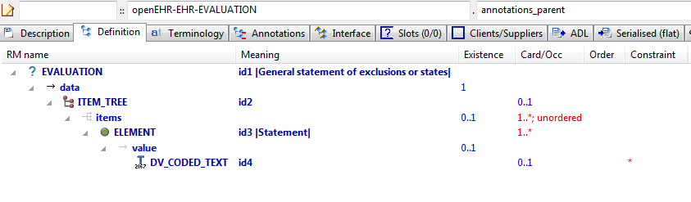

#### Annotations Parent v1 AML Diagram

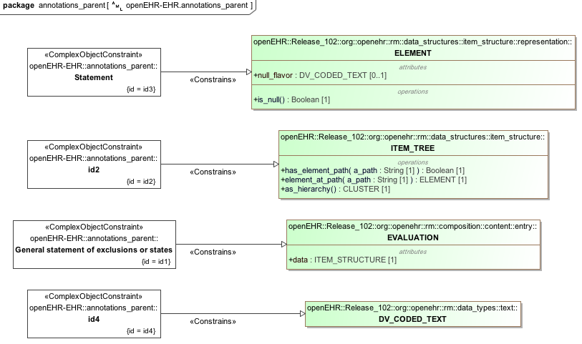

#### Annotations Parent v1 AML Associations Diagram

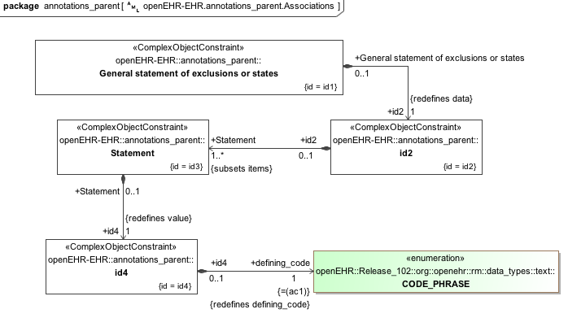

## Description Identification Examples

### Full Id 1 v1 Example

Test full namespaced and versioned archetype identifier.

#### Full Id 1 v1 ADL

archetype (adl_version=2.0.5; rm_release=1.0.2)

org.openehr::openEHR-EHR-OBSERVATION.full_id_1.v1.0.4

language

original_language = <[ISO_639-1::en]>

description

custodian_namespace = <"org.openehr">

custodian_organisation = <"openEHR Foundation <http://www.openEHR.org>">

original_author = <

["name"] = <"Thomas Beale">

["email"] = <"thomas.beale@openEHR.org">

["organisation"] = <"openEHR Foundation <http://www.openEHR.org>">

["date"] = <"2013-08-11">

>

details = <

["en"] = <

language = <[ISO_639-1::en]>

purpose = <"Test full namespaced and versioned archetype identifier.">

keywords = <"ADL", "identifiers", "test">

>

>

lifecycle_state = <"published">

other_details = <

["regression"] = <"PASS">

>

copyright = <"Copyright © 2013 openEHR Foundation <http://www.openEHR.org>">

licence = <"Creative Commons CC-BY-SA <https://creativecommons.org/licenses/by-sa/3.0/>">

definition

OBSERVATION[id1] matches { -- top-level archetype

data

}

terminology

term_definitions = <

["en"] = <

["id1"] = <

text = <"top-level archetype">

description = <"top level test archetype for specialisation lineage">

>

>

>

#### Full Id 1 v1 ADL Diagram

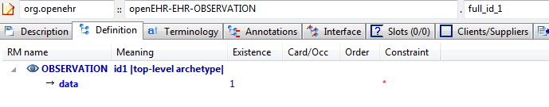

#### Full Id 1 v1 AML Diagram

#### Full Id 1 v1 AML Associations Diagram

### No Ns Inherit Ns v2 Example

Test full namespaced published versioned archetype identifier containing semver.org style 'rc' qualifier at end (release candidate).

#### No Ns Inherit Ns v2 ADL

archetype (adl_version=2.0.0; rm_release=1.0.2)

openEHR-EHR-OBSERVATION.no_ns_inherit_ns.v2.8.0-rc.57

specialize

org.openehr::openEHR-EHR-OBSERVATION.full_id_1.v1

language

original_language = <[ISO_639-1::en]>

description

custodian_namespace = <"org.openehr">

custodian_organisation = <"openEHR Foundation <http://www.openEHR.org>">

original_author = <

["name"] = <"Thomas Beale">

["email"] = <"thomas.beale@openEHR.org">

["organisation"] = <"openEHR Foundation <http://www.openEHR.org>">

["date"] = <"2013-08-11">

>

details = <

["en"] = <

language = <[ISO_639-1::en]>

purpose = <"Test full namespaced published versioned archetype identifier containing semver.org style 'rc' qualifier at end (release candidate).">

keywords = <"ADL", "identifiers", "test">

>

>

lifecycle_state = <"published">

other_details = <

["regression"] = <"PASS">

>

copyright = <"Copyright © 2013 openEHR Foundation <http://www.openEHR.org>">

licence = <"Creative Commons CC-BY-SA <https://creativecommons.org/licenses/by-sa/3.0/>">

definition

OBSERVATION[id1.1] matches { -- specialised archetype

data matches {

HISTORY[id0.2]

}

}

terminology

term_definitions = <

["en"] = <

["id1.1"] = <

text = <"specialised archetype">

description = <"specialised child archetype">

>

>

>

#### No Ns Inherit Ns v2 ADL Diagram

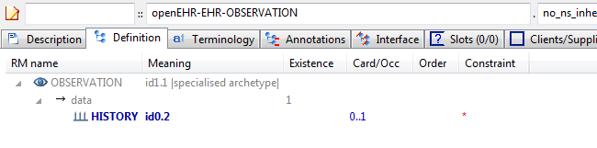

#### No Ns Inherit Ns v2 AML Diagram

#### No Ns Inherit Ns v2 AML Associations Diagram

### Ns Inherit Ns v1 Example

Test full namespaced and versioned id that includes semver.org style 'alpha' qualifier at the end.

#### Ns Inherit Ns v1 ADL

archetype (adl_version=2.0.0; rm_release=1.0.2)

org.openehr::openEHR-EHR-OBSERVATION.ns_inherit_ns.v1.3.15-alpha.47

specialize

org.openehr::openEHR-EHR-OBSERVATION.full_id_1.v1

language

original_language = <[ISO_639-1::en]>

description

custodian_namespace = <"org.openehr">

custodian_organisation = <"openEHR Foundation <http://www.openEHR.org>">

original_author = <

["name"] = <"Thomas Beale">

["email"] = <"thomas.beale@openEHR.org">

["organisation"] = <"openEHR Foundation <http://www.openEHR.org>">

["date"] = <"2008-08-11">

>

details = <

["en"] = <

language = <[ISO_639-1::en]>

purpose = <"Test full namespaced and versioned id that includes semver.org style 'alpha' qualifier at the end.">

keywords = <"ADL", "identifiers", "test">

>

>

lifecycle_state = <"published">

other_details = <

["regression"] = <"PASS">

>

copyright = <"Copyright © 2008 openEHR Foundation <http://www.openEHR.org>">

licence = <"Creative Commons CC-BY-SA <https://creativecommons.org/licenses/by-sa/3.0/>">

definition

OBSERVATION[id1.1] matches { -- specialised archetype

data matches {

HISTORY[id0.3]

}

}

terminology

term_definitions = <

["en"] = <

["id1.1"] = <

text = <"specialised archetype">

description = <"specialised child archetype">

>

>

>

#### Ns Inherit Ns v1 ADL Diagram

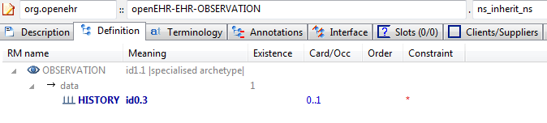

#### Ns Inherit Ns v1 AML Diagram

#### Ns Inherit Ns v1 AML Associations Diagram

### Other Ns Inherit Ns v5 Example

Test specialisation of an archetype that has a namespaced and versioned identifier, by another archetype which has a different namespace.

#### Other Ns Inherit Ns v5 ADL

archetype (adl_version=2.0.5; rm_release=1.0.2)

uk.gov.nhs::openEHR-EHR-OBSERVATION.other_ns_inherit_ns.v5.3.0

specialize

org.openehr::openEHR-EHR-OBSERVATION.full_id_1.v1

language

original_language = <[ISO_639-1::en]>

description

custodian_namespace = <"org.openehr">

custodian_organisation = <"openEHR Foundation <http://www.openEHR.org>">

original_author = <

["name"] = <"Thomas Beale">

["email"] = <"thomas.beale@openEHR.org">

["organisation"] = <"openEHR Foundation <http://www.openEHR.org>">

["date"] = <"2013-08-11">

>

details = <

["en"] = <

language = <[ISO_639-1::en]>

purpose = <"Test specialisation of an archetype that has a namespaced and versioned identifier, by another archetype which has a different namespace.">

keywords = <"ADL", "identifiers", "test">

>

>

lifecycle_state = <"published">

other_details = <

["regression"] = <"PASS">

>

copyright = <"Copyright © 2013 openEHR Foundation <http://www.openEHR.org>">

licence = <"Creative Commons CC-BY-SA <https://creativecommons.org/licenses/by-sa/3.0/>">

definition

OBSERVATION[id1.1] matches { -- specialised archetype

data matches {

HISTORY[id0.4]

}

}

terminology

term_definitions = <

["en"] = <

["id1.1"] = <

text = <"specialised archetype">

description = <"specialised child archetype">

>

>

>

#### Other Ns Inherit Ns v5 ADL Diagram

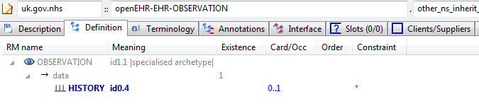

#### Other Ns Inherit Ns v5 AML Diagram

#### Other Ns Inherit Ns v5 AML Associations Diagram

## Description Meta_data Examples

### Child With Oid v1 Example

Example of a specialised archetype containing an ISO OID uid field.

#### Child With Oid v1 ADL

archetype (adl_version=2.0.5; rm_release=1.0.2; uid=2.4.34.666.7.2)

openehr-TEST_PKG-WHOLE.child_with_oid.v1.0.0

specialize

openehr-TEST_PKG-WHOLE.parent_with_oid.v1

language

original_language = <[ISO_639-1::en]>

description

custodian_namespace = <"org.openehr">

custodian_organisation = <"openEHR Foundation <http://www.openEHR.org>">

original_author = <

["name"] = <"Thomas Beale">

["email"] = <"thomas.beale@openEHR.org">

["organisation"] = <"openEHR Foundation <http://www.openEHR.org>">

["date"] = <"2014-11-12">

>

details = <

["en"] = <

language = <[ISO_639-1::en]>

purpose = <"Example of a specialised archetype containing an ISO OID uid field.">

keywords = <"ADL", "meta-data", "test">

>

>

lifecycle_state = <"published">

other_details = <

["regression"] = <"PASS">

>

copyright = <"Copyright © 2014 openEHR Foundation <http://www.openEHR.org>">

licence = <"Creative Commons CC-BY-SA <https://creativecommons.org/licenses/by-sa/3.0/>">

definition

WHOLE[id1.1] matches { -- Child archetype with Oid

string_attr1 matches {"test"}

}

terminology

term_definitions = <

["en"] = <

["id1.1"] = <

text = <"Child archetype with Oid">

description = <"Oid child">

>

>

>

#### Child With Oid v1 ADL Diagram

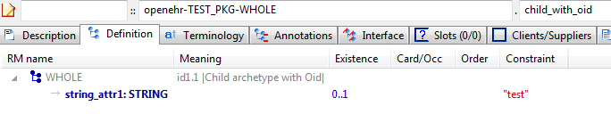

#### Child With Oid v1 AML Diagram

#### Child With Oid v1 AML Associations Diagram

### Child With Uid v1 Example

Example of a specialised archetype containing a GUID uid field

#### Child With Uid v1 ADL

archetype (adl_version=2.0.5; rm_release=1.0.2; uid=A22E8ED5-81B9-46CC-AFF1-612F428F5447)

openehr-TEST_PKG-WHOLE.child_with_uid.v1.0.0

specialize

openehr-TEST_PKG-WHOLE.parent_with_uid.v1

language

original_language = <[ISO_639-1::en]>

description

custodian_namespace = <"org.openehr">

custodian_organisation = <"openEHR Foundation <http://www.openEHR.org>">

original_author = <

["name"] = <"Thomas Beale">

["email"] = <"thomas.beale@openEHR.org">

["organisation"] = <"openEHR Foundation <http://www.openEHR.org>">

["date"] = <"2014-11-12">

>

details = <

["en"] = <

language = <[ISO_639-1::en]>

purpose = <"Example of a specialised archetype containing a GUID uid field">

keywords = <"ADL", "meta-data", "test">

>

>

lifecycle_state = <"published">

other_details = <

["regression"] = <"PASS">

>

copyright = <"Copyright © 2014 openEHR Foundation <http://www.openEHR.org>">

licence = <"Creative Commons CC-BY-SA <https://creativecommons.org/licenses/by-sa/3.0/>">

definition

WHOLE[id1.1] matches { -- Child archetype with Uid

string_attr1 matches {"test"}

}

terminology

term_definitions = <

["en"] = <

["id1.1"] = <

text = <"Child archetype with Uid">

description = <"Uid child">

>

>

>

#### Child With Uid v1 ADL Diagram

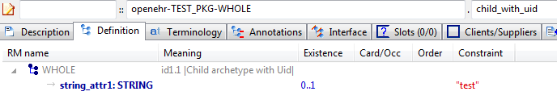

#### Child With Uid v1 AML Diagram

#### Child With Uid v1 AML Associations Diagram

### Child With Uid And Other Metadata v1 Example

Example of a specialised archetype containing a uid and other meta-data that maps to AOM AUTHORED_ARCHETYPE.other_meta_data. Values with same-named keys override those in the parent.

#### Child With Uid And Other Metadata v1 ADL

archetype (adl_version=2.0.5; rm_release=1.0.2; uid=15E82D77-7DB7-4F70-8D8E-EED6FF241B2D; child_flag=true; some_key=some_replacement_value; child_key=xxxxx)

openehr-TEST_PKG-WHOLE.child_with_uid_and_other_metadata.v1.0.0

specialize

openehr-TEST_PKG-WHOLE.parent_with_uid_and_other_metadata.v1

language

original_language = <[ISO_639-1::en]>

description

custodian_namespace = <"org.openehr">

custodian_organisation = <"openEHR Foundation <http://www.openEHR.org>">

original_author = <

["name"] = <"Thomas Beale">

["email"] = <"thomas.beale@openEHR.org">

["organisation"] = <"openEHR Foundation <http://www.openEHR.org>">

["date"] = <"2014-11-12">

>

details = <

["en"] = <

language = <[ISO_639-1::en]>

purpose = <"Example of a specialised archetype containing a uid and other meta-data that maps to AOM AUTHORED_ARCHETYPE.other_meta_data. Values with same-named keys override those in the parent.">

keywords = <"ADL", "meta-data", "test">

>

>

lifecycle_state = <"published">

other_details = <

["regression"] = <"PASS">

>

copyright = <"Copyright © 2014 openEHR Foundation <http://www.openEHR.org>">

licence = <"Creative Commons CC-BY-SA <https://creativecommons.org/licenses/by-sa/3.0/>">

definition

WHOLE[id1.1] -- Parent archetype with uid

terminology

term_definitions = <

["en"] = <

["id1.1"] = <

text = <"Parent archetype with uid">

description = <"Uid parent">

>

>

>

#### Child With Uid And Other Metadata v1 ADL Diagram

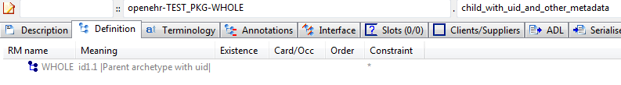

#### Child With Uid And Other Metadata v1 AML Diagram

#### Child With Uid And Other Metadata v1 AML Associations Diagram

### Full Meta Data v0.0.1 Example

This archetype demonstrates the use of governance meta-data.

#### Full Meta Data v0.0.1 ADL

archetype (adl_version=2.0.5; rm_release=1.0.2; generated)

openehr-test_pkg-WHOLE.full_meta_data.v0.0.1

language

original_language = <[ISO_639-1::en]>

description

custodian_namespace = <"org.openehr">

custodian_organisation = <"openEHR Foundation <http://www.openEHR.org>">

original_author = <

["name"] = <"Thomas Beale">

["email"] = <"thomas.beale@openEHR.org">

["organisation"] = <"openEHR Foundation <http://www.openEHR.org>">

["date"] = <"2013-08-11">

>

details = <

["en"] = <

language = <[ISO_639-1::en]>

purpose = <"This archetype demonstrates the use of governance meta-data.">

use = <"This archetype should be used on a clear day with no wind.">

misuse = <"This archetype should not be used around children or dogs.">

keywords = <"governance", "test">

original_resource_uri = <

["resource A"] = <"Some resource available in the English language <http://aaa.bbb/path/to/resource>">

["resource B"] = <"Some other resource available in the English language <http://aaa.bbb/path/to/resource>">

>

>

>

lifecycle_state = <"unmanaged">

other_contributors = <"Marcus Aurelius <marcus@aurelius.net>", "Augustus Caesar <augustus@caesars_palace.net">

original_namespace = <"org.archetypes-r-us">

original_publisher = <"Archetype R Us">

copyright = <"Copyright (c) 2014 openEHR Foundation <http://www.openEHR.org>">

licence = <"Creative Commons CC-BY <https://creativecommons.org/licenses/by/3.0/>">

resource_package_uri = <http://www.openehr.org/ckm/path/to/package>

ip_acknowledgements = <

["loinc"] = <"This content from LOINC® is copyright © 1995 Regenstrief Institute, Inc. and the LOINC Committee, and available at no cost under the license at http://loinc.org/terms-of-use">

["snomedct"] = <"Content from SNOMED CT® is copyright © 2007 IHTSDO <ihtsdo.org>">

>

conversion_details = <

["source_model"] = <"CEM model xyz <http://location.in.clinicalelementmodels.com>">

["tool"] = <"cem2adl v6.3.0">

["time"] = <"2014-11-03T09:05:00">

>

references = <

["1"] = <"Barthel Scale <http://en.wikipedia.org/wiki/Barthel_scale>">

["2"] = <"Barthel Index, the Internet Stroke Center <http://www.strokecenter.org/wp-content/uploads/2011/08/barthel.pdf>">

["3"] = <"O'Sullivan, Susan B; Schmitz, Thomas J (2007). Physical Rehabilitation, Fifth Edition. Philadelphia, PA: F.A. Davis Company. p. 385.">

>

other_details = <

["regression"] = <"PASS">

>

definition

WHOLE[id1] -- -

terminology

term_definitions = <

["en"] = <

["id1"] = <

text = <"-">

description = <"-">

>

>

>

#### Full Meta Data v0.0.1 ADL Diagram

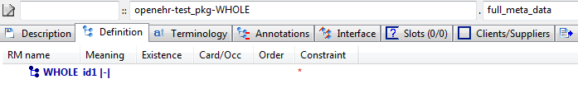

#### Full Meta Data v0.0.1 AML Diagram

#### Full Meta Data v0.0.1 AML Associations Diagram

### Parent With Oid v1 Example

Example of a top-level archetype containing an ISO OID uid field.

#### Parent With Oid v1 ADL

archetype (adl_version=2.0.5; rm_release=1.0.2; uid=2.3.5.4.3.02.27)

openehr-TEST_PKG-WHOLE.parent_with_oid.v1.0.0

language

original_language = <[ISO_639-1::en]>

description

custodian_namespace = <"org.openehr">

custodian_organisation = <"openEHR Foundation <http://www.openEHR.org>">

original_author = <

["name"] = <"Thomas Beale">

["email"] = <"thomas.beale@openEHR.org">

["organisation"] = <"openEHR Foundation <http://www.openEHR.org>">

["date"] = <"2014-11-12">

>

details = <

["en"] = <

language = <[ISO_639-1::en]>

purpose = <"Example of a top-level archetype containing an ISO OID uid field.">

keywords = <"ADL", "meta-data", "test">

>

>

lifecycle_state = <"published">

other_details = <

["regression"] = <"PASS">

>

copyright = <"Copyright © 2014 openEHR Foundation <http://www.openEHR.org>">

licence = <"Creative Commons CC-BY-SA <https://creativecommons.org/licenses/by-sa/3.0/>">

definition

WHOLE[id1] -- Parent archetype with Oid

terminology

term_definitions = <

["en"] = <

["id1"] = <

text = <"Parent archetype with Oid">

description = <"Oid parent">

>

>

>

#### Parent With Oid v1 ADL Diagram

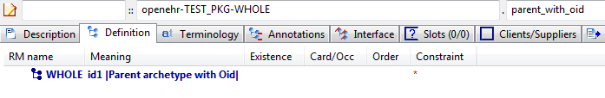

#### Parent With Oid v1 AML Diagram

#### Parent With Oid v1 AML Associations Diagram

### Parent With Uid v1 Example

Example of a top-level archetype containing a GUID uid field.

#### Parent With Uid v1 ADL

archetype (adl_version=2.0.5; rm_release=1.0.2; uid=15E82D77-7DB7-4F70-8D8E-EED6FF241B2D)

openehr-TEST_PKG-WHOLE.parent_with_uid.v1.0.0

language

original_language = <[ISO_639-1::en]>

description

custodian_namespace = <"org.openehr">

custodian_organisation = <"openEHR Foundation <http://www.openEHR.org>">

original_author = <

["name"] = <"Thomas Beale">

["email"] = <"thomas.beale@openEHR.org">

["organisation"] = <"openEHR Foundation <http://www.openEHR.org>">

["date"] = <"2014-11-12">

>

details = <

["en"] = <

language = <[ISO_639-1::en]>

purpose = <"Example of a top-level archetype containing a GUID uid field.">

keywords = <"ADL", "meta-data", "test">

>

>

lifecycle_state = <"published">

other_details = <

["regression"] = <"PASS">

>

copyright = <"Copyright © 2014 openEHR Foundation <http://www.openEHR.org>">

licence = <"Creative Commons CC-BY-SA <https://creativecommons.org/licenses/by-sa/3.0/>">

definition

WHOLE[id1] -- Parent archetype with uid

terminology

term_definitions = <

["en"] = <

["id1"] = <

text = <"Parent archetype with uid">

description = <"Uid parent">

>

>

>

#### Parent With Uid v1 ADL Diagram

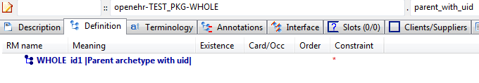

#### Parent With Uid v1 AML Diagram

#### Parent With Uid v1 AML Associations Diagram

### Parent With Uid And Other Metadata v1 Example

Example of a top-level archetype containing a uid and other meta-data that maps to AOM AUTHORED_ARCHETYPE.other_meta_data.

#### Parent With Uid And Other Metadata v1 ADL

archetype (adl_version=2.0.5; rm_release=1.0.2; uid=15E82D77-7DB7-4F70-8D8E-EED6FF241B2D; some_flag=true; some_key=some_value; another_key=another_value)

openehr-TEST_PKG-WHOLE.parent_with_uid_and_other_metadata.v1.0.0

language

original_language = <[ISO_639-1::en]>

description

custodian_namespace = <"org.openehr">

custodian_organisation = <"openEHR Foundation <http://www.openEHR.org>">

original_author = <

["name"] = <"Thomas Beale">

["email"] = <"thomas.beale@openEHR.org">

["organisation"] = <"openEHR Foundation <http://www.openEHR.org>">

["date"] = <"2014-11-12">

>

details = <

["en"] = <

language = <[ISO_639-1::en]>

purpose = <"Example of a top-level archetype containing a uid and other meta-data that maps to AOM AUTHORED_ARCHETYPE.other_meta_data.">

keywords = <"ADL", "meta-data", "test">

>

>

lifecycle_state = <"published">

other_details = <

["regression"] = <"PASS">

>

copyright = <"Copyright © 2014 openEHR Foundation <http://www.openEHR.org>">

licence = <"Creative Commons CC-BY-SA <https://creativecommons.org/licenses/by-sa/3.0/>">

definition

WHOLE[id1] -- Parent archetype with uid

terminology

term_definitions = <

["en"] = <

["id1"] = <

text = <"Parent archetype with uid">

description = <"Uid parent">

>

>

>

#### Parent With Uid And Other Metadata v1 ADL Diagram

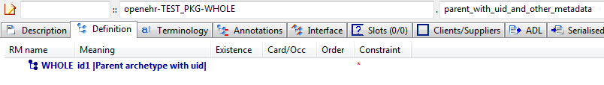

#### Parent With Uid And Other Metadata v1 AML Diagram

#### Parent With Uid And Other Metadata v1 AML Associations Diagram

## Description Text Examples

### Quoted Strings v1 Example

This archetype should parse fine, and when saved and reparsed, no changes should occur in the strings of the at0001 term, i.e. the quoted slash and quoted double quote should remain as they are. However, both should display in the GUI without the backslash symbol.

#### Quoted Strings v1 ADL

archetype (adl_version=2.0.5; rm_release=1.0.2)

openEHR-EHR-CLUSTER.quoted_strings.v1.0.0

language

original_language = <[ISO_639-1::en]>

description

custodian_namespace = <"org.openehr">

custodian_organisation = <"openEHR Foundation <http://www.openEHR.org>">

original_author = <

["organisation"] = <"a\"x'c\\d">

["name"] = <"Peter Gummer">

["email"] = <"a\"x'c\\d">

>

details = <

["en"] = <

language = <[ISO_639-1::en]>

purpose = <"This archetype should parse fine, and when saved and reparsed, no changes should occur in the strings of the at0001 term, i.e. the quoted slash and quoted double quote should remain as they are. However, both should display in the GUI without the backslash symbol.">

use = <"\\">

keywords = <"a\"x'c\\d", "p\"q\\s\"">

>

>

lifecycle_state = <"published">

other_contributors = <"a\"x'c\\d", ...>

other_details = <

["regression"] = <"PASS">

>

copyright = <"Copyright © 2012 openEHR Foundation <http://www.openEHR.org>">

licence = <"Creative Commons CC-BY-SA <https://creativecommons.org/licenses/by-sa/3.0/>">

definition

CLUSTER[id1] matches { -- unknown

items matches {

ELEMENT[id2] occurrences matches {0..1} matches { -- a\b

value matches {

DV_CODED_TEXT[id4] matches {

defining_code matches {[ac1]} -- a\b

}

}

}

ELEMENT[id3] occurrences matches {0..1} matches { -- \a\

value matches {

DV_TEXT[id5] matches {

value matches {"No quoting should happen here"}

}

}

}

}

}

terminology

term_definitions = <

["en"] = <

["id1"] = <

text = <"unknown">

description = <"unknown">

>

["id2"] = <

text = <"a\\b">

description = <"a\"b">

>

["id3"] = <

text = <"\\a\\">

description = <"\"a\"">

>

["at11"] = <

text = <"\\">

description = <"xxx">

>

["at12"] = <

text = <"\\\\">

description = <"xxx">

>

["ac1"] = <

text = <"a\\b">

description = <"a\"b">

>

>

>

value_sets = <

["ac1"] = <

id = <"ac1">

members = <"at11", "at12">

>

>

#### Quoted Strings v1 ADL Diagram

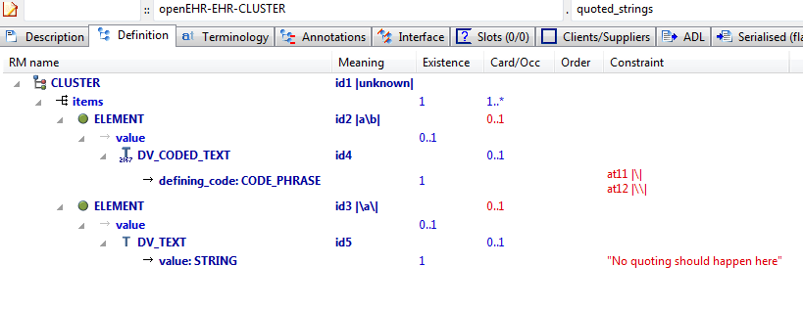

#### Quoted Strings v1 AML Diagram

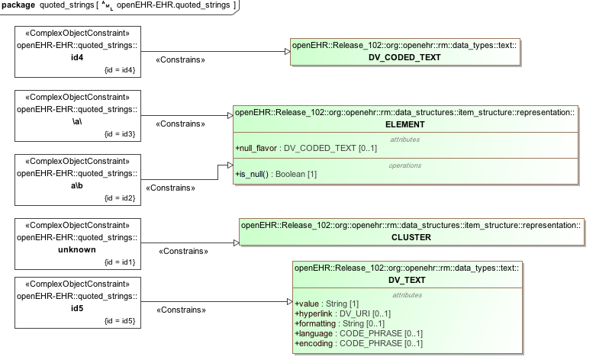

#### Quoted Strings v1 AML Associations Diagram

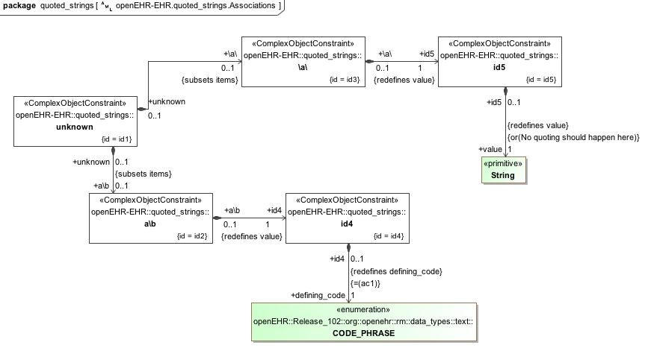

### Unicode Farsi v1 Example

Test unicode language archetype with Farsi translation.

ثبت احتمال خطرداشتن و یا ایجاد شرایط ارزیابی شده به دلیل بروز در اقوام

#### Unicode Farsi v1 ADL

archetype (adl_version=2.0.5; rm_release=1.0.2)

openEHR-EHR-EVALUATION.unicode_farsi.v1.0.0

language

original_language = <[ISO_639-1::en]>

translations = <

["fa"] = <

language = <[ISO_639-1::fa]>

author = <

["name"] = <"unknown">

>

>

>

description

custodian_namespace = <"org.openehr">

custodian_organisation = <"openEHR Foundation <http://www.openEHR.org>">

original_author = <

["name"] = <"Thomas Beale">

["email"] = <"thomas.beale@openEHR.org">

["organisation"] = <"openEHR Foundation <http://www.openEHR.org>">

["date"] = <"2006-04-23">

>

details = <

["en"] = <

language = <[ISO_639-1::en]>

purpose = <"Test unicode language archetype with Farsi translation.">

use = <"For recording information about the prevalence of the condition in relatives and quantifying risk to the subject of care.">

misuse = <"Not for recording problems of individual relatives - use 'openEHR-EHR-EVALUATION.problem' and 'openEHR-EHR-EVALUATION.problem-diagnosis' and set the subject of data to the relative.">

>

["fa"] = <

language = <[ISO_639-1::fa]>

purpose = <"ثبت احتمال خطرداشتن و یا ایجاد شرایط ارزیابی شده به دلیل بروز در اقوام ">

use = <"برای ثبت اطلاعات درباره بروز شرایط در اقوام و احتمال خطر برای موضوع مراقبت ">

misuse = <"برای ثبت مشکلات اقوام فرد -از مشکل و مشکل_تشخیص و مجموعه ای از داده های مربوطه استفاده کنید">

>

>

lifecycle_state = <"published">

other_details = <

["regression"] = <"PASS">

>

copyright = <"Copyright © 2006 openEHR Foundation <http://www.openEHR.org>">

licence = <"Creative Commons CC-BY-SA <https://creativecommons.org/licenses/by-sa/3.0/>">

definition

EVALUATION[id1] matches { -- Risk of condition based on family history

data matches {

ITEM_TREE[id2] matches {

items cardinality matches {1..*; ordered} matches {

ELEMENT[id3] matches { -- Index condition

value matches {

DV_TEXT[id131]

}

}

ELEMENT[id5] occurrences matches {0..1} matches { -- Assessed risk

value matches {

DV_CODED_TEXT[id132] matches {

defining_code matches {[ac2]} -- Assessed risk

}

}

}

CLUSTER[id102] occurrences matches {0..1} matches { -- Affected relatives

items matches {

CLUSTER[id103] occurrences matches {0..*} matches { -- Relative

name matches {

DV_CODED_TEXT[id133] matches {

defining_code matches {[ac1]} -- Relationship

}

}

items matches {

ELEMENT[id104] occurrences matches {0..1} matches { -- Name

value matches {

DV_TEXT[id134]

}

}

ELEMENT[id105] occurrences matches {0..1} matches { -- Age at onset

value matches {

DV_QUANTITY[id135] matches {

property matches {[at127]}

[units, magnitude] matches {

[{"yr"}, {|0.0..200.0|}],

[{"mth"}, {|0.0..36.0|}],

[{"wk"}, {|0.0..52.0|}],

[{"day"}, {|0.0..56.0|}]

}

}

}

}

ELEMENT[id128] occurrences matches {0..1} matches { -- Date of onset

value matches {

DV_DATE[id136] matches {

value matches {yyyy-??-??}

}

}

}

ELEMENT[id106] occurrences matches {0..1} matches { -- Age at death

value matches {

DV_QUANTITY[id137] matches {

property matches {[at128]}

units matches {"yr"}

magnitude matches {|0.0..200.0|}

}

}

}

ELEMENT[id107] occurrences matches {0..1} matches { -- Date of death

value matches {

DV_DATE[id138] matches {

value matches {yyyy-??-??}

}

}

}

ELEMENT[id108] occurrences matches {0..1} matches { -- Index condition was cause of death

value matches {

DV_BOOLEAN[id139] matches {

value matches {True, False}

}

}

}

ELEMENT[id109] occurrences matches {0..1} matches { -- Severity

value matches {

DV_ORDINAL[id140] matches {

[value, symbol] matches {

[{1}, {[at110]}],

[{4}, {[at111]}],

[{7}, {[at112]}]

}

}

}

}

ELEMENT[id129] occurrences matches {0..1} matches { -- More specific condition

value matches {

DV_TEXT[id141]

}

}

ELEMENT[id113] occurrences matches {0..1} matches { -- Clinical description

value matches {

DV_TEXT[id142]

}

}

ELEMENT[id114] occurrences matches {0..1} matches { -- Genetic relative

value matches {

DV_BOOLEAN[id143] matches {

value matches {True, False}

}

}

}

}

}

}

}

CLUSTER[id115] occurrences matches {0..*} matches { -- Affected ratio

items cardinality matches {1..4; ordered} matches {

ELEMENT[id116] occurrences matches {0..1} matches { -- Degree

value matches {

DV_CODED_TEXT[id144] matches {

defining_code matches {[ac3]} -- Degree

}

}

}

ELEMENT[id123] occurrences matches {0..1} matches { -- Gender

value matches {

DV_CODED_TEXT[id145] matches {

defining_code matches {[ac4]} -- Gender

}

}

}

ELEMENT[id127] occurrences matches {0..1} matches { -- Number unaffected

value matches {

DV_COUNT[id146] matches {

magnitude matches {|0..100|}

}

}

}

ELEMENT[id130] matches { -- Number affected

value matches {

DV_COUNT[id147] matches {

magnitude matches {|0..100|}

}

}

}

}

}

}

}

}

protocol matches {

ITEM_LIST[id11] matches {

items matches {

ELEMENT[id12] occurrences matches {0..1} matches { -- Risk calculation

value matches {

DV_TEXT[id148]

}

}

}

}

}

}

terminology

term_definitions = <

["en"] = <

["id102"] = <

text = <"Affected relatives">

description = <"The family members affected by the condition">

>

["at111"] = <

text = <"Moderate">

description = <"Significant morbidity and reduced capability">

>

["at112"] = <

text = <"Severe">

description = <"Major morbidity with significant social impact">

>

["id113"] = <

text = <"Clinical description">

description = <"A clinical description of the affected relatives condition">

>

["id114"] = <

text = <"Genetic relative">

description = <"A genetic relative of the data subject - not an adoptive relative">

>

["id115"] = <

text = <"Affected ratio">

description = <"A ratio of the affected to non-affected relatives of a particular type">

>

["id116"] = <

text = <"Degree">

description = <"The proximity or line of the relatives">

>

["at117"] = <

text = <"First degree relatives">

description = <"Relatives with 50% genetic share - parent, sibling, child">

>

["at118"] = <

text = <"Second degree relatives">

description = <"Relatives with 25% genetic share - grand parent, aunts and uncles, nieces and nephews, grand children">

>

["at119"] = <

text = <"Third degree relatives">

description = <"Relatives with 12.5% genetic share, great grand parents, great aunts and uncles, first cousins, children of neices and nephews, great grand children">

>

["at120"] = <

text = <"Maternal relatives">

description = <"Related through mother">

>

["id103"] = <

text = <"Relative">

description = <"Details about the affected relative">

>

["at121"] = <

text = <"Paternal relatives">

description = <"Related through father">

>

["at122"] = <

text = <"Family">

description = <"Entire family">

>

["id123"] = <

text = <"Gender">

description = <"The gender of the relatives included in the affected ratio">

>

["at124"] = <

text = <"Male">

description = <"Male gender">

>

["at125"] = <

text = <"Female">

description = <"Female gender">

>

["at126"] = <

text = <"Male and female">

description = <"Male and female relatives">

>

["id127"] = <

text = <"Number unaffected">

description = <"The number of relatives in this group unaffected by the index condition">

>

["id128"] = <

text = <"Date of onset">

description = <"Date of onset">

>

["id129"] = <

text = <"More specific condition">

description = <"A coded entry which is more specific than the index condition">

>

["id130"] = <

text = <"Number affected">

description = <"The number affected by the index condition">

>

["id104"] = <

text = <"Name">

description = <"Optional name of the person for future reference">

>

["id105"] = <

text = <"Age at onset">

description = <"The age at which the condition was apparent">

>

["id106"] = <

text = <"Age at death">

description = <"The age at which this relative died">

>

["id107"] = <

text = <"Date of death">

description = <"The year or date of death">

>

["id108"] = <

text = <"Index condition was cause of death">

description = <"Indication that the index was a significant factor in the death of this relative">

>

["id109"] = <

text = <"Severity">

description = <"The severity of the condition for this relative">

>

["at110"] = <

text = <"Mild">

description = <"Little affect on lifestyle">

>

["id1"] = <

text = <"Risk of condition based on family history">

description = <"Evaluation to indicate that there is, or is not, a significant risk of this subject of care having, now or in the future, a condition due to prior occurrence in a family member.">

>

["id3"] = <

text = <"Index condition">

description = <"The condition on which the risk assessment is focussed">

>

["at4"] = <

text = <"Significance of risk">

description = <"The likelihood that this person will develop this condition or suffer in this way in the future">

>

["id5"] = <

text = <"Assessed risk">

description = <"The degree of risk conferred on the subject by the presence of this condition amongst relatives">

>

["at7"] = <

text = <"Not significant">

description = <"The person is not assessed at being at higher risk than the general population">

>

["at8"] = <

text = <"Minimal significance">

description = <"The person may be of somewhat greater risk of developing the condition ">

>

["at9"] = <

text = <"Significant">

description = <"The person is considered to be more likely to develop the condition than the general population">

>

["at10"] = <

text = <"Highly significant">

description = <"The person is considered to be likely to develop the condition">

>

["id12"] = <

text = <"Risk calculation">

description = <"The means of calculating the risk">

>

["ac1"] = <

text = <"Relationship">

description = <"The relationship of this relative to the subject">

>

["ac2"] = <

text = <"Assessed risk">

description = <"The degree of risk conferred on the subject by the presence of this condition amongst relatives">

>

["ac3"] = <

text = <"Degree">

description = <"The proximity or line of the relatives">

>

["ac4"] = <

text = <"Gender">

description = <"The gender of the relatives included in the affected ratio">

>

["at127"] = <

text = <"Time">

description = <"Time">

>

["at128"] = <

text = <"Time">

description = <"Time">

>

["ac5"] = <

text = <"Severity">

description = <"The severity of the condition for this relative">

>

["ac6"] = <

text = <"Severity (synthesised)">

description = <"The severity of the condition for this relative (synthesised)">

>

>

["fa"] = <

["id102"] = <

text = <"اقوام تاثیر پذیرنده">

description = <"اعضا خانواده که تحت تاثیر شرایط قرار می گیرند">

>

["at111"] = <

text = <"متوسط">

description = <"بیماری مهم و کاهش دهنده توانایی">

>

["at112"] = <

text = <"شدید">

description = <"بیماری عمده با تاثیر اجتماعی عمده">

>

["id113"] = <

text = <"شرح بالینی">

description = <"شرح بالینی از شرایط اقوام تاثیر پذیر">

>

["id114"] = <

text = <"اقوام وابسته از نظر ژنتیکی">

description = <" اقوام وابسته از نظر ژنتیکی و موضوع داده ها -منظور اقوام وابسته نیست">

>

["id115"] = <

text = <"نسبت تاثیر پذیری">

description = <"نسبتی از تاثیر پذیری به اقوام تاثیر نپذیرفته ا ز شرایط خاص">

>

["id116"] = <

text = <"درجه">

description = <"نزدیکی اقوام">

>

["at117"] = <

text = <"اقوام درجه یک">

description = <"نسبت ژنتیکی-والدین ، خواهر، فرزند 50% اقوام با">

>

["at118"] = <

text = <"اقوام درجه دو">

description = <"نسبت ژنتیکی-مادربزرگ یا پدر بزرگ ، امه و عمو، خواهر یا برادر زاده ،نوه 25% اقوام با">

>

["at119"] = <

text = <"اقوام درجه سه">

description = <"نسبت ژنتیکی-جد ، امه و عمو مادری یا پدری،اولین پسر عمو یا دختر عمو ، فرزند خواهر زاده یا برادر زاده،فرزند نوه 12.5% اقوام با">

>

["at120"] = <

text = <"اقوام مادری">

description = <"مربوط به مادر">

>

["id103"] = <

text = <"نسبت">

description = <"جزییات در مورد اقوام تاثیر پذیر">

>

["at121"] = <

text = <"اقوام والدین">

description = <"مربوط به پدر">

>

["at122"] = <

text = <"خانواده">

description = <"کل خانواده">

>

["id123"] = <

text = <"جنس">

description = <"جنس اقوام که شامل نسبت تاثیر پذیری نیز می باشد">

>

["at124"] = <

text = <"مذکر">

description = <"جنس مذکر">

>

["at125"] = <

text = <"مونث">

description = <"جنس مونث">

>

["at126"] = <

text = <"مذکر و مونث">

description = <"اقوام مذکر و مونث">

>

["id127"] = <

text = <"تعداد افراد تاثیر نپذیرنده">

description = <"تعداد اقوامی که در این گروه توسط شرایط ایندکس شده تحتا تاثیر قرار گرفته اند">

>

["id128"] = <

text = <"تاریخ بروز">

description = <"تاریخ بروز">

>

["id129"] = <

text = <"شرایط خاص تر">

description = <"موارد وارد کرده شده که نسبت به شرایط ایندکس خاص تر هستند">

>

["id130"] = <

text = <"تعداد موارد تاثیر پذیرفته">

description = <"تعداد موارد تاثیر پذیرفته توسط شرایط ایندکس">

>

["id104"] = <

text = <"نام">

description = <"نام اختیاری فرد برای ارجاع در آینده">

>

["id105"] = <

text = <"سن در زمان بروز">

description = <"سنی که شرایط ظاهر شده است ">

>

["id106"] = <

text = <"سن در زمان فوت">

description = <"سنی که این اقوام فوت کرده است">

>

["id107"] = <

text = <"تاریخ فوت">

description = <"سال یا تاریخ فوت">

>

["id108"] = <

text = <"شرایط ایندکس باعث فوت شده اند">

description = <"ایندکاسیونی که ایندکس ، فاکتور مهمی درفوت این اقوام بوده است ">

>

["id109"] = <

text = <"شدت">

description = <"شدت شرایط این اقوام">

>

["at110"] = <

text = <"خفیف">

description = <"تاثیر اندک بر شیوه زندگی">

>

["id1"] = <

text = <"احتمال خطر شرایط بر اساس سابقه خانوادگی">

description = <"ارزشیابی برای مشخص کردن اینکه احتمال خطر مهمی در مورد این موضوع اکنون یا در آینده وجود دارد، شرایطی به دلیل رخداد قبلی شرایط در اعضا خانواده فرد ">

>

["id3"] = <

text = <"ایندکس شرایط">

description = <"شرایطی که احتمال خطر بر آن متمرکز شده است">

>

["at4"] = <

text = <"اهمیت احتمال خطر">

description = <"احتمال اینکه این شرایط برای فرد ایجاد شود یا به طریقی در آینده رنج ببرد">

>

["id5"] = <

text = <"احتمال خطر ارزیابی شده">

description = <"درجه ای از احتمال خطر بر موضوع توسط حضور این شرایط در میان اقوام">

>

["at7"] = <

text = <"مهم نیست">

description = <"فرد برای مشخص شدن اینکه در احتمال خطر بالایی نسبت به جمعیت معمول قرار دارد ارزیابی نشده است ">

>

["at8"] = <

text = <"اهمیت اندک">

description = <"فرد ممکن است احتمال خطر بیشتری برای ایجاد شرایط داشته باشد">

>

["at9"] = <

text = <"مهم">

description = <"فرد در احتمال خطر ببیشتری برای ایجاد شرایط نسبت به جمعیت معمول قرار دارد ">

>

["at10"] = <

text = <"اهمیت بالا">

description = <"فرد در احتمال خطر بالایی برای ایجاد شرایط نسبت به جمعیت معمول قرار دارد">

>

["id12"] = <

text = <"Risk calculation">

description = <"The means of calculating the risk">

>

["ac1"] = <

text = <"ارتباط">

description = <"ارتباط این اقوام با موضوع">

>

["ac2"] = <

text = <"*Assessed risk(en)">

description = <"*The degree of risk conferred on the subject by the presence of this condition amongst relatives(en)">

>

["ac3"] = <

text = <"*Degree(en)">

description = <"*The proximity or line of the relatives(en)">

>

["ac4"] = <

text = <"*Gender(en)">

description = <"*The gender of the relatives included in the affected ratio(en)">

>

["at127"] = <

text = <"*Time (en)">

description = <"*Time (en)">

>

["at128"] = <

text = <"*Time (en)">

description = <"*Time (en)">

>

["ac5"] = <

text = <"*Severity(en)">

description = <"*The severity of the condition for this relative(en)">

>

["ac6"] = <

text = <"شدت (synthesised)">

description = <"شدت شرایط این اقوام (synthesised)">

>

>

>

term_bindings = <

["openehr"] = <

["at127"] = <http://openehr.org/id/128>

["at128"] = <http://openehr.org/id/128>

>

>

value_sets = <

["ac2"] = <

id = <"ac2">

members = <"at7", "at8", "at9", "at10">

>

["ac3"] = <

id = <"ac3">

members = <"at117", "at118", "at119", "at120", "at121", "at122">

>

["ac4"] = <

id = <"ac4">

members = <"at124", "at125", "at126">

>

["ac5"] = <

id = <"ac5">

members = <"at110", "at111", "at112">

>

["ac6"] = <

id = <"ac6">

members = <"at110", "at111", "at112">

>

>

#### Unicode Farsi v1 ADL Diagram

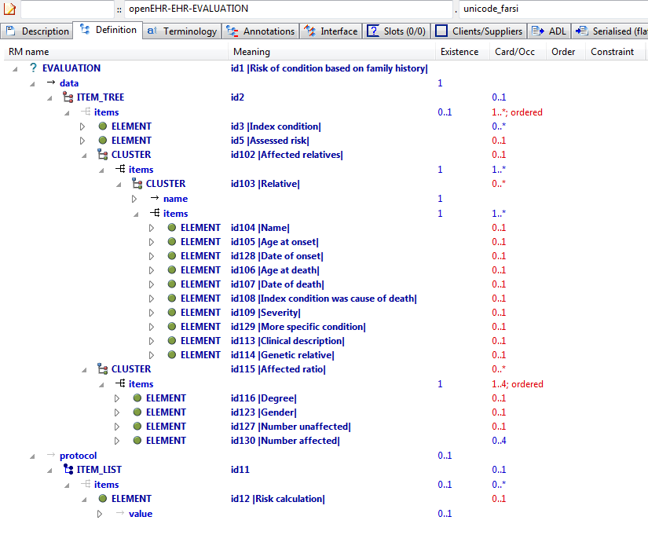

#### Unicode Farsi v1 AML Diagram

#### Unicode Farsi v1 AML Associations Diagram

### Three Languages v1 Example

a quoi ça sert

what this is for

funktsiia

#### Three Languages v1 ADL

archetype (adl_version=2.0.5; rm_release=1.0.2)

openEHR-EHR-OBSERVATION.three_languages.v1.0.0

language

original_language = <[ISO_639-1::en]>

translations = <

["fr"] = <

language = <[ISO_639-1::fr]>

author = <

["name"] = <"Frederik Tyler">

["email"] = <"freddy@something.somewhere.co.uk">

>

accreditation = <"British Medical Translator id 00400595">

>

["ru"] = <

language = <[ISO_639-1::ru]>

author = <

["name"] = <"Nina Alexandrovna">

["organisation"] = <"Dostoevsky Media Services">

["email"] = <"nina@translation.dms.ru">

>

accreditation = <"Russian Translator id 892230-3A">

>

>

description

custodian_namespace = <"org.openehr">

custodian_organisation = <"openEHR Foundation <http://www.openEHR.org>">

original_author = <

["name"] = <"Thomas Beale">

["email"] = <"thomas.beale@openEHR.org">

["organisation"] = <"openEHR Foundation <http://www.openEHR.org>">

["date"] = <"2012-10-21">

>

details = <

["fr"] = <

language = <[ISO_639-1::fr]>

purpose = <"a quoi ça sert">

use = <"ceçi explique la fonction de l'archetype">

keywords = <"ceçi", "est", "une", "liste", "de", "mots", "clés">

misuse = <"les interdictions de l'utilisation de cet archetype">

original_resource_uri = <

["ligne guide"] = <"http://guidelines.are.us/wherever/fr">

["medline"] = <"http://some%20medline%20ref">

>

>

["en"] = <

language = <[ISO_639-1::en]>

purpose = <"what this is for">

use = <"this explains the usage of the archetype">

keywords = <"this", "is", "a", "list", "of", "keywords">

misuse = <"this is not what it is used for">

original_resource_uri = <

["guideline"] = <"http://guidelines.are.us/wherever/en">

["medline"] = <"http://some%20medline%20ref">

>

>

["ru"] = <

language = <[ISO_639-1::ru]>

purpose = <"funktsiia">

use = <"v kakih sluchaiah ispol'zuetsia dannii arkhetip">

keywords = <"eto", "spisok", "kliuchevih", "slov">

misuse = <"Eto ob'iasniaet, pochemu etot arkhetip bil ispol'zovan ne po prednaznacheniiu">

original_resource_uri = <

["guideline"] = <"http://guidelines.are.us/wherever/ru">

["medline"] = <"http://some%20medline%20ref">

>

>

>

other_contributors = <"friend 1", "friend 2", "friend 3">

lifecycle_state = <"published">

other_details = <

["regression"] = <"PASS">

>

copyright = <"Copyright © 2003 openEHR Foundation <http://www.openEHR.org>">

licence = <"Creative Commons CC-BY-SA <https://creativecommons.org/licenses/by-sa/3.0/>">

definition

OBSERVATION[id1] matches { -- most minimal

data

}

terminology

term_definitions = <

["fr"] = <

["id1"] = <

text = <"le plus minimal">

description = <"le plus minimal">

>

>

["en"] = <

["id1"] = <

text = <"most minimal">

description = <"most minimal">

>

>

["ru"] = <

["id1"] = <

text = <"le plus minimal">

description = <"le plus minimal">

>

>

>

#### Three Languages v1 ADL Diagram

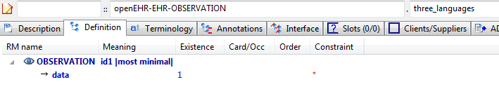

#### Three Languages v1 AML Diagram

#### Three Languages v1 AML Associations Diagram

## Flattening Examples

### Lab Test Panel - Lipid Studies v1 Example

Test flattening of overlays of new elements onto cloned structures. This archetype overlays one changed element on a repeated cloning of a structure with 4 elements. The flattened result will show all clones of those structures, with each being made up of the unchanged (inherited) elements, and the overridden elements defined in this archetype.

#### Lab Test Panel - Lipid Studies v1 ADL

archetype (adl_version=2.0.5; rm_release=1.0.2)

openEHR-EHR-CLUSTER.lab_test_panel-lipid_studies.v1.0.0

specialize

openEHR-EHR-CLUSTER.lab_test_panel.v1

language

original_language = <[ISO_639-1::en]>

description

custodian_namespace = <"org.openehr">

custodian_organisation = <"openEHR Foundation <http://www.openEHR.org>">

original_author = <

["name"] = <"Ian McNicoll">

["email"] = <"ian@freshehr.com">

["organisation"] = <"freshEHR Clinical Informatics, UK">

["date"] = <"2014-04-18">

>

details = <

["en"] = <

language = <[ISO_639-1::en]>

purpose = <"Test flattening of overlays of new elements onto cloned structures. This archetype overlays one changed element on a repeated cloning of a structure with 4 elements. The flattened result will show all clones of those structures, with each being made up of the unchanged (inherited) elements, and the overridden elements defined in this archetype.">

keywords = <"ADL", "flattening", "test">

>

>

lifecycle_state = <"published">

other_details = <

["regression"] = <"PASS">

>

copyright = <"Copyright © 2014 openEHR Foundation <http://www.openEHR.org>">

licence = <"Creative Commons CC-BY-SA <https://creativecommons.org/licenses/by-sa/3.0/>">

definition

CLUSTER[id1.1] matches { -- Lipid studies panel

/items matches {

CLUSTER[id3.1] matches { -- LDL Cholesterol Result

items matches {

ELEMENT[id2.1] matches { -- LDL Cholesterol

value matches {

DV_QUANTITY[id0.1] matches {

property matches {[at0.1]}

magnitude matches {|>=0.0|}

units matches {"mmol/l"}

}

}

}

}

}

CLUSTER[id3.2] matches { -- HDL Cholesterol Result

items matches {

ELEMENT[id2.2] matches { -- HDL Cholesterol

value matches {

DV_QUANTITY[id0.2] matches {

property matches {[at0.1]}

magnitude matches {|>=0.0|}

units matches {"mmol/l"}

}

}

}

}

}

CLUSTER[id3.3] matches { -- Ratio Result

items matches {

ELEMENT[id2.3] matches { -- Ratio

value matches {

DV_QUANTITY[id0.3] matches {

property matches {[at0.1]}

magnitude matches {|>=0.0|}

units matches {"mmol/l"}

}

}

}

}

}

CLUSTER[id3.4] matches { -- Triglyceride Result

items matches {

ELEMENT[id2.4] matches { -- Triglyceride

value matches {

DV_QUANTITY[id0.4] matches {

property matches {[at0.1]}

magnitude matches {|>=0.0|}

units matches {"mosmol/l"}

}

}

}

}

}

CLUSTER[id3.5] matches { -- Total Result

items matches {

ELEMENT[id2.5] matches { -- Total cholesterol

value matches {

DV_QUANTITY[id0.5] matches {

property matches {[at0.1]}

magnitude matches {|>=0.0|}

units matches {"mosmol/l"}

}

}

}

}

}

CLUSTER[id3.6] -- ! - Laboratory Result

}

}

terminology

term_definitions = <

["en"] = <

["id1.1"] = <

text = <"Lipid studies panel">

description = <"Laboratory test results as a single value or in a panel/battery format common to clinical pathology testing.!">

>

["id2.1"] = <

text = <"LDL Cholesterol">

description = <"Actual value of the result.">

>

["id2.2"] = <

text = <"HDL Cholesterol">

description = <"Actual value of the result.">

>

["id2.3"] = <

text = <"Ratio">

description = <"Actual value of the result.">

>

["id2.4"] = <

text = <"Triglyceride">

description = <"Actual value of the result.">

>

["id2.5"] = <

text = <"Total cholesterol">

description = <"Actual value of the result.">

>

["id3.1"] = <

text = <"LDL Cholesterol Result">

description = <"Specific detailed result, including both the value of the result item, and additional information that may be useful for clinical interpretation.">

>

["id3.2"] = <

text = <"HDL Cholesterol Result">

description = <"Specific detailed result, including both the value of the result item, and additional information that may be useful for clinical interpretation.">

>

["id3.3"] = <

text = <"Ratio Result">

description = <"Specific detailed result, including both the value of the result item, and additional information that may be useful for clinical interpretation.">

>

["id3.4"] = <

text = <"Triglyceride Result">

description = <"Specific detailed result, including both the value of the result item, and additional information that may be useful for clinical interpretation.">

>

["id3.5"] = <

text = <"Total Result">

description = <"Specific detailed result, including both the value of the result item, and additional information that may be useful for clinical interpretation.">

>

["id3.6"] = <

text = <"! - Laboratory Result">

description = <"Specific detailed result, including both the value of the result item, and additional information that may be useful for clinical interpretation.">

>

["at0.1"] = <

text = <"(added by post-parse processor)">

description = <"(added by post-parse processor)">

>

>

>

#### Lab Test Panel - Lipid Studies v1 ADL Diagram

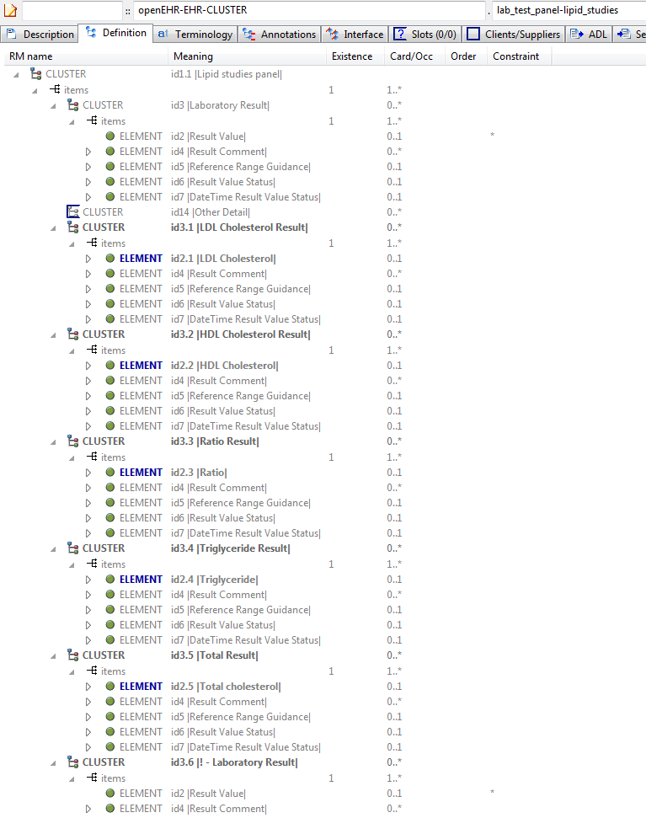

#### Lab Test Panel - Lipid Studies v1 AML Diagram

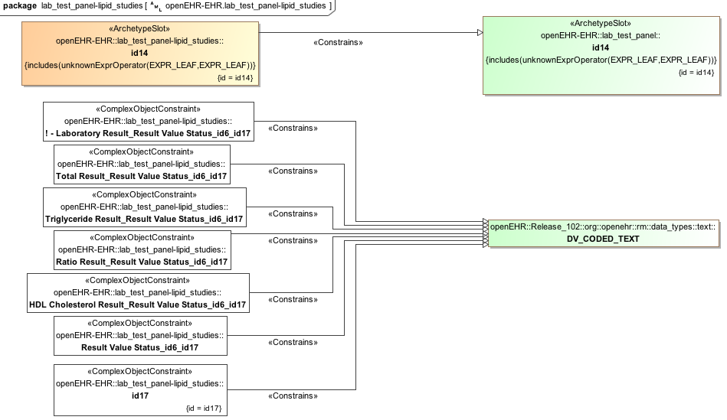

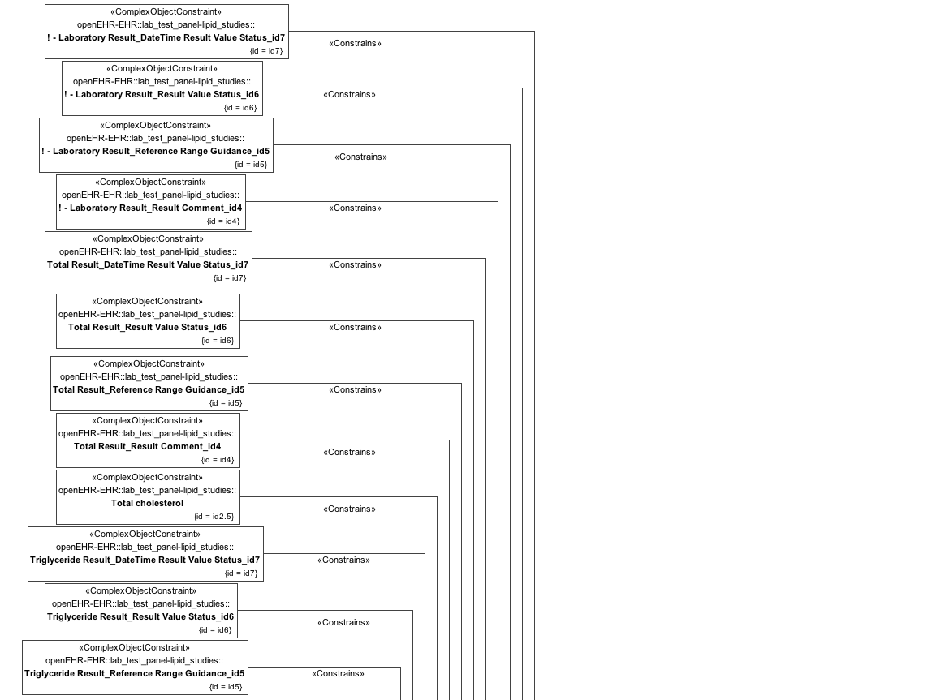

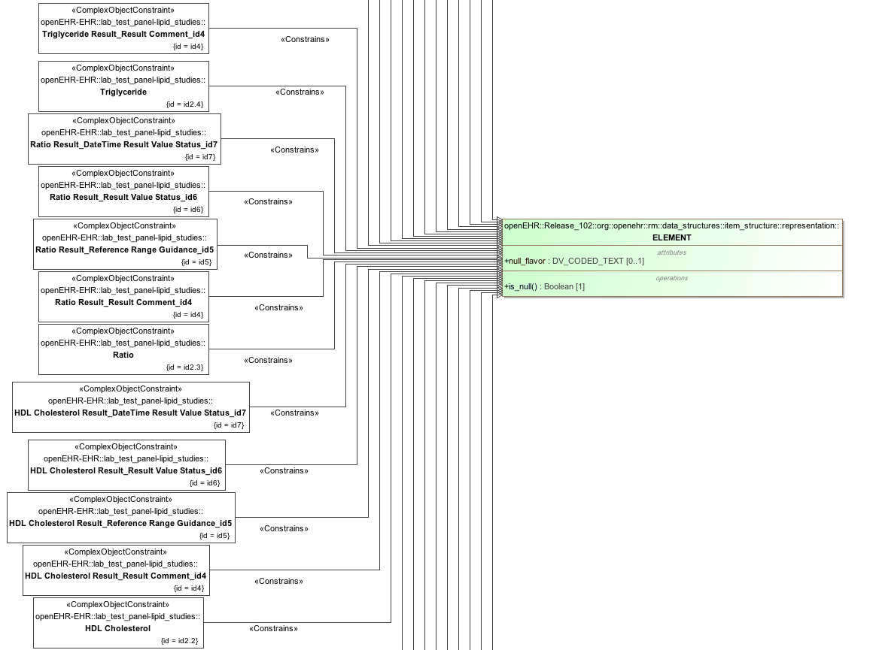

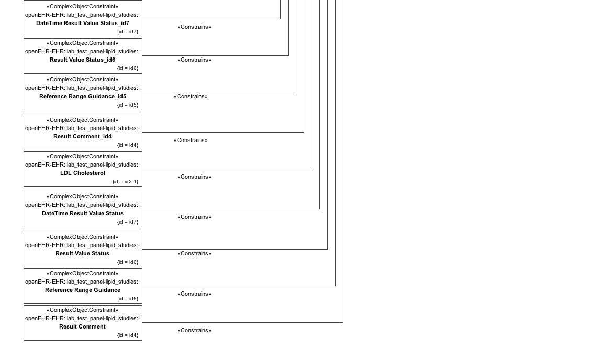

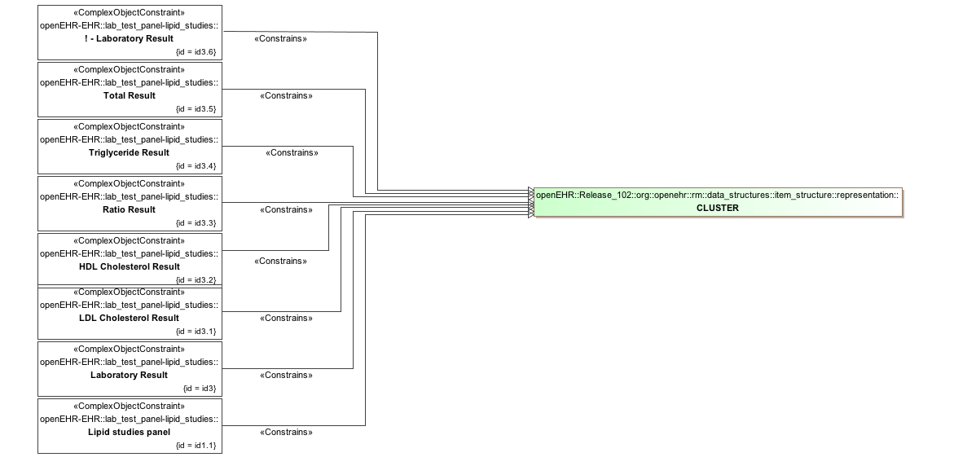

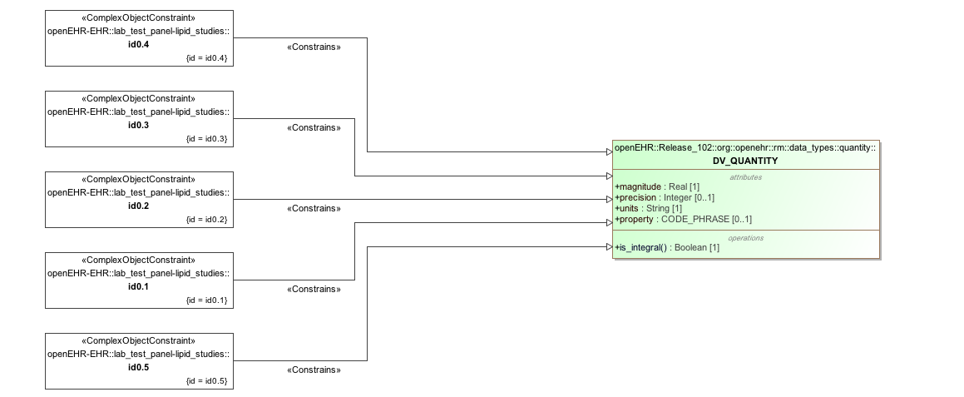

#### Lab Test Panel - Lipid Studies v1 AML Associations Diagram

### Lab Test Panel v1 Example

Parent for flattening tests on lab-style archetypes.

#### Lab Test Panel v1 ADL

archetype (adl_version=2.0.5; rm_release=1.0.2)

openEHR-EHR-CLUSTER.lab_test_panel.v1.0.0

language

original_language = <[ISO_639-1::en]>

description

custodian_namespace = <"org.openehr">

custodian_organisation = <"openEHR Foundation <http://www.openEHR.org>">

original_author = <

["name"] = <"Ian McNicoll">

["email"] = <"ian@freshehr.com">

["organisation"] = <"freshEHR Clinical Informatics, UK">

["date"] = <"2014-04-18">

>

details = <

["en"] = <

language = <[ISO_639-1::en]>

purpose = <"Parent for flattening tests on lab-style archetypes.">

keywords = <"ADL", "flattening", "test">

>

>

lifecycle_state = <"published">

other_details = <

["regression"] = <"PASS">

>

copyright = <"Copyright © 2014 openEHR Foundation <http://www.openEHR.org>">

licence = <"Creative Commons CC-BY-SA <https://creativecommons.org/licenses/by-sa/3.0/>">

definition

CLUSTER[id1] matches { -- Laboratory test panel

items matches {

CLUSTER[id3] matches { -- Laboratory Result

items matches {

ELEMENT[id2] occurrences matches {0..1} -- Result Value

ELEMENT[id4] matches { -- Result Comment

value matches {

DV_TEXT[id15]

}

}

ELEMENT[id5] occurrences matches {0..1} matches { -- Reference Range Guidance

value matches {

DV_TEXT[id16]

}

}

ELEMENT[id6] occurrences matches {0..1} matches { -- Result Value Status

value matches {

DV_CODED_TEXT[id17] matches {

defining_code matches {[ac1]} -- Result Value Status (synthesised)

}

}

}

ELEMENT[id7] occurrences matches {0..1} matches { -- DateTime Result Value Status

value matches {

DV_DATE_TIME[id18]

}

}

}

}

allow_archetype CLUSTER[id14] matches { -- Other Detail

include

archetype_id/value matches {/.*/}

}

}

}

terminology

term_definitions = <

["en"] = <

["id1"] = <

text = <"Laboratory test panel">

description = <"Laboratory test results as a single value or in a panel/battery format common to clinical pathology testing.">

>

["id2"] = <

text = <"Result Value">

description = <"Actual value of the result.">

>

["id3"] = <

text = <"Laboratory Result">

description = <"Specific detailed result, including both the value of the result item, and additional information that may be useful for clinical interpretation.">

>

["id4"] = <

text = <"Result Comment">

description = <"Comment about the Result.">

>

["id5"] = <

text = <"Reference Range Guidance">

description = <"Additional advice on the applicability of the reference range.">

>

["id6"] = <

text = <"Result Value Status">

description = <"The status of the result value.">

>

["id7"] = <

text = <"DateTime Result Value Status">

description = <"The date and/or time that the entire result was issued for the recorded ‘Result value status’.">

>

["at8"] = <

text = <"Registered">

description = <"No result yet available.">

>

["at9"] = <

text = <"Interim">

description = <"This is an initial or interim result: data may be missing or verification not been performed.">

>

["at10"] = <

text = <"Final">

description = <"The result is complete and verified by the responsible pathologist.">

>

["at11"] = <

text = <"Amended">

description = <"The result has been modified subsequent to being Final, and is complete and verified by the responsible pathologist.">

>

["at12"] = <

text = <"Cancelled/Aborted">

description = <"The result is unavailable because the test was not started or not completed.">

>

["at13"] = <

text = <"Not requested">

description = <"The result is not available as the test was not requested.">

>

["id14"] = <

text = <"Other Detail">

description = <"Further details including the specimen for the panel or a further nested panel.">

>

["ac1"] = <

text = <"Result Value Status (synthesised)">

description = <"The status of the result value. (synthesised)">

>

>

>

value_sets = <

["ac1"] = <

id = <"ac1">

members = <"at8", "at9", "at10", "at11", "at12", "at13">

>

>

#### Lab Test Panel v1 ADL Diagram

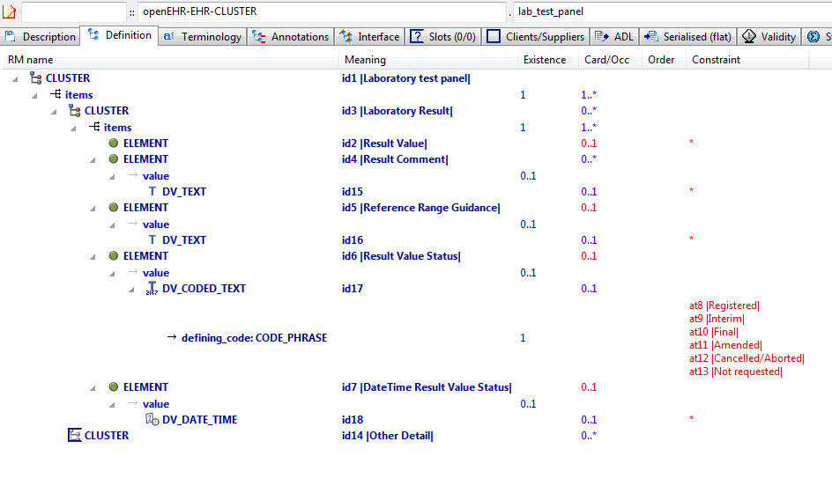

#### Lab Test Panel v1 AML Diagram

#### Lab Test Panel v1 AML Associations Diagram

### Request - Pathology Test v1 Example

Test flattening when child archetype contains a differential path that contains an overridden id code midway through (id122.1).

#### Request - Pathology Test v1 ADL

archetype (adl_version=2.0.5; rm_release=1.0.2)

openEHR-EHR-INSTRUCTION.request-pathology_test.v1.0.0

specialize

openEHR-EHR-INSTRUCTION.request.v1

language

original_language = <[ISO_639-1::en]>

description

custodian_namespace = <"org.openehr">

custodian_organisation = <"openEHR Foundation <http://www.openEHR.org>">

original_author = <

["name"] = <"Dr Ian McNicoll">

["email"] = <"ian.mcnicoll@oceaninformatics.com">

["organisation"] = <"Ocean Informatics UK <http://www.oceaninformatics.com>">

["date"] = <"2009-08-12">

>

details = <

["en"] = <

language = <[ISO_639-1::en]>

purpose = <"Test flattening when child archetype contains a differential path that contains an overridden id code midway through (id122.1).">

>

>

lifecycle_state = <"published">

other_details = <

["regression"] = <"PASS">

>

copyright = <"Copyright © 2009 openEHR Foundation <http://www.openEHR.org>">

licence = <"Creative Commons CC-BY-SA <https://creativecommons.org/licenses/by-sa/3.0/>">

definition

INSTRUCTION[id1.1] matches { -- PathologyTest Request

/activities[id2]/description[id10]/items[id122.1]/name matches {

DV_TEXT[id0.146]

}

/activities[id2]/description[id10]/items[id136.1]/name matches {

DV_TEXT[id0.147]

}

}

terminology

term_definitions = <

["en"] = <

["id1.1"] = <

text = <"PathologyTest Request">

description = <"Generic request for a pathology request.">

>

["id122.1"] = <

text = <"Pathology Test Requested">

description = <"Identification of the pathology test requested. This is often coded with an external terminology.">

>

["id136.1"] = <

text = <"Description of Test">

description = <"A detailed narrative description of the pathology test requested.">

>

>

>

#### Request - Pathology Test v1 ADL Diagram

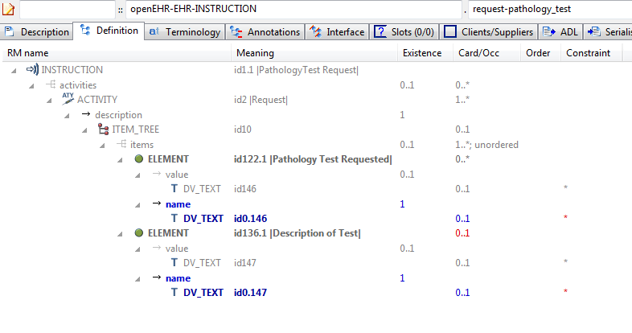

#### Request - Pathology Test v1 AML Diagram

#### Request - Pathology Test v1 AML Associations Diagram

### Request v1 Example

Parent archetype for archetypes testing flattening when child archetype contains a differential path with an overridden id code.

#### Request v1 ADL

archetype (adl_version=2.0.5; rm_release=1.0.2)

openEHR-EHR-INSTRUCTION.request.v1.0.0

language

original_language = <[ISO_639-1::en]>

description

custodian_namespace = <"org.openehr">

custodian_organisation = <"openEHR Foundation <http://www.openEHR.org>">

original_author = <

["name"] = <"Dr Ian McNicoll">

["email"] = <"ian.mcnicoll@oceaninformatics.com">

["organisation"] = <"Ocean Informatics UK <http://www.oceaninformatics.com>">

["date"] = <"2009-08-12">

>

details = <

["en"] = <

language = <[ISO_639-1::en]>

purpose = <"Parent archetype for archetypes testing flattening when child archetype contains a differential path with an overridden id code.">

keywords = <"ADL", "flattening", "test">

>

>

lifecycle_state = <"published">

other_details = <

["regression"] = <"PASS">

>

copyright = <"Copyright © 2009 openEHR Foundation <http://www.openEHR.org>">

licence = <"Creative Commons CC-BY-SA <https://creativecommons.org/licenses/by-sa/3.0/>">

definition

INSTRUCTION[id1] matches { -- Healthcare service request

activities matches {

ACTIVITY[id2] occurrences matches {1..*} matches { -- Request

description matches {

ITEM_TREE[id10] matches {

items cardinality matches {1..*; unordered} matches {

ELEMENT[id122] matches { -- Service requested

value matches {

DV_TEXT[id146]

}

}

ELEMENT[id136] occurrences matches {0..1} matches { -- Description of service

value matches {

DV_TEXT[id147]

}

}

}

}

}

}

}

}

terminology

term_definitions = <

["en"] = <

["id1"] = <

text = <"Healthcare service request">

description = <"Request for a range of different healthcare services, for example, a referral, lab request, equipment request.">

>

["id2"] = <

text = <"Request">

description = <"Current Activity.">

>

["id122"] = <

text = <"Service requested">

description = <"Identification of the service requested. This is often coded with an external terminology.">

>

["id136"] = <

text = <"Description of service">

description = <"A detailed narrative description of the service requested.">

>

>

>

#### Request v1 ADL Diagram

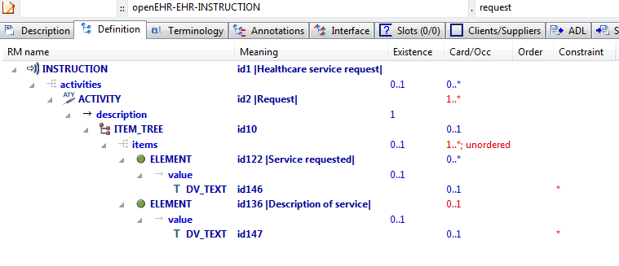

#### Request v1 AML Diagram

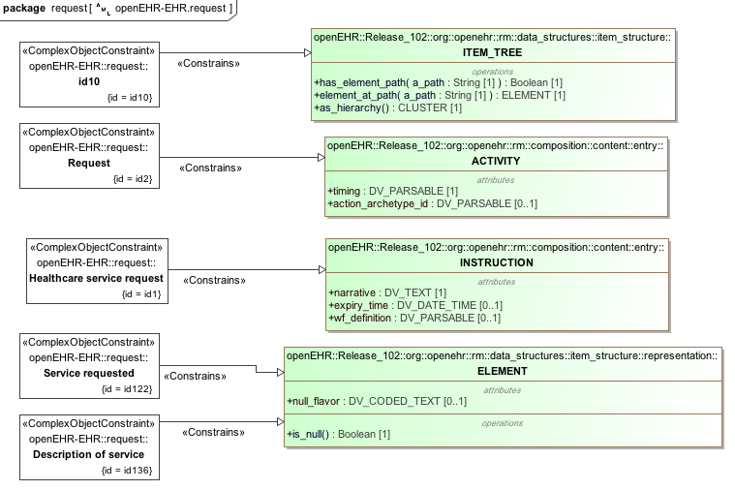

#### Request v1 AML Associations Diagram

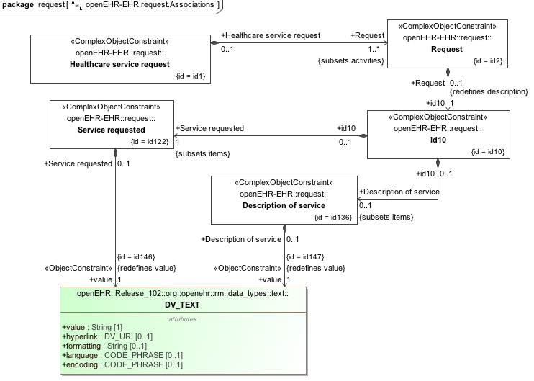

### Flat Test Parent 1 - Add Node Use Node v1 Example

Test flattening of differential path containing terminal attribute not in parent ('state'); test internal references to path in flat parent and path in current archetype.

#### Flat Test Parent 1 - Add Node Use Node v1 ADL

archetype (adl_version=2.0.5; rm_release=1.0.2)

openEHR-EHR-OBSERVATION.flat_test_parent_1-add_node_use_node.v1.0.0

specialize

openEHR-EHR-OBSERVATION.flat_test_parent_1.v1

language

original_language = <[ISO_639-1::en]>

description

custodian_namespace = <"org.openehr">

custodian_organisation = <"openEHR Foundation <http://www.openEHR.org>">

original_author = <

["name"] = <"Ian McNicoll">

["organisation"] = <"Ocean Informatics UK <http://www.oceaninformatics.com>">

["email"] = <"ian.mcnicoll@oceaninformatics.com">

["date"] = <"2009-11-07">

>

details = <

["en"] = <

language = <[ISO_639-1::en]>

purpose = <"Test flattening of differential path containing terminal attribute not in parent ('state'); test internal references to path in flat parent and path in current archetype.">

keywords = <"ADL", "flattening", "test">

>

>

lifecycle_state = <"unmanaged">

other_details = <

["regression"] = <"PASS">

>

copyright = <"Copyright © 2009 openEHR Foundation <http://www.openEHR.org>">

licence = <"Creative Commons CC-BY-SA <https://creativecommons.org/licenses/by-sa/3.0/>">

definition

OBSERVATION[id1.1] matches { -- Blood Glucose Test Result

/data[id2]/events[id3]/state matches {

ITEM_TREE[id0.8] matches {

items matches {

ELEMENT[id0.9] occurrences matches {0..1} matches { -- Fasting state

value matches {

DV_BOOLEAN[id0.17] matches {

value matches {True}

}

}

}

}

}

}

/data[id2]/events matches {

POINT_EVENT[id0.2] occurrences matches {0..1} matches { -- Baseline Measurement

offset matches {

DV_DURATION[id0.21] matches {

value matches {PT0S}

}

}

data matches {

use_node ITEM_TREE[id0.22] /data[id2]/events[id3]/data[id4] -- /data[id2]/events[id3]/data[id4]

}

state matches {

use_node ITEM_TREE[id0.23] /data[id2]/events[id3]/state[id0.8] -- /data[id2]/events[id3]/state[id0.8]

}

}

}

}

terminology

term_definitions = <

["en"] = <

["id0.2"] = <

text = <"Baseline Measurement">

description = <"Specific point in time measurement which provides a reference glucose reading against which subsequent measurements can be compared.">

>

["id0.3"] = <

text = <"1 Hour Measurement">

description = <"Specific point in time measurement taken 1 hour after the Baseline Measurement and subsequent glucose/insulin challenge.">

>

["id0.5"] = <

text = <"2 Hour Measurement">

description = <"Specific point in time measurement taken 2 hours after the Baseline Measurement and subsequent glucose/insulin challenge.">

>

["id0.9"] = <

text = <"Fasting state">

description = <"Fasting state">

>

["id1.1"] = <

text = <"Blood Glucose Test Result">

description = <"The findings and interpretation of glucose tests performed on plasma, serum or whole blood.">

>

>

>

#### Flat Test Parent 1 - Add Node Use Node v1 ADL Diagram

#### Flat Test Parent 1 - Add Node Use Node v1 AML Diagram

#### Flat Test Parent 1 - Add Node Use Node v1 AML Associations Diagram

### Flat Test Parent 1 v1 Example

Parent of archetypes for flattening tests

#### Flat Test Parent 1 v1 ADL

archetype (adl_version=2.0.5; rm_release=1.0.2)

openEHR-EHR-OBSERVATION.flat_test_parent_1.v1.0.0

language

original_language = <[ISO_639-1::en]>

description

custodian_namespace = <"org.openehr">

custodian_organisation = <"openEHR Foundation <http://www.openEHR.org>">

original_author = <

["name"] = <"Ian McNicoll">

["email"] = <"ian.mcnicoll@oceaninformatics.com">

["organisation"] = <"Ocean Informatics UK <http://www.oceaninformatics.com>">

["date"] = <"2009-11-07">

>

details = <

["en"] = <

language = <[ISO_639-1::en]>

purpose = <"Parent of archetypes for flattening tests">

keywords = <"ADL", "flattening", "test">

>

>

lifecycle_state = <"published">

other_details = <

["regression"] = <"PASS">

>

copyright = <"Copyright © 2009 openEHR Foundation <http://www.openEHR.org>">

licence = <"Creative Commons CC-BY-SA <https://creativecommons.org/licenses/by-sa/3.0/>">

definition

OBSERVATION[id1] matches { -- Pathology Test Result

data matches {

HISTORY[id2] matches {

events cardinality matches {1..*; unordered} matches {

EVENT[id3] matches { -- Any event

data matches {

ITEM_TREE[id4] matches {

items cardinality matches {2..*; unordered} matches {

ELEMENT[id6] matches { -- Test Result Name

value matches {

DV_TEXT[id112]

}

}

}

}

}

}

}

}

}

}

terminology

term_definitions = <

["en"] = <

["id1"] = <

text = <"Pathology Test Result">

description = <"The findings and interpretation of pathology tests performed on patient-related specimens.">

>

["id3"] = <

text = <"Any event">

description = <"Any event.">

>

["id6"] = <

text = <"Test Result Name">

description = <"Identification of the pathology test performed, sometimes including specimen type and patient state.">

>

>

>

#### Flat Test Parent 1 v1 ADL Diagram

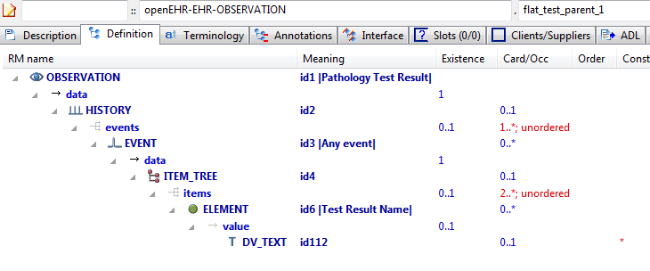

#### Flat Test Parent 1 v1 AML Diagram

#### Flat Test Parent 1 v1 AML Associations Diagram

### Flattening Parent 1 v1 Example

Overwrite parent 'matches-any' node (id13) with 2 child nodes.

#### Flattening Parent 1 v1 ADL

archetype (adl_version=2.0.5; rm_release=1.0.2)

openEHR-EHR-OBSERVATION.flattening_parent_1.v1.0.0

language

original_language = <[ISO_639-1::en]>

description

custodian_namespace = <"org.openehr">

custodian_organisation = <"openEHR Foundation <http://www.openEHR.org>">

original_author = <

["name"] = <"Thomas Beale">

["email"] = <"thomas.beale@openEHR.org">

["organisation"] = <"openEHR Foundation <http://www.openEHR.org>">

["date"] = <"2009-05-06">

>

details = <

["en"] = <

language = <[ISO_639-1::en]>

purpose = <"Overwrite parent 'matches-any' node (id13) with 2 child nodes.">

keywords = <"ADL", "flattening", "test">

>

>

lifecycle_state = <"published">

other_details = <

["regression"] = <"PASS">

>

copyright = <"Copyright © 2009 openEHR Foundation <http://www.openEHR.org>">

licence = <"Creative Commons CC-BY-SA <https://creativecommons.org/licenses/by-sa/3.0/>">

definition

OBSERVATION[id1] matches { -- Substance Use

data matches {

HISTORY[id2] matches {

events cardinality matches {1..*; unordered} matches {

EVENT[id3] occurrences matches {0..1} matches { -- Any event

data matches {

ITEM_TREE[id4] matches {

items matches {

ELEMENT[id5] occurrences matches {0..1} matches { -- Substance

value matches {

DV_TEXT[id20]

}

}

CLUSTER[id11] occurrences matches {0..1} matches { -- Consumption details

items matches {

ELEMENT[id12] occurrences matches {0..1} matches { -- Form

value matches {

DV_TEXT[id21]

}

}

ELEMENT[id19] occurrences matches {0..1} matches { -- Method of use

value matches {

DV_TEXT[id22]

}

}

ELEMENT[id6] occurrences matches {0..1} matches { -- Frequency

value matches {

DV_CODED_TEXT[id23] matches {

defining_code matches {[ac1]} -- Frequency

}

}

}

ELEMENT[id13] occurrences matches {0..*} -- Amount

}

}

ELEMENT[id14] occurrences matches {0..1} matches { -- Triggers

value matches {

DV_TEXT[id24]

}

}

allow_archetype CLUSTER[id15] occurrences matches {0..*} matches { -- Readiness for change

include

archetype_id/value matches {/openEHR-EHR-CLUSTER\.change\.v1/}

}

ELEMENT[id17] occurrences matches {0..1} matches { -- Evidence of dependence

value matches {

DV_TEXT[id25]

}

}

}

}

}

}

}

}

}

}

terminology

term_definitions = <

["en"] = <

["id1"] = <

text = <"Substance Use">

description = <"Generic archetype to record the actual use or consumption of a defined substance at the present time, a specific time or over a period of time. ">

>

["id3"] = <

text = <"Any event">

description = <"Any event">

>

["id5"] = <

text = <"Substance">

description = <"Identification of substance ">

>

["id6"] = <

text = <"Frequency">

description = <"Frequency of use of substance">

>

["at7"] = <

text = <"Daily use">

description = <"Used every day">

>

["at8"] = <

text = <"Weekly use">

description = <"Used at least weekly">

>

["at9"] = <

text = <"Irregular use">

description = <"Used irregularly">

>

["at10"] = <

text = <"No use">

description = <"Not used at all">

>

["id11"] = <

text = <"Consumption details">

description = <"Details about the consumption of the substance">

>

["id12"] = <

text = <"Form">

description = <"Form of the substance used">

>

["id13"] = <

text = <"Amount">

description = <"Amount of substance consumed. Data type can be further specified in specialised archetypes or in templates">

>

["id14"] = <

text = <"Triggers">

description = <"Identified triggers which stimulate or cause use">

>

["id15"] = <

text = <"Readiness for change">

description = <"Details about the readiness to change use or consumption of substance">

>

["id17"] = <

text = <"Evidence of dependence">

description = <"Description of any evidence of dependence on the substance">

>

["id19"] = <

text = <"Method of use">

description = <"Method of use or consumption of the substance">

>

["ac1"] = <

text = <"Frequency">

description = <"Frequency of use of substance">

>

>

>

value_sets = <

["ac1"] = <

id = <"ac1">

members = <"at7", "at8", "at9", "at10">

>

>

#### Flattening Parent 1 v1 ADL Diagram

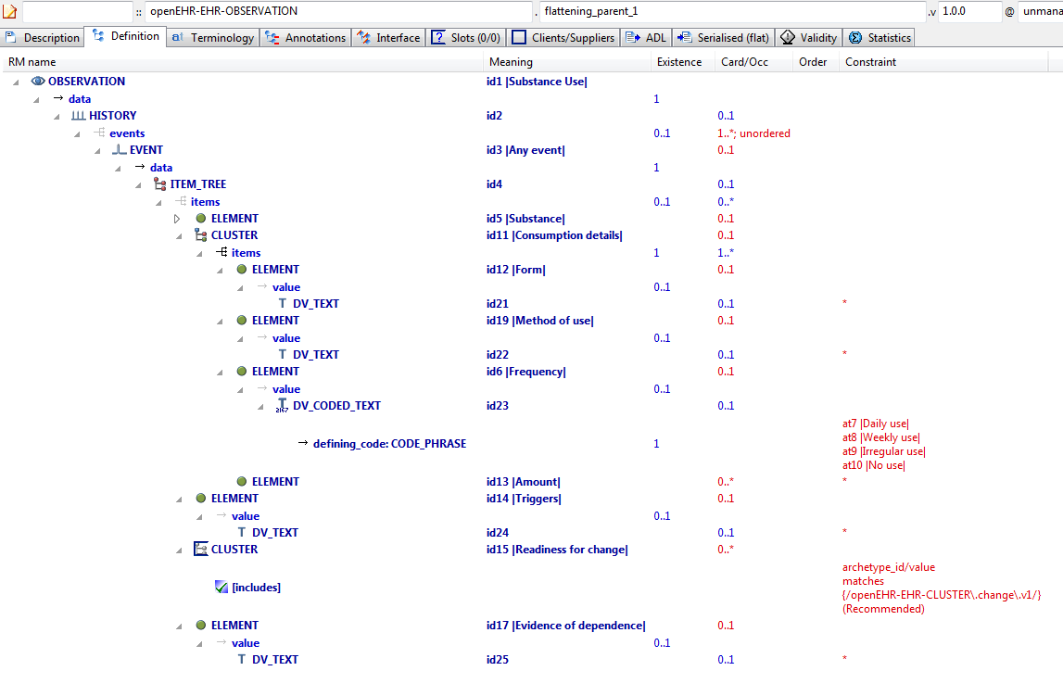

#### Flattening Parent 1 v1 AML Diagram

#### Flattening Parent 1 v1 AML Associations Diagram

### Override To Multiple v1 Example

Parent of flattening example archetypes.

#### Override To Multiple v1 ADL

archetype (adl_version=2.0.5; rm_release=1.0.2)

openEHR-EHR-OBSERVATION.override_to_multiple.v1.0.0

specialize

openEHR-EHR-OBSERVATION.flattening_parent_1.v1

language

original_language = <[ISO_639-1::en]>

description

custodian_namespace = <"org.openehr">

custodian_organisation = <"openEHR Foundation <http://www.openEHR.org>">

original_author = <

["name"] = <"Thomas Beale">

["organisation"] = <"openEHR Foundation <http://www.openEHR.org>">

["email"] = <"thomas.beale@openEHR.org">

["date"] = <"2009-05-06">

>

details = <

["en"] = <

language = <[ISO_639-1::en]>

purpose = <"Parent of flattening example archetypes.">

keywords = <"ADL", "flattening", "test">

>

>

lifecycle_state = <"published">

other_details = <

["regression"] = <"PASS">

>

copyright = <"Copyright © 2009 openEHR Foundation <http://www.openEHR.org>">

licence = <"Creative Commons CC-BY-SA <https://creativecommons.org/licenses/by-sa/3.0/>">

definition

OBSERVATION[id1.1] matches { -- Tobacco Use

/data[id2]/events[id3]/data[id4]/items[id5]/value matches {

DV_CODED_TEXT[id20.1] matches {

defining_code matches {[at0.2]}

}

}

/data[id2]/events[id3]/data[id4]/items[id11]/items[id12]/value matches {

DV_CODED_TEXT[id21.1] matches {

defining_code matches {[ac0.1]} -- (added by post-parse processor)

}

}

/data[id2]/events[id3]/data[id4]/items[id11]/items matches {

ELEMENT[id13.1] matches { -- Number smoked

value matches {

DV_QUANTITY[id0.5] matches {

property matches {[at0.7]}

units matches {"/h", "/d", "/wk"}

}

}

}

ELEMENT[id13.2] matches { -- Grams of tobacco

value matches {

DV_QUANTITY[id0.6] matches {

property matches {[at0.8]}

units matches {"gm/d", "gm/wk"}

}

}

}

}

}

terminology

term_definitions = <

["en"] = <

["at0.2"] = <

text = <"Tobacco">

description = <"Tobacco used">

>

["at0.3"] = <

text = <"Cigarettes - manufactured">

description = <"Commercial, manufactured cigarettes">

>

["at0.4"] = <

text = <"Cigarettes - roll-your-own">

description = <"Home-made, roll-your-own cigarettes">

>

["at0.5"] = <

text = <"Cigars">

description = <"Commercial cigars">

>

["at0.6"] = <

text = <"Pipe">

description = <"Tobacco smoked within a pipe">

>

["id1.1"] = <

text = <"Tobacco Use">

description = <"Archetype to record the actual use or consumption of a tobacco at the present time, a specific time or over a period of time. ">

>

["id13.1"] = <

text = <"Number smoked">

description = <"Number of units containing tobacco consumed eg cigarettes or cigars">

>

["id13.2"] = <

text = <"Grams of tobacco">

description = <"Weight of tobacco consumed eg in a pipe">

>

["ac0.1"] = <

text = <"(added by post-parse processor)">

description = <"(added by post-parse processor)">

>

["ac0.2"] = <

text = <"(added by post-parse processor)">

description = <"(added by post-parse processor)">

>

["at0.7"] = <

text = <"Frequency">

description = <"Frequency">

>

["at0.8"] = <

text = <"Flow rate, mass">

description = <"Flow rate, mass">

>

>

>

term_bindings = <

["openehr"] = <

["at0.7"] = <http://openehr.org/id/382>

["at0.8"] = <http://openehr.org/id/347>

>

>

value_sets = <

["ac0.1"] = <

id = <"ac0.1">

members = <"at0.3", "at0.4", "at0.5", "at0.6">

>

["ac0.2"] = <

id = <"ac0.2">

members = <"at7", "at8", "at9", "at10">

>

>

#### Override To Multiple v1 ADL Diagram

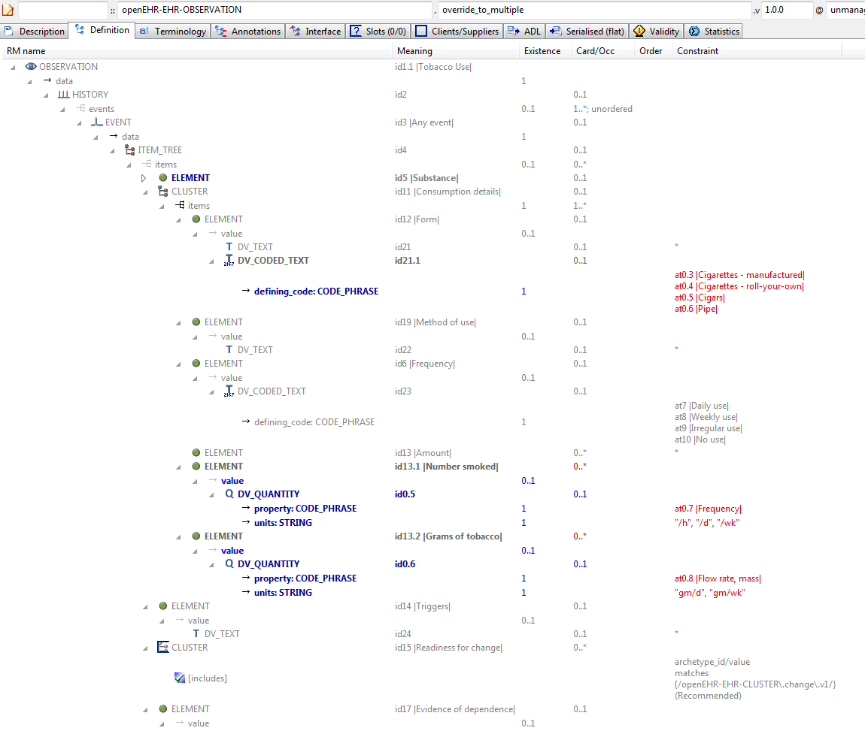

#### Override To Multiple v1 AML Diagram

#### Override To Multiple v1 AML Associations Diagram

## Reference_model Enumeration_types Examples

### Enum Type 1 v1 Example

Illustrate enumerated type constraints. In this archetype, the DV_PROPORTION.type field has integer values that are actually the values of a declared enumeration type PROPORTION_KIND based on the Integer primitive type.

#### Enum Type 1 v1 ADL

archetype (adl_version=2.0.5; rm_release=1.0.2)

openEHR-EHR-OBSERVATION.audiogram.v1.0.0

language

original_language = <[ISO_639-1::en]>

description

custodian_namespace = <"org.openehr">

custodian_organisation = <"openEHR Foundation <http://www.openEHR.org>">

original_author = <

["name"] = <"Thomas Beale">

["email"] = <"thomas.beale@openEHR.org">

["organisation"] = <"openEHR Foundation <http://www.openEHR.org>">

["date"] = <"2014-06-10">

>

details = <

["en"] = <

language = <[ISO_639-1::en]>

purpose = <"Illustrate enumerated type constraints. In this archetype, the DV_PROPORTION.type field has integer values that are actually the values of a declared enumeration type PROPORTION_KIND based on the Integer primitive type.">

keywords = <"ADL", "test", "enumerated types">

>

>

lifecycle_state = <"published">

other_details = <

["regression"] = <"PASS">

>

copyright = <"Copyright © 2014 openEHR Foundation <http://www.openEHR.org>">

licence = <"Creative Commons CC-BY-SA <https://creativecommons.org/licenses/by-sa/3.0/>">

definition

OBSERVATION[id1] matches { -- Enumeration test

data matches {

HISTORY[id2] matches {

events cardinality matches {1..*; unordered} matches {

POINT_EVENT[id3] occurrences matches {0..1} matches { -- Any event

data matches {

ITEM_TREE[id4] matches {

items cardinality matches {1..*; unordered} matches {

ELEMENT[id5] occurrences matches {0..1} matches { -- test enum 1

value matches {

DV_PROPORTION[id6] matches {

numerator matches {|0.0..1.0|; 0.0}

is_integral matches {False}

type matches {1}

}

}

}

ELEMENT[id7] occurrences matches {0..1} matches { -- test enum 2

value matches {

DV_PROPORTION[id8] matches {

numerator matches {|0.0..1.0|; 0.0}

is_integral matches {False}

type matches {2, 3}

}

}

}

}

}

}

}

}

}

}

}

terminology

term_definitions = <

["en"] = <

["id1"] = <

text = <"Enumeration test">

description = <"Enumeration test">

>

["id3"] = <

text = <"Any event">

description = <"Any unspecified point in time or interval event.">

>

["id5"] = <

text = <"test enum 1">

description = <"test enum 1">

>

["id7"] = <

text = <"test enum 2">

description = <"test enum 2">

>

>

>

#### Enum Type 1 v1 ADL Diagram

#### Enum Type 1 v1 AML Diagram

#### Enum Type 1 v1 AML Associations Diagram

## Reference_model Generic_types Examples

### Generic Parameters v1 Example

Illustrate constraining of fields whose types in the RM are a generic type parameter, i.e. typically 'T', 'U' etc. In this example, the upper and lower fields are of type 'T' in the RM definition of DV_INTERVAL.

#### Generic Parameters v1 ADL

archetype (adl_version=2.0.5; rm_release=1.0.2)

openEHR-EHR-CLUSTER.generic_parameters.v1.0.0

language

original_language = <[ISO_639-1::en]>

description

custodian_namespace = <"org.openehr">

custodian_organisation = <"openEHR Foundation <http://www.openEHR.org>">

original_author = <

["name"] = <"Thomas Beale">

["email"] = <"thomas.beale@openEHR.org">

["organisation"] = <"openEHR Foundation <http://www.openEHR.org>">

["date"] = <"2014-06-12">

>

details = <

["en"] = <

language = <[ISO_639-1::en]>

purpose = <"Illustrate constraining of fields whose types in the RM are a generic type parameter, i.e. typically 'T', 'U' etc. In this example, the upper and lower fields are of type 'T' in the RM definition of DV_INTERVAL.">

keywords = <"ADL", "test", "generic types">

>

>

lifecycle_state = <"published">

other_details = <

["regression"] = <"PASS">

>

copyright = <"Copyright © 2006 openEHR Foundation <http://www.openEHR.org>">

licence = <"Creative Commons CC-BY-SA <https://creativecommons.org/licenses/by-sa/3.0/>">

definition

CLUSTER[id1] matches { -- Specimen

items matches {

ELEMENT[id2] occurrences matches {0..1} matches { -- Datetime range

value matches {

DV_INTERVAL<DV_DATE_TIME>[id3] matches {

upper matches {

DV_DATE_TIME[id4]

}

lower matches {

DV_DATE_TIME[id5]

}

}

}

}

}

}

terminology

term_definitions = <

["en"] = <

["id1"] = <

text = <"Specimen">

description = <"unknown">

>

["id2"] = <

text = <"Datetime range">

description = <"Date/time range">

>

>

>

#### Generic Parameters v1 ADL Diagram

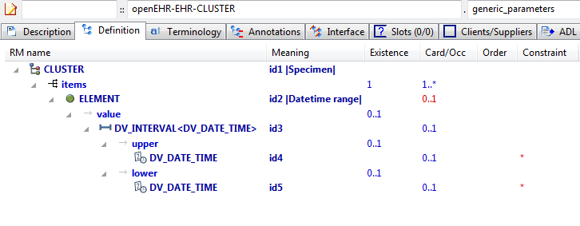

#### Generic Parameters v1 AML Diagram

#### Generic Parameters v1 AML Associations Diagram

### Rm Conforming Rm Subtype v1 Example

Test for conformance of RM subtype (here: POINT_EVENT) to statically declared RM type (EVENT). This archetype should pass validation.

#### Rm Conforming Rm Subtype v1 ADL

archetype (adl_version=2.0.5; rm_release=1.0.2)

openEHR-EHR-OBSERVATION.rm_conforming_rm_subtype.v1.0.0

language

original_language = <[ISO_639-1::en]>

description

custodian_namespace = <"org.openehr">

custodian_organisation = <"openEHR Foundation <http://www.openEHR.org>">

original_author = <

["name"] = <"Thomas Beale">

["email"] = <"thomas.beale@openEHR.org">

["organisation"] = <"openEHR Foundation <http://www.openEHR.org>">

["date"] = <"2009-03-18">

>

details = <

["en"] = <

language = <[ISO_639-1::en]>

purpose = <"Test for conformance of RM subtype (here: POINT_EVENT) to statically declared RM type (EVENT). This archetype should pass validation.">

keywords = <"ADL", "test", "RM checking">

>

>

lifecycle_state = <"published">

other_details = <

["regression"] = <"PASS">

>

copyright = <"Copyright © 2009 openEHR Foundation <http://www.openEHR.org>">

licence = <"Creative Commons CC-BY-SA <https://creativecommons.org/licenses/by-sa/3.0/>">

definition

OBSERVATION[id1] matches { -- An Observation

data matches {

HISTORY[id5] matches {

events cardinality matches {1..*; unordered} matches {

POINT_EVENT[id2] occurrences matches {0..1} matches { -- A Point_event

offset matches {

DV_DURATION[id6] matches {

value matches {PT1M}

}

}

data matches {

ITEM_LIST[id7] matches {

items cardinality matches {1..6; ordered} matches {

ELEMENT[id3] occurrences matches {0..1} -- Element #1

ELEMENT[id4] occurrences matches {0..1} -- Element #2

}

}

}

}

}

}

}

}

terminology

term_definitions = <

["en"] = <

["id1"] = <

text = <"An Observation">

description = <"An Observation">

>

["id2"] = <

text = <"A Point_event">

description = <"A Point_event">

>

["id3"] = <

text = <"Element #1">

description = <"Element #1">

>

["id4"] = <

text = <"Element #2">

description = <"Element #2">

>

>

>

#### Rm Conforming Rm Subtype v1 ADL Diagram

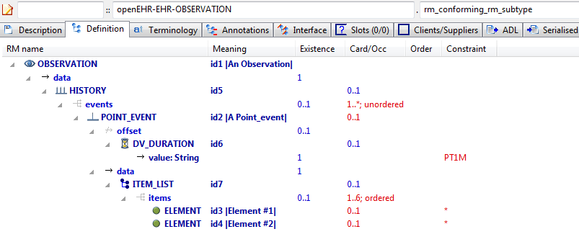

#### Rm Conforming Rm Subtype v1 AML Diagram

#### Rm Conforming Rm Subtype v1 AML Associations Diagram

### Rm Correct Non Generic v1 Example

Example containing properly constraints conforming to the RM, with no RM type overrides or generic type markers, even though one type (HISTORY) is declared generic in the RM.

#### Rm Correct Non Generic v1 ADL

archetype (adl_version=2.0.5; rm_release=1.0.2)

openEHR-EHR-OBSERVATION.rm_correct_non_generic.v1.0.0

language

original_language = <[ISO_639-1::en]>

description

custodian_namespace = <"org.openehr">

custodian_organisation = <"openEHR Foundation <http://www.openEHR.org>">

original_author = <

["name"] = <"Thomas Beale">

["organisation"] = <"Ocean Informatics">

["email"] = <"thomas.beale@oceaninformatics.com">

["date"] = <"12/03/2009">

>

details = <

["en"] = <

language = <[ISO_639-1::en]>

purpose = <"Example containing properly constraints conforming to the RM, with no RM type overrides or generic type markers, even though one type (HISTORY) is declared generic in the RM.">

keywords = <"ADL", "test", "RM checker">

>

>

lifecycle_state = <"published">

other_details = <

["regression"] = <"PASS">

>

copyright = <"Copyright © 2009 openEHR Foundation <http://www.openEHR.org>">

licence = <"Creative Commons CC-BY-SA <https://creativecommons.org/licenses/by-sa/3.0/>">

definition

OBSERVATION[id1] matches { -- an Observation

data matches {

HISTORY[id4] matches {

events cardinality matches {1..*; unordered} matches {

EVENT[id3] occurrences matches {0..*} matches { -- some Event

data matches {

ITEM_LIST[id5]

}

}

}

}

}

}

terminology

term_definitions = <

["en"] = <

["id1"] = <

text = <"an Observation">

description = <"an Observation">

>

["id3"] = <

text = <"some Event">

description = <"some Event">

>

>

>

#### Rm Correct Non Generic v1 ADL Diagram

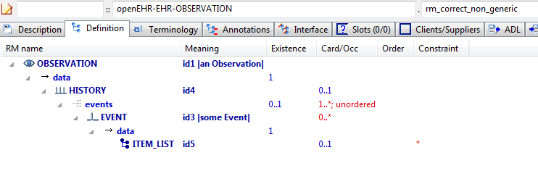

#### Rm Correct Non Generic v1 AML Diagram

#### Rm Correct Non Generic v1 AML Associations Diagram

## Specialisation Examples

### Code List Constrained v1 Example

Example of narrowing constraint of code list inherited from parent.

#### Code List Constrained v1 ADL

archetype (adl_version=2.0.5; rm_release=1.0.2)

openEHR-EHR-EVALUATION.code_list_constrained.v1.0.0

specialize

openEHR-EHR-EVALUATION.code_list_parent.v1

language

original_language = <[ISO_639-1::en]>

description

custodian_namespace = <"org.openehr">

custodian_organisation = <"openEHR Foundation <http://www.openEHR.org>">

original_author = <

["name"] = <"Thomas Beale">

["email"] = <"thomas.beale@openEHR.org">

["organisation"] = <"openEHR Foundation <http://www.openEHR.org>">

["date"] = <"2012-02-20">

>

details = <

["en"] = <

language = <[ISO_639-1::en]>

purpose = <"Example of narrowing constraint of code list inherited from parent.">

keywords = <"ADL", "test", "specialisation">

>

>

lifecycle_state = <"published">

other_details = <

["regression"] = <"PASS">

>

copyright = <"Copyright © 2013 openEHR Foundation <http://www.openEHR.org>">

licence = <"Creative Commons CC-BY-SA <https://creativecommons.org/licenses/by-sa/3.0/>">

definition

EVALUATION[id1.1] matches { -- Adverse reaction exclusions

/data[id2]/items[id3]/value/defining_code matches {[ac1.1]}

}

terminology

term_definitions = <

["en"] = <

["id1.1"] = <

text = <"Adverse reaction exclusions">

description = <"A category of conditions or states which have been excluded as cause of adverse reaction">

>

["ac1.1"] = <

text = <"Specific exclusions">

description = <"Reduced set of exclusions">

>

>

>

value_sets = <

["ac1.1"] = <

id = <"ac1.1">

members = <"at6", "at7", "at10", "at13">

>

>

#### Code List Constrained v1 ADL Diagram

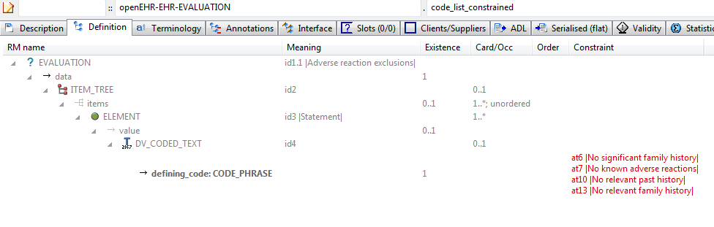

#### Code List Constrained v1 AML Diagram

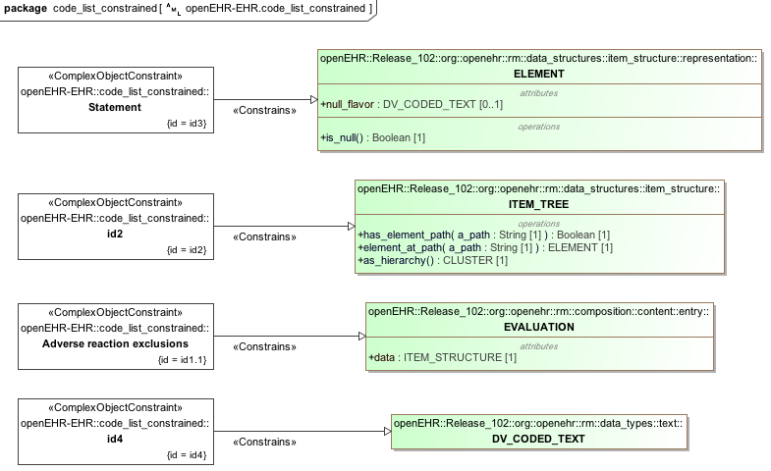

#### Code List Constrained v1 AML Associations Diagram

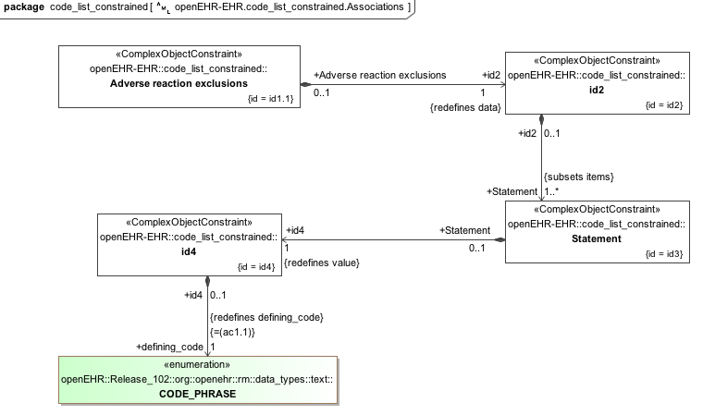

### Code List Parent v1 Example

Archetype containing a C_TERMINOLOGY_CODE list which can be further constrained in child archetypes.

#### Code List Parent v1 ADL

archetype (adl_version=2.0.5; rm_release=1.0.2)

openEHR-EHR-EVALUATION.code_list_parent.v1.0.0

language

original_language = <[ISO_639-1::en]>

description

custodian_namespace = <"org.openehr">

custodian_organisation = <"openEHR Foundation <http://www.openEHR.org>">

original_author = <

["name"] = <"Thomas Beale">

["email"] = <"thomas.beale@openEHR.org">

["organisation"] = <"openEHR Foundation <http://www.openEHR.org>">

["date"] = <"2013-02-20">

>

details = <

["en"] = <

language = <[ISO_639-1::en]>

purpose = <"Archetype containing a C_TERMINOLOGY_CODE list which can be further constrained in child archetypes.">

keywords = <"ADL", "test", "specialisation">

>

>

lifecycle_state = <"published">

other_details = <

["regression"] = <"PASS">

>

copyright = <"Copyright © 2013 openEHR Foundation <http://www.openEHR.org>">

licence = <"Creative Commons CC-BY-SA <https://creativecommons.org/licenses/by-sa/3.0/>">

definition

EVALUATION[id1] matches { -- General statement of exclusions or states

data matches {

ITEM_TREE[id2] matches {

items cardinality matches {1..*; unordered} matches {

ELEMENT[id3] occurrences matches {1..*} matches { -- Statement

value matches {

DV_CODED_TEXT[id4] matches {

defining_code matches {[ac1]} -- Statement

}

}

}

}

}

}

}

terminology

term_definitions = <

["en"] = <

["id1"] = <

text = <"General statement of exclusions or states">

description = <"A category of conditions or states which have been excluded">

>

["id3"] = <

text = <"Statement">

description = <"The statement about what is excluded">

>

["at4"] = <

text = <"No significant illness">

description = <"The person has no significant medical condition">

>

["at5"] = <

text = <"No significant past history">

description = <"The person has no significant past medical history">

>

["at6"] = <

text = <"No significant family history">

description = <"The person has no relatives with significant health problems">

>

["at7"] = <

text = <"No known adverse reactions">

description = <"The person has had no adverse reactions, including intolerances, sensitivities or allergies, to medications, food, animals or chemicals">

>

["at8"] = <

text = <"No known sensitivities">

description = <"No sensitivity to any medications, foods or substances">

>

["at9"] = <

text = <"No known intolerances">

description = <"No known or recorded intolerances to medications, foods or other substances">

>

["at10"] = <

text = <"No relevant past history">

description = <"No past problems or procedures relevant to the current situation">

>

["at11"] = <

text = <"No hospitalisations">

description = <"No admissions to hospital">

>

["at12"] = <

text = <"No major surgery">

description = <"No major operations or procedures">

>

["at13"] = <

text = <"No relevant family history">

description = <"No family history relevant to the current situation">

>

["at14"] = <

text = <"No known allergies">

description = <"No allergies known to any medications, foods or substances">

>

["ac1"] = <

text = <"Statement">

description = <"The statement about what is excluded">

>

>

>

value_sets = <

["ac1"] = <

id = <"ac1">

members = <"at4", "at5", "at6", "at7", "at10", "at13", "at14", "at11", "at12", "at8", "at9">

>

>

#### Code List Parent v1 ADL Diagram

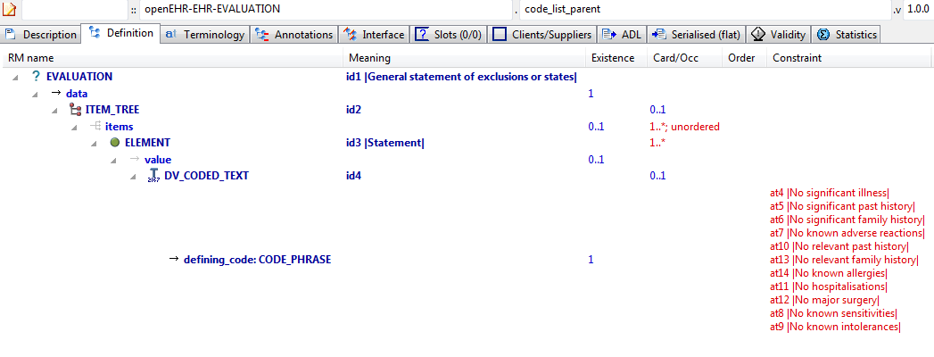

#### Code List Parent v1 AML Diagram

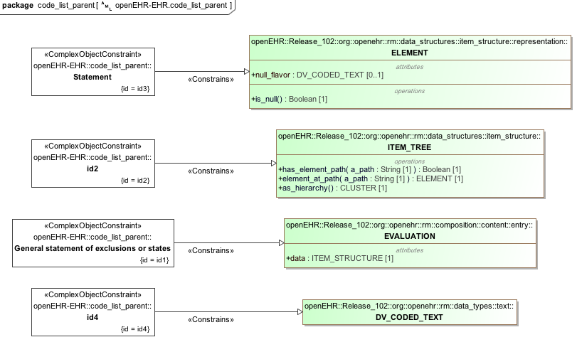

#### Code List Parent v1 AML Associations Diagram

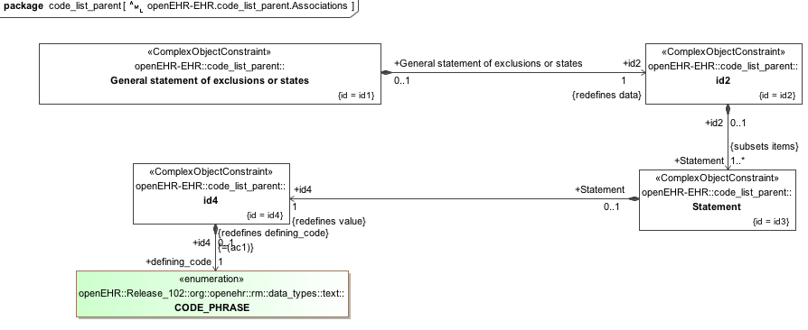

### Body Temp Narrow Dv Quantity v1 Example

Specialised archetype illustrating constraint narrowing of a DV_QUANTITY. In this example, the two logical possibilities from the parent, i.e. deg F and deg C are reduced to just the deg C constraint.

#### Body Temp Narrow Dv Quantity v1 ADL

archetype (adl_version=2.0.5; rm_release=1.0.2)

openEHR-EHR-OBSERVATION.body_temp_narrow_dv_quantity.v1.0.0

specialize

openEHR-EHR-OBSERVATION.body_temp_test.v1

language

original_language = <[ISO_639-1::en]>

description

custodian_namespace = <"org.openehr">

custodian_organisation = <"openEHR Foundation <http://www.openEHR.org>">

original_author = <

["name"] = <"Rong Chen">

["email"] = <"rong.chen@cambio.se">

["organisation"] = <"Cambio Healthcare Systems <http://www.cambio.se/>">

["date"] = <"2012-04-18">

>

details = <

["en"] = <

language = <[ISO_639-1::en]>

purpose = <"Specialised archetype illustrating constraint narrowing of a DV_QUANTITY. In this example, the two logical possibilities from the parent, i.e. deg F and deg C are reduced to just the deg C constraint.">

keywords = <"ADL", "test", "specialisation", "constraint narrowing">

>

>

lifecycle_state = <"published">

other_details = <

["regression"] = <"PASS">

>

copyright = <"Copyright © 2012 openEHR Foundation <http://www.openEHR.org>">

licence = <"Creative Commons CC-BY-SA <https://creativecommons.org/licenses/by-sa/3.0/>">

definition

OBSERVATION[id1.1] matches { -- Body temperature new GP

/data[id3]/events[id4]/data[id2]/items[id5]/value matches {

DV_QUANTITY[id61] matches {

property matches {[at57]}

[units, precision] matches {

[{"°C"}, {1}]

}

}

}

}

terminology

term_definitions = <

["en"] = <

["id1.1"] = <

text = <"Body temperature new GP">

description = <"A measurement of the body temperature, which is a surrogate for the whole body temperature of the person.">

>

>

>

#### Body Temp Narrow Dv Quantity v1 ADL Diagram

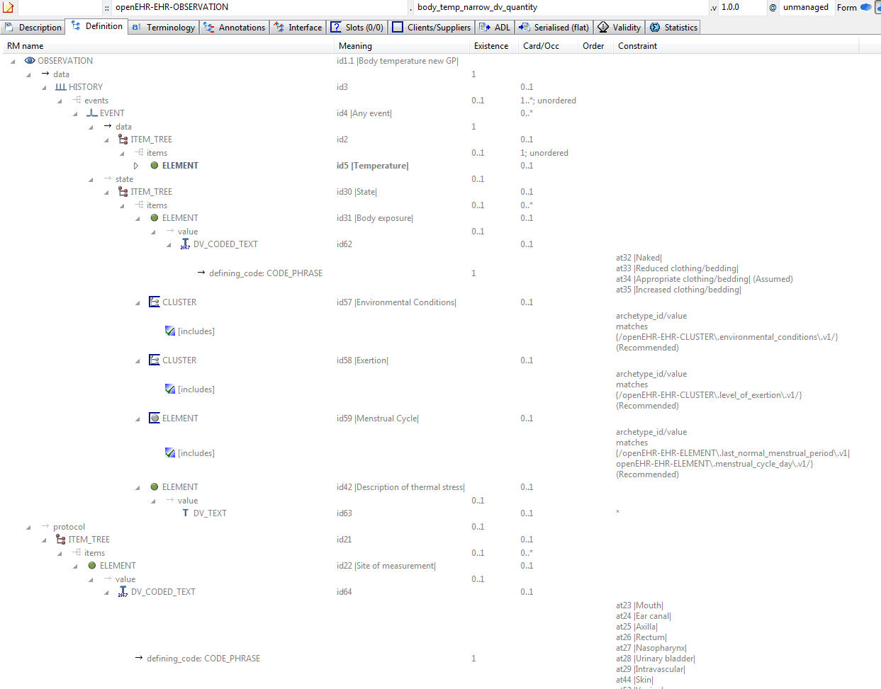

#### Body Temp Narrow Dv Quantity v1 AML Diagram

#### Body Temp Narrow Dv Quantity v1 AML Associations Diagram

### Body Temp Redefine Exist Occ Example

Specialised archetype showing the use of constraints for existence and occurrences matches {0}. These are used to remove attributes and objects respectively.

#### Body Temp Redefine Exist Occ ADL

archetype (adl_version=2.0.5; rm_release=1.0.2)

openEHR-EHR-OBSERVATION.body_temp_redefine_exist_occ.v1.0.0

specialize

openEHR-EHR-OBSERVATION.body_temp_test.v1

language

original_language = <[ISO_639-1::en]>

description

custodian_namespace = <"org.openehr">

custodian_organisation = <"openEHR Foundation <http://www.openEHR.org>">

original_author = <

["name"] = <"Rong Chen">

["email"] = <"rong.chen@cambio.se">

["organisation"] = <"Cambio Healthcare Systems <http://www.cambio.se/>">

["date"] = <"2012-04-18">

>

details = <

["en"] = <

language = <[ISO_639-1::en]>

purpose = <"Specialised archetype showing the use of constraints for existence and occurrences matches {0}. These are used to remove attributes and objects respectively.">

keywords = <"ADL", "test", "specialisation", "occurrences">

>

>

lifecycle_state = <"published">

other_details = <

["regression"] = <"PASS">

>

copyright = <"Copyright © 2012 openEHR Foundation <http://www.openEHR.org>">

licence = <"Creative Commons CC-BY-SA <https://creativecommons.org/licenses/by-sa/3.0/>">

definition

OBSERVATION[id1.1] matches { -- Body temperature new GP

/data[id3]/events[id4]/state existence matches {0}

/protocol[id21]/items matches {

allow_archetype CLUSTER[id60] occurrences matches {0}

}

}

terminology

term_definitions = <

["en"] = <

["id1.1"] = <

text = <"Body temperature new GP">

description = <"A measurement of the body temperature, which is a surrogate for the whole body temperature of the person.">

>

>

>

#### Body Temp Redefine Exist Occ ADL Diagram

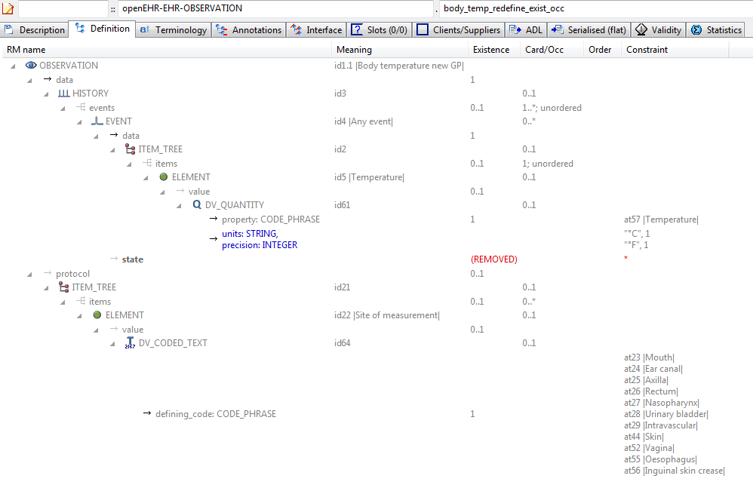

#### Body Temp Redefine Exist Occ AML Diagram

#### Body Temp Redefine Exist Occ AML Associations Diagram

### Body Temp Test v1 Example

A parent archetype for testing various child refinements, including occurrences matches {0}.

#### Body Temp Test v1 ADL

archetype (adl_version=2.0.5; rm_release=1.0.2)

openEHR-EHR-OBSERVATION.body_temp_test.v1.0.0

language

original_language = <[ISO_639-1::en]>

description

custodian_namespace = <"org.openehr">

custodian_organisation = <"openEHR Foundation <http://www.openEHR.org>">

original_author = <

["name"] = <"Thomas Beale">

["email"] = <"thomas.beale@openEHR.org">

["organisation"] = <"openEHR Foundation <http://www.openEHR.org>">

["date"] = <"2012-04-18">

>

details = <

["en"] = <

language = <[ISO_639-1::en]>

purpose = <"A parent archetype for testing various child refinements, including occurrences matches {0}.">

keywords = <"ADL", "test", "specialisation">

>

>

lifecycle_state = <"published">

other_details = <

["regression"] = <"PASS">

>

copyright = <"Copyright © 2012 openEHR Foundation <http://www.openEHR.org>">

licence = <"Creative Commons CC-BY-SA <https://creativecommons.org/licenses/by-sa/3.0/>">

definition

OBSERVATION[id1] matches { -- Body temperature

data matches {

HISTORY[id3] matches {

events cardinality matches {1..*; unordered} matches {

EVENT[id4] occurrences matches {0..*} matches { -- Any event

data matches {

ITEM_TREE[id2] matches {

items cardinality matches {1; unordered} matches {

ELEMENT[id5] matches { -- Temperature

value matches {

DV_QUANTITY[id61] matches {

property matches {[at57]}

[units, precision] matches {

[{"°C"}, {1}],

[{"°F"}, {1}]

}

}

}

}

}

}

}

state matches {

ITEM_TREE[id30] matches { -- State

items matches {

ELEMENT[id31] occurrences matches {0..1} matches { -- Body exposure

value matches {

DV_CODED_TEXT[id62] matches {

defining_code matches {[ac1; at34]} -- Body exposure

}

}

}

allow_archetype CLUSTER[id57] occurrences matches {0..1} matches { -- Environmental Conditions

include

archetype_id/value matches {/openEHR-EHR-CLUSTER\.environmental_conditions\.v1/}

}

allow_archetype CLUSTER[id58] occurrences matches {0..1} matches { -- Exertion

include

archetype_id/value matches {/openEHR-EHR-CLUSTER\.level_of_exertion\.v1/}

}

allow_archetype ELEMENT[id59] occurrences matches {0..1} matches { -- Menstrual Cycle

include

archetype_id/value matches {/openEHR-EHR-ELEMENT\.last_normal_menstrual_period\.v1|openEHR-EHR-ELEMENT\.menstrual_cycle_day\.v1/}

}

ELEMENT[id42] occurrences matches {0..1} matches { -- Description of thermal stress

value matches {

DV_TEXT[id63]

}

}

}

}

}

}

}

}

}

protocol matches {

ITEM_TREE[id21] matches {

items matches {

ELEMENT[id22] occurrences matches {0..1} matches { -- Site of measurement

value matches {

DV_CODED_TEXT[id64] matches {

defining_code matches {[ac2]} -- Site of measurement

}

}

}

allow_archetype CLUSTER[id60] occurrences matches {0..1} matches { -- Device

include

archetype_id/value matches {/openEHR-EHR-CLUSTER\.device\.v1/}

}

}

}

}

}

terminology

term_definitions = <

["en"] = <

["id1"] = <

text = <"Body temperature">

description = <"A measurement of the body temperature, which is a surrogate for the whole body temperature of the person.">

>

["id4"] = <

text = <"Any event">

description = <"Any event">

>

["id5"] = <

text = <"Temperature">

description = <"The measured body temperature (as a surrogate for the whole body).">

>

["id22"] = <

text = <"Site of measurement">

description = <"The anatomical site of measurement of the temperature.">

>

["at23"] = <

text = <"Mouth">

description = <"Temperature is measured within the mouth.">

>

["at24"] = <

text = <"Ear canal">

description = <"Temperature is measured from within the external auditory canal.">

>

["at25"] = <

text = <"Axilla">

description = <"Temperature is measured from the skin of the axilla with the arm positioned down by the side.">

>

["at26"] = <

text = <"Rectum">

description = <"Temperature measured within the rectum.">

>

["at27"] = <

text = <"Nasopharynx">

description = <"Temperature is measured within the nasopharynx.">

>

["at28"] = <

text = <"Urinary bladder">

description = <"Temperature is measured in the urinary bladder.">

>

["at29"] = <

text = <"Intravascular">

description = <"Temperature is measured within the vascular system.">

>

["id30"] = <

text = <"State">

description = <"State information about the patient.">

>

["id31"] = <

text = <"Body exposure">

description = <"The thermal situation of the person who is having the temperature taken.">

>

["at32"] = <

text = <"Naked">

description = <"No clothing, bedding or covering.">

>

["at33"] = <

text = <"Reduced clothing/bedding">

description = <"The person is covered by a lesser amount of clothing or bedding than deemed appropriate for the environmental circumstances.">

>

["at34"] = <

text = <"Appropriate clothing/bedding">

description = <"The person is covered by an amount of clothing or bedding deemed appropriate for the environmental circumstances.">

>

["at35"] = <

text = <"Increased clothing/bedding">

description = <"The person is covered by an increased amount of clothing or bedding than deemed appropriate for the environmental circumstances.">

>

["id42"] = <

text = <"Description of thermal stress">

description = <"Description of the conditions applied to the subject that might influence their measured body temperature.">

>

["at44"] = <

text = <"Skin">

description = <"Temperature is measured from exposed skin.">

>

["at52"] = <

text = <"Vagina">

description = <"Temperature is measured within the vagina.">

>

["at55"] = <

text = <"Oesophagus">

description = <"Temperatue is measured within the oesophagus.">

>

["at56"] = <

text = <"Inguinal skin crease">

description = <"Temperature is measured in the inguinal skin crease between the leg and abdominal wall.">

>

["id57"] = <

text = <"Environmental Conditions">

description = <"Details about the environmental conditions at the time of temperature measurement.">

>

["id58"] = <

text = <"Exertion">

description = <"Details about the exertion of the person at the time of temperature measurement.">

>

["id59"] = <

text = <"Menstrual Cycle">

description = <"Details about the menstrual cycle of a woman.">

>

["id60"] = <

text = <"Device">

description = <"Details about the device use to measure body temperature.">

>

["ac1"] = <

text = <"Body exposure">

description = <"The thermal situation of the person who is having the temperature taken.">

>

["ac2"] = <

text = <"Site of measurement">

description = <"The anatomical site of measurement of the temperature.">

>

["at57"] = <

text = <"Temperature">

description = <"Temperature">

>

>

>

term_bindings = <

["LNC205"] = <

["/data[id3]/events[id4]/data[id2]/items[id5]"] = <http://LNC205.org/id/8310-5>

>

["openehr"] = <

["at57"] = <http://openehr.org/id/127>

>

>

value_sets = <

["ac1"] = <

id = <"ac1">

members = <"at32", "at33", "at34", "at35">

>

["ac2"] = <

id = <"ac2">

members = <"at23", "at24", "at25", "at26", "at27", "at28", "at29", "at44", "at52", "at55", "at56">

>

>

#### Body Temp Test v1 ADL Diagram

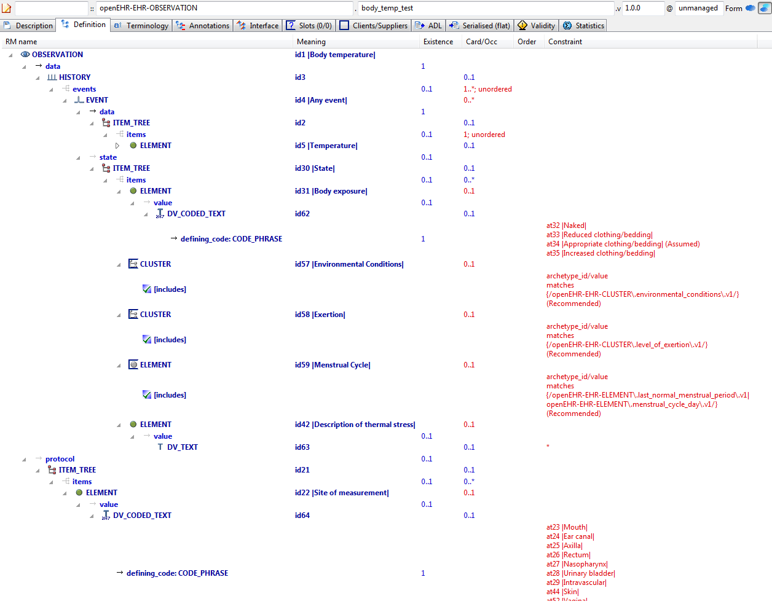

#### Body Temp Test v1 AML Diagram

#### Body Temp Test v1 AML Associations Diagram

### Ordering Added Nodes v1 Example

Example specialised archetype containing additional nodes and ordering markers within a container attribute defined in the parent. The parent container already includes member ELEMENTs, so the 'after' and 'before' markers in this descendant are used to obtain the intended overall order in the flattened result.

#### Ordering Added Nodes v1 ADL

archetype (adl_version=2.0.5; rm_release=1.0.2)

openEHR-EHR-OBSERVATION.ordering_added_nodes.v1.0.0

specialize

openEHR-EHR-OBSERVATION.spec_test_parent.v1

language

original_language = <[ISO_639-1::en]>

description

custodian_namespace = <"org.openehr">

custodian_organisation = <"openEHR Foundation <http://www.openEHR.org>">

original_author = <

["name"] = <"Thomas Beale">

["email"] = <"thomas.beale@openEHR.org">

["organisation"] = <"openEHR Foundation <http://www.openEHR.org>">

["date"] = <"2008-08-11">

>

details = <

["en"] = <

language = <[ISO_639-1::en]>

purpose = <"Example specialised archetype containing additional nodes and ordering markers within a container attribute defined in the parent. The parent container already includes member ELEMENTs, so the 'after' and 'before' markers in this descendant are used to obtain the intended overall order in the flattened result.">

keywords = <"ADL", "test", "specialisation">

>

>

lifecycle_state = <"published">

other_details = <

["regression"] = <"PASS">

>

copyright = <"Copyright © 2008 openEHR Foundation <http://www.openEHR.org>">

licence = <"Creative Commons CC-BY-SA <https://creativecommons.org/licenses/by-sa/3.0/>">

definition

OBSERVATION[id1.1] matches { -- specialisation containing ordered extension nodes

/data/events[id3]/data/items matches {

after [id5]

ELEMENT[id0.1] matches { -- Text field 2

value matches {

DV_TEXT[id0.3] -- Text field 3

}

}

ELEMENT[id0.2] matches { -- Quantity 2

value matches {

DV_QUANTITY[id0.4]

}

}

before [id8]

ELEMENT[id0.3] matches { -- Text field 3

value matches {

DV_TEXT[id0.5]

}

}

}

}

terminology

term_definitions = <

["en"] = <

["id0.1"] = <

text = <"Text field 2">

description = <"*">

>

["id0.2"] = <

text = <"Quantity 2">

description = <"*">

>

["id0.3"] = <

text = <"Text field 3">

description = <"*">

>

["id1.1"] = <

text = <"specialisation containing ordered extension nodes">

description = <"specialisation containing ordered extension nodes">

>

>

>

#### Ordering Added Nodes v1 ADL Diagram

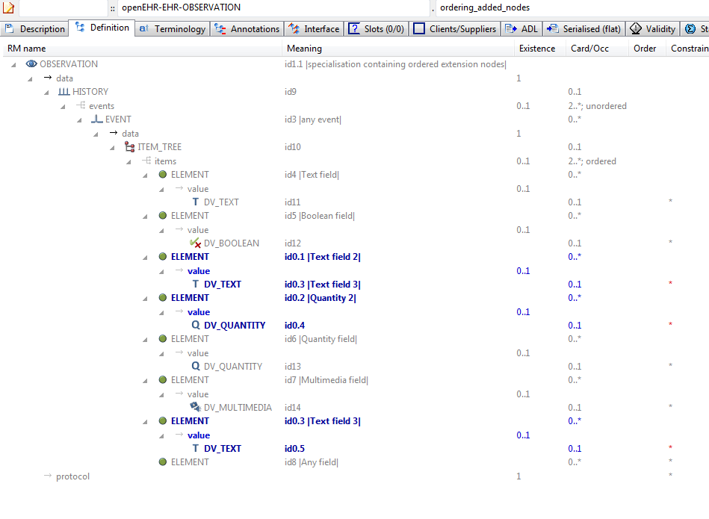

#### Ordering Added Nodes v1 AML Diagram

#### Ordering Added Nodes v1 AML Associations Diagram

### Ordering Parent - Merge Children v1 Example

Example of merging child nodes into parent in a specific order.

#### Ordering Parent - Merge Children v1 ADL

archetype (adl_version=2.0.5; rm_release=1.0.2)

openEHR-EHR-OBSERVATION.ordering_parent-merge_children.v1.0.0

specialize

openEHR-EHR-OBSERVATION.ordering_parent.v1

language

original_language = <[ISO_639-1::en]>

description

custodian_namespace = <"org.openehr">

custodian_organisation = <"openEHR Foundation <http://www.openEHR.org>">

original_author = <

["name"] = <"Sam Heard">

["organisation"] = <"Ocean Informatics, United Kingdom">

["email"] = <"sam.heard@oceaninformatics.com">

["date"] = <"07/11/2009">

>

details = <

["en"] = <

language = <[ISO_639-1::en]>

purpose = <"Example of merging child nodes into parent in a specific order.">

>

>

lifecycle_state = <"published">

other_details = <

["regression"] = <"PASS">

>

copyright = <"Copyright © 2009 openEHR Foundation <http://www.openEHR.org>">

licence = <"Creative Commons CC-BY-SA <https://creativecommons.org/licenses/by-sa/3.0/>">

definition

OBSERVATION[id1.1] matches { -- Blood matching

/data[id2]/events[id3]/data[id4]/items matches {

ELEMENT[id10]

ELEMENT[id10.1] occurrences matches {0..1} matches { -- Rhesus

value matches {

DV_TEXT[id0.11]

}

}

ELEMENT[id10.2] occurrences matches {0..1} matches { -- ABO

value matches {

DV_TEXT[id0.12]

}

}

ELEMENT[id0.1] occurrences matches {0..1} matches { -- Antibodies detected

value matches {

DV_BOOLEAN[id0.13]

}

}

before [id12]

CLUSTER[id0.2] occurrences matches {0..1} -- Antibodies

}

}

terminology

term_definitions = <

["en"] = <

["id1.1"] = <

text = <"Blood matching">

description = <"Blood group information including ABO, Rhesus and antibodies etc.">

>

["id0.1"] = <

text = <"Antibodies detected">

description = <"Antibodies have been detected.">

>

["id0.2"] = <

text = <"Antibodies">

description = <"Group of findings relating to one antibody.">

>

["id10.1"] = <

text = <"Rhesus">

description = <"Rhesus blood group information.">

>

["id10.2"] = <

text = <"ABO">

description = <"ABO blood group information.">

>

>

>

#### Ordering Parent - Merge Children v1 ADL Diagram

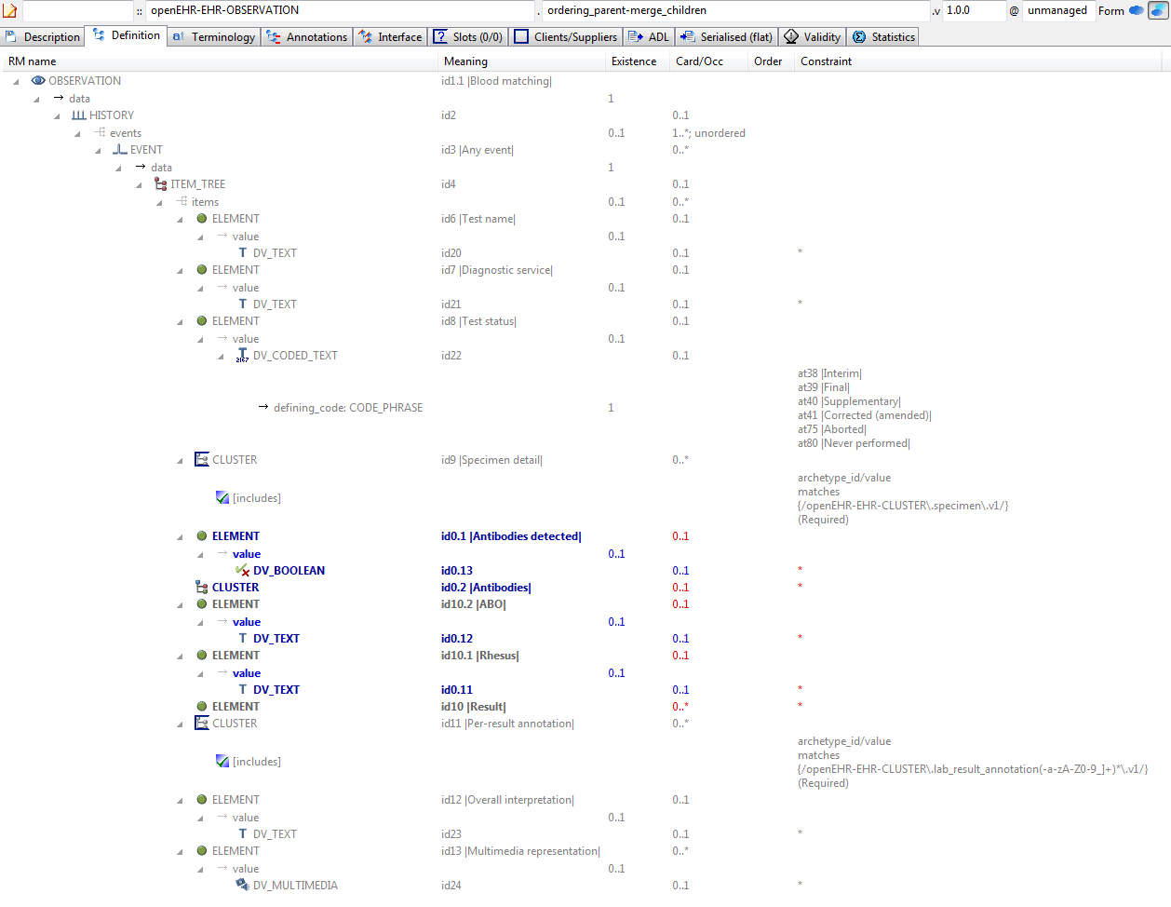

#### Ordering Parent - Merge Children v1 AML Diagram

#### Ordering Parent - Merge Children v1 AML Associations Diagram

### Ordering Parent v1 Example

Parent for child that redefines and adds nodes, marked for a certain location in flat, using 'before' keyword.

#### Ordering Parent v1 ADL

archetype (adl_version=2.0.5; rm_release=1.0.2)

openEHR-EHR-OBSERVATION.ordering_parent.v1.0.0

language

original_language = <[ISO_639-1::en]>

description

custodian_namespace = <"org.openehr">

custodian_organisation = <"openEHR Foundation <http://www.openEHR.org>">

original_author = <

["name"] = <"Dr Ian McNicoll">

["organisation"] = <"Ocean Informatics UK <http://www.oceaninformatics.com>">

["email"] = <"ian.mcnicoll@oceaninformatics.com">

["date"] = <"2009-11-07">

>

details = <

["en"] = <

language = <[ISO_639-1::en]>

purpose = <"Parent for child that redefines and adds nodes, marked for a certain location in flat, using 'before' keyword.">

keywords = <"ADL", "test", "specialisation">

>

>

lifecycle_state = <"published">

other_details = <

["regression"] = <"PASS">

>

copyright = <"Copyright © 2009 openEHR Foundation <http://www.openEHR.org>">

licence = <"Creative Commons CC-BY-SA <https://creativecommons.org/licenses/by-sa/3.0/>">

definition

OBSERVATION[id1] matches { -- Laboratory test

data matches {

HISTORY[id2] matches {

events cardinality matches {1..*; unordered} matches {

EVENT[id3] occurrences matches {0..*} matches { -- Any event

data matches {

ITEM_TREE[id4] matches {

items matches {

ELEMENT[id6] occurrences matches {0..1} matches { -- Test name

value matches {

DV_TEXT[id20]

}

}

ELEMENT[id7] occurrences matches {0..1} matches { -- Diagnostic service

value matches {

DV_TEXT[id21]

}

}

ELEMENT[id8] occurrences matches {0..1} matches { -- Test status

value matches {

DV_CODED_TEXT[id22] matches {

defining_code matches {[ac1]} -- Test status (synthesised)

}

}

}

allow_archetype CLUSTER[id9] occurrences matches {0..*} matches { -- Specimen detail

include

archetype_id/value matches {/openEHR-EHR-CLUSTER\.specimen\.v1/}

exclude

archetype_id/value matches {/.*/}

}

ITEM[id10] occurrences matches {0..*} -- Result

allow_archetype CLUSTER[id11] occurrences matches {0..*} matches { -- Per-result annotation

include

archetype_id/value matches {/openEHR-EHR-CLUSTER\.lab_result_annotation(-a-zA-Z0-9_]+)*\.v1/}

exclude

archetype_id/value matches {/.*/}

}

ELEMENT[id12] occurrences matches {0..1} matches { -- Overall interpretation

value matches {

DV_TEXT[id23]

}

}

ELEMENT[id13] occurrences matches {0..*} matches { -- Multimedia representation

value matches {

DV_MULTIMEDIA[id24]

}

}

}

}

}

}

}

}

}

}

terminology

term_definitions = <

["en"] = <

["id1"] = <

text = <"Laboratory test">

description = <"To record the result of a laboratory test which may be used to record a single valued test but will often be specialised or templated to represent multiple value or 'panel' tests.

This archetype also acts as the parent for specialisations appropriate for more specific laboratory tests microbiology, histopathology.">

>

["id3"] = <

text = <"Any event">

description = <"Any event.">

>

["id6"] = <

text = <"Test name">

description = <"Specific identifier for this lab test. e.g. Full blood count , blood glucose, urine microbiology. May equate to the result name for a single value result. Commonly a coded term e.g from LOINC or SNOMED-CT.">

>

["id7"] = <

text = <"Diagnostic service">

description = <"The type of high-level diagnostic service e.g. biochemistry, haematology.">

>

["id8"] = <

text = <"Test status">

description = <"The status of the lab test as a whole.">

>

["id9"] = <

text = <"Specimen detail">

description = <"Details of the specimen being reported where all individual results are derived from the same specimen.">

>

["id10"] = <

text = <"Result">

description = <"The result of the test.">

>

["id11"] = <

text = <"Per-result annotation">

description = <"Slot to allow an annotation to be added to a particular test result at run-time.">

>

["id12"] = <

text = <"Overall interpretation">

description = <"An overall interpretative comment on this test.">

>

["id13"] = <

text = <"Multimedia representation">

description = <"Representations of the whole test in mutlimedia e.g image, audio, video.">

>

["ac1"] = <

text = <"Test status (synthesised)">

description = <"The status of the lab test as a whole. (synthesised)">

>

["at38"] = <

text = <"Interim">

description = <"This is an initial or interim result - further updates are anticipated.">

>

["at39"] = <

text = <"Final">

description = <"This is the final result. No further alterations are anticipated.">

>

["at40"] = <

text = <"Supplementary">

description = <"This is a supplementary result ehich should be appended to a previous result.">

>

["at41"] = <

text = <"Corrected (amended)">

description = <"This is a correction which should completely replace any previous results.">

>

["at75"] = <

text = <"Aborted">

description = <"The test was aborted and never completed.">

>

["at80"] = <

text = <"Never performed">

description = <"The test was never performed.">

>

>

>

value_sets = <

["ac1"] = <

id = <"ac1">

members = <"at38", "at39", "at40", "at41", "at75", "at80">

>

>

#### Ordering Parent v1 ADL Diagram

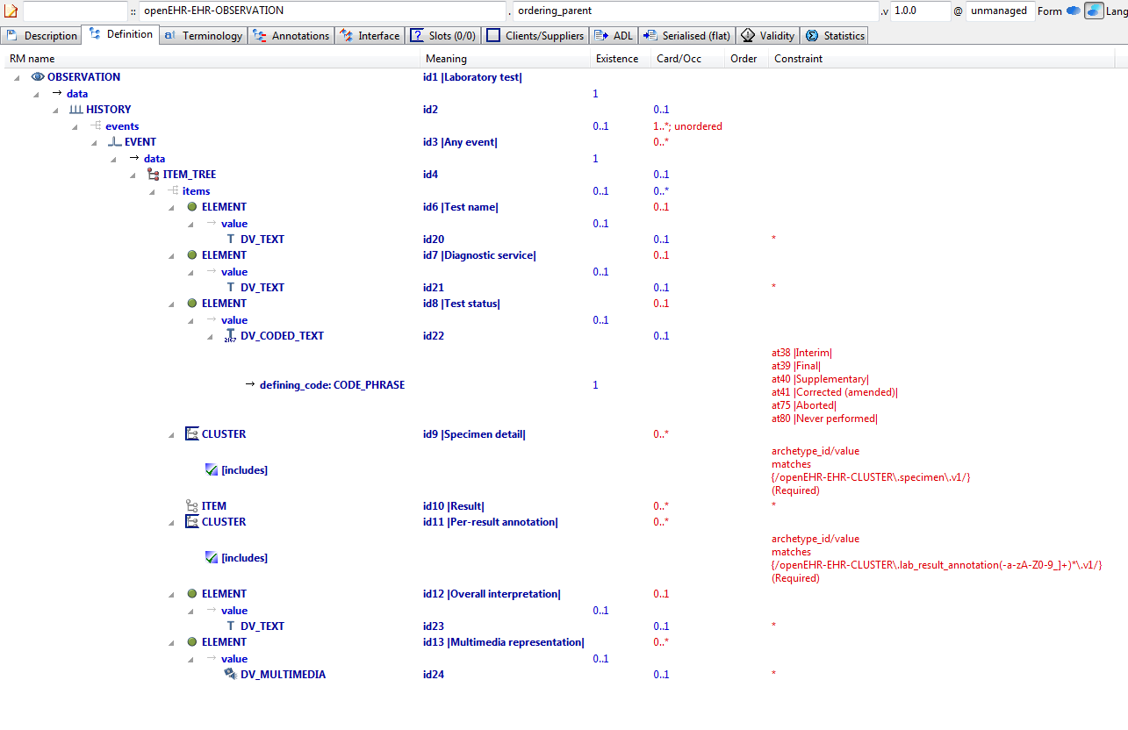

#### Ordering Parent v1 AML Diagram

#### Ordering Parent v1 AML Associations Diagram

### Redefine 1 Value v1 Example

Example of redefinition of a value set into a narrower subset of the original.

#### Redefine 1 Value v1 ADL

archetype (adl_version=2.0.5; rm_release=1.0.2)

openEHR-EHR-OBSERVATION.redefine_1_value.v1.0.0

specialize

openEHR-EHR-OBSERVATION.spec_test_parent.v1

language

original_language = <[ISO_639-1::en]>

description

custodian_namespace = <"org.openehr">

custodian_organisation = <"openEHR Foundation <http://www.openEHR.org>">

original_author = <

["name"] = <"Thomas Beale">

["email"] = <"thomas.beale@openEHR.org">

["organisation"] = <"openEHR Foundation <http://www.openEHR.org>">

["date"] = <"2008-08-11">

>

details = <

["en"] = <

language = <[ISO_639-1::en]>

purpose = <"Example of redefinition of a value set into a narrower subset of the original.">

keywords = <"ADL", "test", "specialisation">

>

>

lifecycle_state = <"published">

other_details = <

["regression"] = <"PASS">

>

copyright = <"Copyright © 2008 openEHR Foundation <http://www.openEHR.org>">

licence = <"Creative Commons CC-BY-SA <https://creativecommons.org/licenses/by-sa/3.0/>">

definition

OBSERVATION[id1.1] matches { -- first level specialisation archetype

/data/events[id3]/data/items matches {

ELEMENT[id4.1] matches { -- Redefined text field

value matches {

DV_CODED_TEXT[id0.6] matches {

defining_code matches {[ac0.1]} -- (added by post-parse processor)

}

}

}

}

}

terminology

term_definitions = <

["en"] = <

["at0.1"] = <

text = <"internal code A">

description = <"internal code A description">

>

["at0.2"] = <

text = <"internal code B">

description = <"internal code B description">

>

["id1.1"] = <

text = <"first level specialisation archetype">

description = <"first level specialisation test archetype">

>

["id4.1"] = <

text = <"Redefined text field">

description = <"redefined text field">

>

["ac0.1"] = <

text = <"(added by post-parse processor)">

description = <"(added by post-parse processor)">

>

>

>

value_sets = <

["ac0.1"] = <

id = <"ac0.1">

members = <"at0.1", "at0.2">

>

>

#### Redefine 1 Value v1 ADL Diagram

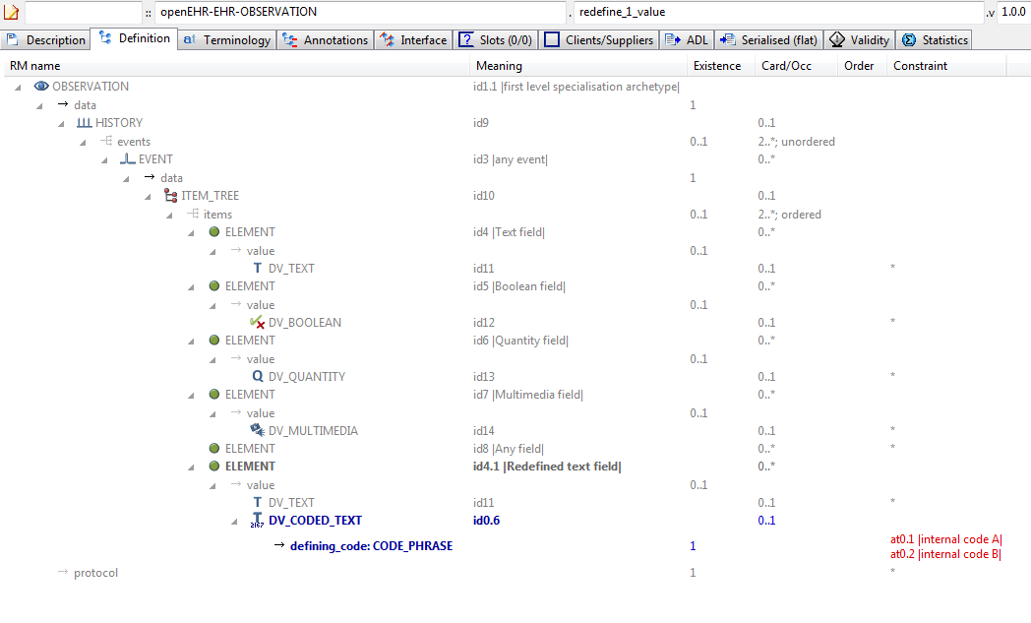

#### Redefine 1 Value v1 AML Diagram

#### Redefine 1 Value v1 AML Associations Diagram

### Redefine Cardinality v1 Example

Example showing narrowing of cardinality in specialised archetype. The narrower cardinality replaces the cardinality from the parent in the computed flat form.

#### Redefine Cardinality v1 ADL

archetype (adl_version=2.0.5; rm_release=1.0.2)

openEHR-EHR-OBSERVATION.redefine_cardinality.v1.0.0

specialize

openEHR-EHR-OBSERVATION.spec_test_parent.v1

language

original_language = <[ISO_639-1::en]>

description

custodian_namespace = <"org.openehr">

custodian_organisation = <"openEHR Foundation <http://www.openEHR.org>">

original_author = <

["name"] = <"Thomas Beale">

["email"] = <"thomas.beale@openEHR.org">

["organisation"] = <"openEHR Foundation <http://www.openEHR.org>">

["date"] = <"2008-08-11">

>

details = <

["en"] = <

language = <[ISO_639-1::en]>

purpose = <"Example showing narrowing of cardinality in specialised archetype. The narrower cardinality replaces the cardinality from the parent in the computed flat form.">

keywords = <"ADL", "test", "specialisation", "cardinality">

>

>

lifecycle_state = <"published">

other_details = <

["regression"] = <"PASS">

>

copyright = <"Copyright © 2008 openEHR Foundation <http://www.openEHR.org>">

licence = <"Creative Commons CC-BY-SA <https://creativecommons.org/licenses/by-sa/3.0/>">

definition

OBSERVATION[id1.1] matches { -- specialised archetype

/data/events cardinality matches {2..8; ordered}

}

terminology

term_definitions = <

["en"] = <

["id1.1"] = <

text = <"specialised archetype">

description = <"">

>

>

>

#### Redefine Cardinality v1 ADL Diagram

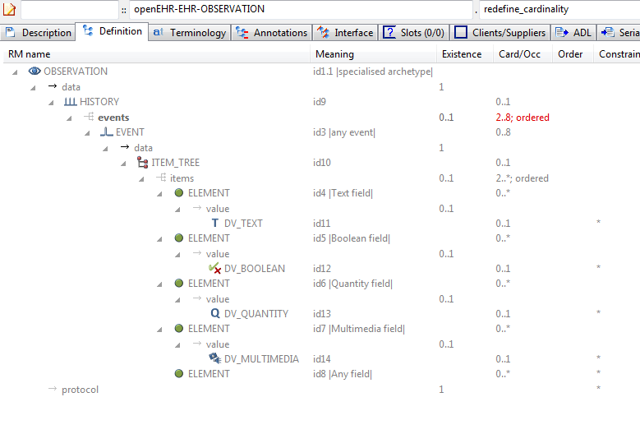

#### Redefine Cardinality v1 AML Diagram

#### Redefine Cardinality v1 AML Associations Diagram

### Redefine Node To Clones v1 Example

Example of redefinition of a single node into multiple clones. Each of the ELEMENT[id8.x] nodes is a distinct clone of the ELEMENT[id8] node from the parent archetype.

#### Redefine Node To Clones v1 ADL

archetype (adl_version=2.0.5; rm_release=1.0.2)

openEHR-EHR-OBSERVATION.redefine_node_to_clones.v1.0.0

specialize

openEHR-EHR-OBSERVATION.spec_test_parent.v1

language

original_language = <[ISO_639-1::en]>

description

custodian_namespace = <"org.openehr">

custodian_organisation = <"openEHR Foundation <http://www.openEHR.org>">

original_author = <

["name"] = <"Thomas Beale">

["email"] = <"thomas.beale@openEHR.org">

["organisation"] = <"openEHR Foundation <http://www.openEHR.org>">

["date"] = <"2008-08-11">

>

details = <

["en"] = <

language = <[ISO_639-1::en]>

purpose = <"Example of redefinition of a single node into multiple clones. Each of the ELEMENT[id8.x] nodes is a distinct clone of the ELEMENT[id8] node from the parent archetype.">

keywords = <"ADL", "test", "specialisation">

>

>

lifecycle_state = <"published">

other_details = <

["regression"] = <"PASS">

>

copyright = <"Copyright © 2008 openEHR Foundation <http://www.openEHR.org>">

licence = <"Creative Commons CC-BY-SA <https://creativecommons.org/licenses/by-sa/3.0/>">

definition

OBSERVATION[id1.1] matches { -- multi-level redefinition archetype

/data/events[id3]/data/items matches {

ELEMENT[id8.1] matches { -- 1st redefine of at0007 node

value matches {

DV_QUANTITY[id0.7]

}

}

ELEMENT[id8.2] matches { -- 2nd redefine of at0007 node

value matches {

DV_QUANTITY[id0.8]

}

}

ELEMENT[id8.3] matches { -- 3rd redefine of at0007 node

value matches {

DV_QUANTITY[id0.9]

}

}

}

}

terminology

term_definitions = <

["en"] = <

["id1.1"] = <

text = <"multi-level redefinition archetype">

description = <"specialisation containing multiple redefine of a single parent node">

>

["id8.1"] = <

text = <"1st redefine of at0007 node">

description = <"1st redefine of at0007 node">

>

["id8.2"] = <

text = <"2nd redefine of at0007 node">

description = <"1st redefine of at0007 node">

>

["id8.3"] = <

text = <"3rd redefine of at0007 node">

description = <"1st redefine of at0007 node">

>

>

>

#### Redefine Node To Clones v1 ADL Diagram

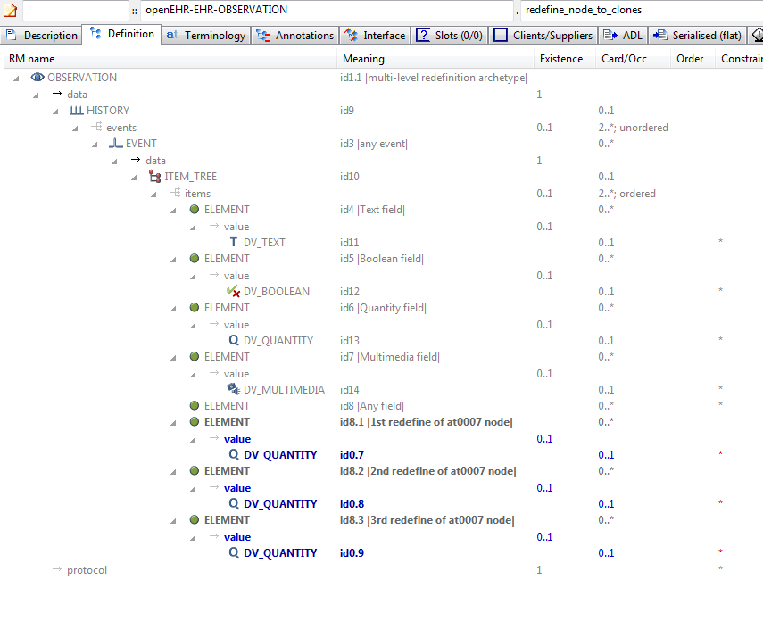

#### Redefine Node To Clones v1 AML Diagram

#### Redefine Node To Clones v1 AML Associations Diagram

### Redefine Occurrences v1 Example

Example of refinement of occurrences to {0..1} from {0..*}.

#### Redefine Occurrences v1 ADL

archetype (adl_version=2.0.5; rm_release=1.0.2)

openEHR-EHR-OBSERVATION.redefine_occurrences.v1.0.0

specialise

openEHR-EHR-OBSERVATION.spec_test_parent.v1

language

original_language = <[ISO_639-1::en]>

description

custodian_namespace = <"org.openehr">

custodian_organisation = <"openEHR Foundation <http://www.openEHR.org>">

original_author = <

["name"] = <"Thomas Beale">

["email"] = <"thomas.beale@openEHR.org">

["organisation"] = <"openEHR Foundation <http://www.openEHR.org>">

["date"] = <"2008-08-11">

>

details = <

["en"] = <

language = <[ISO_639-1::en]>

purpose = <"Example of refinement of occurrences to {0..1} from {0..*}.">

keywords = <"ADL", "test", "specialisation">

>

>

lifecycle_state = <"published">

other_details = <

["regression"] = <"PASS">

>

copyright = <"Copyright © 2008 openEHR Foundation <http://www.openEHR.org>">

licence = <"Creative Commons CC-BY-SA <https://creativecommons.org/licenses/by-sa/3.0/>">

definition

OBSERVATION[id1.1] matches {

/data[id9]/events matches {

EVENT[id3.1] occurrences matches {0..1}

}

}

ontology

term_definitions = <

["en"] = <

["id1.1"] = <

text = <"specialised archetype">

description = <"">

>

["id3.1"] = <

text = <"any event - occurrences specialised">

description = <"">

>

>

>

#### Redefine Occurrences v1 ADL Diagram

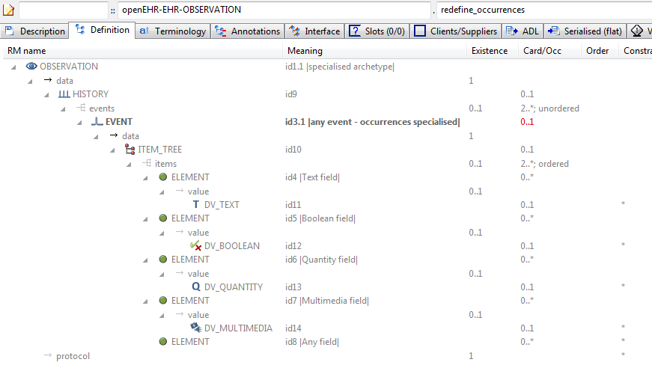

#### Redefine Occurrences v1 AML Diagram

#### Redefine Occurrences v1 AML Associations Diagram

### Spec Test Obs v1 Example

Test OBSERVATION specialisation parent archetype.

#### Spec Test Obs v1 ADL

archetype (adl_version=2.0.5; rm_release=1.0.2)

openEHR-EHR-OBSERVATION.spec_test_obs.v1.0.0

language

original_language = <[ISO_639-1::en]>

description

custodian_namespace = <"org.openehr">

custodian_organisation = <"openEHR Foundation <http://www.openEHR.org>">

original_author = <

["name"] = <"Thomas Beale">

["email"] = <"thomas.beale@openEHR.org">

["organisation"] = <"openEHR Foundation <http://www.openEHR.org>">

["date"] = <"2008-08-11">

>

details = <

["en"] = <

language = <[ISO_639-1::en]>

purpose = <"Test OBSERVATION specialisation parent archetype.">

keywords = <"ADL", "test", "specialisation">

>

>

lifecycle_state = <"published">

other_details = <

["regression"] = <"PASS">

>

copyright = <"Copyright © 2008 openEHR Foundation <http://www.openEHR.org>">

licence = <"Creative Commons CC-BY-SA <https://creativecommons.org/licenses/by-sa/3.0/>">

definition

OBSERVATION[id1] matches { -- top-level archetype

data matches {

HISTORY[id9] matches {

events cardinality matches {2..*; unordered} matches {

EVENT[id3] matches { -- any event

data matches {

ITEM_TREE[id10] matches {

items cardinality matches {2..*; ordered} matches {

ELEMENT[id4] matches { -- Text field

value matches {

DV_TEXT[id11]

}

}

ELEMENT[id5] matches { -- Boolean field

value matches {

DV_BOOLEAN[id12]

}

}

ELEMENT[id6] matches { -- Quantity field

value matches {

DV_QUANTITY[id13]

}

}

ELEMENT[id7] matches { -- Multimedia field

value matches {

DV_MULTIMEDIA[id14]

}

}

ELEMENT[id8] -- Any field

}

}

}

}

}

}

}

protocol existence matches {1}

}

terminology

term_definitions = <

["en"] = <

["id1"] = <

text = <"top-level archetype">

description = <"top level test archetype for specialisation lineage">

>

["id3"] = <

text = <"any event">

description = <"*">

>

["id4"] = <

text = <"Text field">

description = <"test text field">

>

["id5"] = <

text = <"Boolean field">

description = <"test boolean field">

>

["id6"] = <

text = <"Quantity field">

description = <"test quantity field">

>

["id7"] = <

text = <"Multimedia field">

description = <"test multimedia field">

>

["id8"] = <

text = <"Any field">

description = <"test any-value field">

>

>

>

#### Spec Test Obs v1 ADL Diagram

#### Spec Test Obs v1 AML Diagram

#### Spec Test Obs v1 AML Associations Diagram

### Spec Test Parent v1 Example

Test OBSERVATION specialisation parent archetype.

#### Spec Test Parent v1 ADL

archetype (adl_version=2.0.5; rm_release=1.0.2)

openEHR-EHR-OBSERVATION.spec_test_parent.v1.0.0

language

original_language = <[ISO_639-1::en]>

description

original_author = <

["organisation"] = <"Ocean Informatics">

["name"] = <"Thomas Beale">

["date"] = <"11/8/2008">

>

details = <

["en"] = <

language = <[ISO_639-1::en]>

purpose = <"Test OBSERVATION specialisation parent archetype.">

>

>

lifecycle_state = <"unmanaged">

other_details = <

["regression"] = <"PASS">

>

definition

OBSERVATION[id1] matches { -- top-level archetype

data matches {

HISTORY[id9] matches {

events cardinality matches {2..*; unordered} matches {

EVENT[id3] matches { -- any event

data matches {

ITEM_TREE[id10] matches {

items cardinality matches {2..*; ordered} matches {

ELEMENT[id4] matches { -- Text field

value matches {

DV_TEXT[id11]

}

}

ELEMENT[id5] matches { -- Boolean field

value matches {

DV_BOOLEAN[id12]

}

}

ELEMENT[id6] matches { -- Quantity field

value matches {

DV_QUANTITY[id13]

}

}

ELEMENT[id7] matches { -- Multimedia field

value matches {

DV_MULTIMEDIA[id14]

}

}

ELEMENT[id8] -- Any field

}

}

}

}

}

}

}

protocol existence matches {1}

}

terminology

term_definitions = <

["en"] = <

["id1"] = <

text = <"top-level archetype">

description = <"top level test archetype for specialisation lineage">

>

["id3"] = <

text = <"any event">

description = <"*">

>

["id4"] = <

text = <"Text field">

description = <"test text field">

>

["id5"] = <

text = <"Boolean field">

description = <"test boolean field">

>

["id6"] = <

text = <"Quantity field">

description = <"test quantity field">

>

["id7"] = <

text = <"Multimedia field">

description = <"test multimedia field">

>

["id8"] = <

text = <"Any field">

description = <"test any-value field">

>

>

>

#### Spec Test Parent v1 ADL Diagram

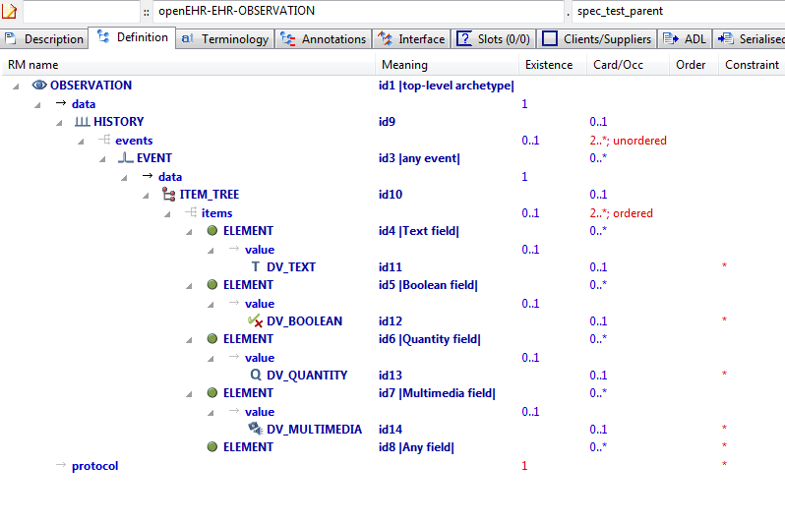

#### Spec Test Parent v1 AML Diagram

#### Spec Test Parent v1 AML Associations Diagram

### Tuple Parent v1 Example

Example archetype containing tuple constraints for the types DV_QUANTITY and DV_ORDINAL.

#### Tuple Parent v1 ADL

archetype (adl_version=2.0.5; rm_release=1.0.2)

openEHR-EHR-OBSERVATION.tuple_parent.v1.0.0

language

original_language = <[ISO_639-1::en]>

description

custodian_namespace = <"org.openehr">

custodian_organisation = <"openEHR Foundation <http://www.openEHR.org>">

original_author = <

["name"] = <"Thomas Beale">

["email"] = <"thomas.beale@openEHR.org">

["organisation"] = <"openEHR Foundation <http://www.openEHR.org>">

["date"] = <"2014-02-28">

>

details = <

["en"] = <

language = <[ISO_639-1::en]>

purpose = <"Example archetype containing tuple constraints for the types DV_QUANTITY and DV_ORDINAL.">

keywords = <"ADL", "test", "specialisation", "tuples">

>

>

lifecycle_state = <"published">

other_details = <

["regression"] = <"PASS">

>

copyright = <"Copyright © 2014 openEHR Foundation <http://www.openEHR.org>">

licence = <"Creative Commons CC-BY-SA <https://creativecommons.org/licenses/by-sa/3.0/>">

definition

OBSERVATION[id1] matches { -- Intravascular pressure

data matches {

HISTORY[id2] matches {

events cardinality matches {1..*; unordered} matches {

EVENT[id3] occurrences matches {0..*} matches { -- Any event

data matches {

ITEM_TREE[id4] matches {

items cardinality matches {1; ordered} matches {

ELEMENT[id6] occurrences matches {0..1} matches { -- Pressure

value matches {

DV_QUANTITY[id42] matches {

property matches {[at29]}

[magnitude, units, precision] matches {

[{|>=0.0|}, {"mm[Hg]"}, {2}],

[{|>=0.0|}, {"cm[H20]"}, {2}]

}

}

}

}

ELEMENT[id16] occurrences matches {0..1} matches { -- Ordinal

value matches {

DV_ORDINAL[id43] matches {

[value, symbol] matches {

[{0}, {[at17]}],

[{2}, {[at18]}],

[{4}, {[at19]}],

[{6}, {[at20]}],

[{8}, {[at21]}]

}

}

}

}

}

}

}

}

}

}

}

}

terminology

term_definitions = <

["en"] = <

["id1"] = <

text = <"Intravascular pressure">

description = <"The pressure in a specific location, blood vessel or heart cavity, at a specific phase of the heart or an average over the heart cycle.">

>

["id3"] = <

text = <"Any event">

description = <"Generic event.">

>

["id6"] = <

text = <"Pressure">

description = <"The mean pressure measured.">

>

["id16"] = <

text = <"Ordinal">

description = <"Ordinal value.">

>

["at17"] = <

text = <"Markedly reduced">

description = <"The pressure is much lower than normal or expected.">

>

["at18"] = <

text = <"Lowered">

description = <"The pressure is reduced.">

>

["at19"] = <

text = <"Normal/expected">

description = <"The pressure is normal or as expected.">

>

["at20"] = <

text = <"raised">

description = <"The pressure is raised.">

>

["at21"] = <

text = <"Markedly increased">

description = <"The pressure is much higher than normal or expected.">

>

["at29"] = <

text = <"Pressure">

description = <"Pressure">

>

["ac1"] = <

text = <"Ordinal (synthesised)">

description = <"Ordinal value. (synthesised)">

>

>

>

term_bindings = <

["openehr"] = <

["at29"] = <http://openehr.org/id/125>

>

>

value_sets = <

["ac1"] = <

id = <"ac1">

members = <"at17", "at18", "at19", "at20", "at21">

>

>

#### Tuple Parent v1 ADL Diagram

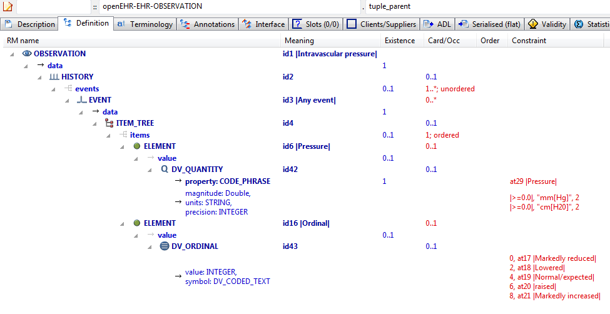

#### Tuple Parent v1 AML Diagram

#### Tuple Parent v1 AML Associations Diagram

### Tuple Redefine To Narrower v1 Example

Illustrate redefinition of tuple to narrower tuple.

#### Tuple Redefine To Narrower v1 ADL

archetype (adl_version=2.0.5; rm_release=1.0.2)

openEHR-EHR-OBSERVATION.tuple_redefine_to_narrower.v1.0.0

specialize

openEHR-EHR-OBSERVATION.tuple_parent.v1

language

original_language = <[ISO_639-1::en]>

description

custodian_namespace = <"org.openehr">

custodian_organisation = <"openEHR Foundation <http://www.openEHR.org>">

original_author = <

["name"] = <"Thomas Beale">

["email"] = <"thomas.beale@openEHR.org">

["organisation"] = <"openEHR Foundation <http://www.openEHR.org>">

["date"] = <"2014-02-28">

>

details = <

["en"] = <

language = <[ISO_639-1::en]>

purpose = <"Illustrate redefinition of tuple to narrower tuple.">

keywords = <"ADL", "test", "specialisation", "tuples">

>

>

lifecycle_state = <"published">

other_details = <

["regression"] = <"PASS">

>

copyright = <"Copyright © 2014 openEHR Foundation <http://www.openEHR.org>">

licence = <"Creative Commons CC-BY-SA <https://creativecommons.org/licenses/by-sa/3.0/>">

definition

OBSERVATION[id1.1] matches { -- Intravascular pressure redefined

/data[id2]/events[id3]/data[id4]/items[id16]/value matches {

DV_ORDINAL[id43] matches {

[value, symbol] matches {

[{0}, {[at17]}],

[{6}, {[at20]}],

[{8}, {[at21]}]

}

}

}

}

terminology

term_definitions = <

["en"] = <

["id1.1"] = <

text = <"Intravascular pressure redefined">

description = <"The pressure in a specific location, blood vessel or heart cavity, at a specific phase of the heart or an average over the heart cycle.">

>

["ac0.1"] = <

text = <"Intravascular pressure redefined (synthesised)">

description = <"The pressure in a specific location, blood vessel or heart cavity, at a specific phase of the heart or an average over the heart cycle. (synthesised)">

>

>

>

value_sets = <

["ac0.1"] = <

id = <"ac0.1">

members = <"at17", "at20", "at21">

>

>

#### Tuple Redefine To Narrower v1 ADL Diagram

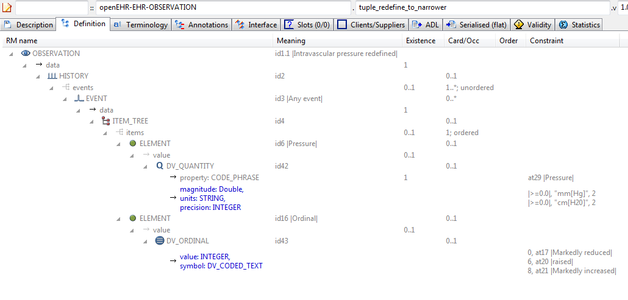

#### Tuple Redefine To Narrower v1 AML Diagram

#### Tuple Redefine To Narrower v1 AML Associations Diagram

### Tuple Redefine To Single v1 Example

Illustrate redefinition of tuple to narrower tuple consisting of one item only.

#### Tuple Redefine To Single v1 ADL

archetype (adl_version=2.0.5; rm_release=1.0.2)

openEHR-EHR-OBSERVATION.tuple_redefine_to_single.v1.0.0

specialize

openEHR-EHR-OBSERVATION.tuple_parent.v1

language

original_language = <[ISO_639-1::en]>

description

custodian_namespace = <"org.openehr">

custodian_organisation = <"openEHR Foundation <http://www.openEHR.org>">

original_author = <

["name"] = <"Thomas Beale">

["email"] = <"thomas.beale@openEHR.org">

["organisation"] = <"openEHR Foundation <http://www.openEHR.org>">

["date"] = <"2014-02-28">

>

details = <

["en"] = <

language = <[ISO_639-1::en]>

purpose = <"Illustrate redefinition of tuple to narrower tuple consisting of one item only.">

keywords = <"ADL", "test", "specialisation", "tuple">

>

>

lifecycle_state = <"published">

other_details = <

["regression"] = <"PASS">

>

copyright = <"Copyright © 2014 openEHR Foundation <http://www.openEHR.org>">

licence = <"Creative Commons CC-BY-SA <https://creativecommons.org/licenses/by-sa/3.0/>">

definition

OBSERVATION[id1.1] matches { -- Intravascular pressure redefined

/data[id2]/events[id3]/data[id4]/items[id6]/value matches {

DV_QUANTITY[id42] matches {

[magnitude, units, precision] matches {

[{|>=0.0|}, {"cm[H20]"}, {2}]

}

}

}

}

terminology

term_definitions = <

["en"] = <

["id1.1"] = <

text = <"Intravascular pressure redefined">

description = <"The pressure in a specific location, blood vessel or heart cavity, at a specific phase of the heart or an average over the heart cycle.">

>

>

>

#### Tuple Redefine To Single v1 ADL Diagram

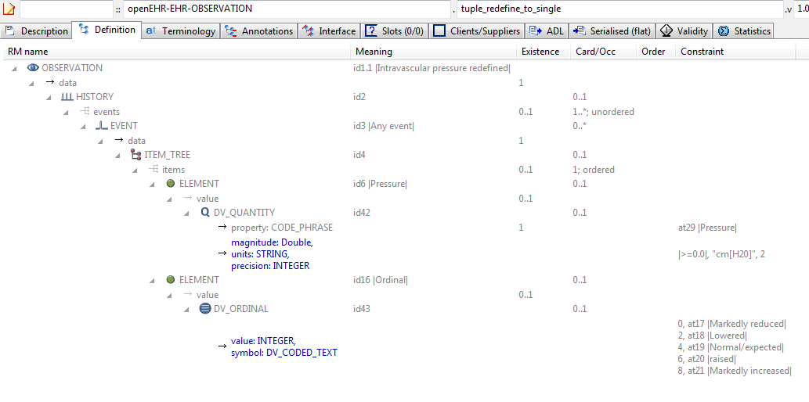

#### Tuple Redefine To Single v1 AML Diagram

#### Tuple Redefine To Single v1 AML Associations Diagram

### Section Parent v1 Example

To provide a root heading for physical examination in all structured recordings.

#### Section Parent v1 ADL

archetype (adl_version=2.0.5; rm_release=1.0.2)

openEHR-EHR-SECTION.section_parent.v1.0.0

language

original_language = <[ISO_639-1::en]>

description

custodian_namespace = <"org.openehr">

custodian_organisation = <"openEHR Foundation <http://www.openEHR.org>">

original_author = <

["name"] = <"Thomas Beale">

["email"] = <"thomas.beale@openEHR.org">

["organisation"] = <"openEHR Foundation <http://www.openEHR.org>">

["date"] = <"2007-04-08">

>

details = <

["en"] = <

language = <[ISO_639-1::en]>

purpose = <"To provide a root heading for physical examination in all structured recordings.">

keywords = <"ADL", "test", "specialisation">

>

>

lifecycle_state = <"published">

other_details = <

["regression"] = <"PASS">

>

copyright = <"Copyright © 2007 openEHR Foundation <http://www.openEHR.org>">

licence = <"Creative Commons CC-BY-SA <https://creativecommons.org/licenses/by-sa/3.0/>">

definition

SECTION[id1] -- Physical examination

terminology

term_definitions = <

["en"] = <

["id1"] = <

text = <"Physical examination">

description = <"An open section for recording physical examination findings">

>

>

>

#### Section Parent v1 ADL Diagram

#### Section Parent v1 AML Diagram

#### Section Parent v1 AML Associations Diagram

## Terminology Term Bindings Examples

### Term Bindings Basic Example

Simple example of LOINC terminology bindings to id-codes. In this case, the bound terms define the meaning, i.e. say what each node 'is-about'.

#### Term Bindings Basic ADL

archetype (adl_version=2.0.5; rm_release=1.0.2)

openEHR-EHR-OBSERVATION.term_bindings_basic.v1.0.0

language

original_language = <[ISO_639-1::en]>

description

custodian_namespace = <"org.openehr">

custodian_organisation = <"openEHR Foundation <http://www.openEHR.org>">

original_author = <

["name"] = <"Thomas Beale">

["email"] = <"thomas.beale@openEHR.org">

["organisation"] = <"openEHR Foundation <http://www.openEHR.org>">

["date"] = <"2012-10-21">

>

details = <

["en"] = <

language = <[ISO_639-1::en]>

purpose = <"Simple example of LOINC terminology bindings to id-codes. In this case, the bound terms define the meaning, i.e. say what each node 'is-about'.">

keywords = <"ADL", "test", "terminology bindings">

>

>

lifecycle_state = <"published">

other_details = <

["regression"] = <"PASS">

>

copyright = <"Copyright © 2012 openEHR Foundation <http://www.openEHR.org>">

licence = <"Creative Commons CC-BY-SA <https://creativecommons.org/licenses/by-sa/3.0/>">

definition

OBSERVATION[id1] matches { -- Apgar score

data matches {

HISTORY[id3] matches {

events cardinality matches {1..*; unordered} matches {

POINT_EVENT[id4] occurrences matches {0..1} matches { -- 1 minute

data matches {

ITEM_LIST[id2] matches {

items cardinality matches {1..6; ordered} matches {

ELEMENT[id5] occurrences matches {0..1} -- Total

}

}

}

}

POINT_EVENT[id7] occurrences matches {0..1} matches { -- 5 minute

data matches {

use_node ITEM_LIST[id9] /data[id3]/events[id4]/data[id2] -- /data[id3]/events[1 minute]/data[id2]

}

}

}

}

}

}

terminology

term_definitions = <

["en"] = <

["id1"] = <

text = <"Apgar score">

description = <"Clinical score derived from assessment of respiratory effort, heart rate, reflex irritability, muscle tone and skin colour.">

>

["id4"] = <

text = <"1 minute">

description = <"Apgar score 1 minute after birth">

>

["id5"] = <

text = <"Total">

description = <"The sum of the 5 ordinal scores for each component parameter.">

>

["id7"] = <

text = <"5 minute">

description = <"Apgar score 5 minutes after birth">

>

>

>

term_bindings = <

["LNC205"] = <

["id5"] = <http://LNC205.org/id/9272-6>

["id7"] = <http://LNC205.org/id/9271-8>

>

>

#### Term Bindings Basic ADL Diagram

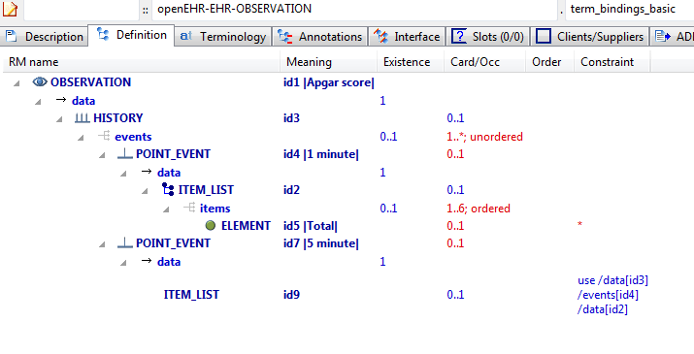

#### Term Bindings Basic AML Diagram

#### Term Bindings Basic AML Associations Diagram

### Term Bindings Paths Example

Simple example of a term binding to a path rather than a code. The meaning of this is that the binding only relates to the node at the path, whereas with a code-only binding, it relates to every location where that node appears (e.g. due to use_node internal references) or that the code appears (due to static definition).

#### Term Bindings Paths ADL

archetype (adl_version=2.0.5; rm_release=1.0.2)

openEHR-EHR-OBSERVATION.term_bindings_paths.v1.0.0

language

original_language = <[ISO_639-1::en]>

description

custodian_namespace = <"org.openehr">

custodian_organisation = <"openEHR Foundation <http://www.openEHR.org>">

original_author = <

["name"] = <"Thomas Beale">

["email"] = <"thomas.beale@openEHR.org">

["organisation"] = <"openEHR Foundation <http://www.openEHR.org>">

["date"] = <"2012-10-21">

>

details = <

["en"] = <

language = <[ISO_639-1::en]>

purpose = <"Simple example of a term binding to a path rather than a code. The meaning of this is that the binding only relates to the node at the path, whereas with a code-only binding, it relates to every location where that node appears (e.g. due to use_node internal references) or that the code appears (due to static definition).">

keywords = <"ADL", "test", "terminology bindings">

>

>

lifecycle_state = <"published">

other_details = <

["regression"] = <"PASS">

>

copyright = <"Copyright © 2012 openEHR Foundation <http://www.openEHR.org>">

licence = <"Creative Commons CC-BY-SA <https://creativecommons.org/licenses/by-sa/3.0/>">

definition

OBSERVATION[id1] matches { -- Apgar score

data matches {

HISTORY[id3] matches {

events cardinality matches {1..*; unordered} matches {

POINT_EVENT[id4] occurrences matches {0..1} matches { -- 1 minute

data matches {

ITEM_LIST[id2] matches {

items cardinality matches {1..6; ordered} matches {

ELEMENT[id5] occurrences matches {0..1} -- Total

}

}

}

}

POINT_EVENT[id7] occurrences matches {0..1} matches { -- 5 minute

data matches {

use_node ITEM_LIST[id9] /data[id3]/events[id4]/data[id2] -- /data[id3]/events[1 minute]/data[id2]

}

}

}

}

}

}

terminology

term_definitions = <

["en"] = <

["id1"] = <

text = <"Apgar score">

description = <"Clinical score derived from assessment of respiratory effort, heart rate, reflex irritability, muscle tone and skin colour.">

>

["id4"] = <

text = <"1 minute">

description = <"Apgar score 1 minute after birth">

>

["id5"] = <

text = <"Total">

description = <"The sum of the 5 ordinal scores for each component parameter.">

>

["id7"] = <

text = <"5 minute">

description = <"Apgar score 5 minutes after birth">

>

>

>

term_bindings = <

["LNC205"] = <

["/data[id3]/events[id4]/data[id2]/items[id5]"] = <http://LNC205.org/id/9272-6>

>

>

#### Term Bindings Paths ADL Diagram

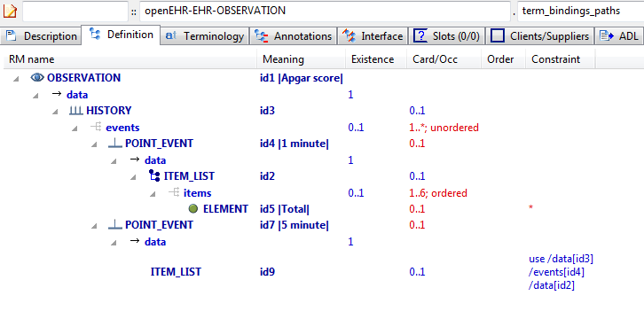

#### Term Bindings Paths AML Diagram

#### Term Bindings Paths AML Associations Diagram

### Term Bindings Paths Use Refs v1 Example

Example of bindings to paths that traverse use_node references, i.e. paths that are computed when taking a use_node internal reference into account.

#### Term Bindings Paths Use Refs v1 ADL

archetype (adl_version=2.0.5; rm_release=1.0.2)

openEHR-EHR-OBSERVATION.term_bindings_paths_use_refs.v1.0.0

language

original_language = <[ISO_639-1::en]>

description

custodian_namespace = <"org.openehr">

custodian_organisation = <"openEHR Foundation <http://www.openEHR.org>">

original_author = <

["name"] = <"Thomas Beale">

["email"] = <"thomas.beale@openEHR.org">

["organisation"] = <"openEHR Foundation <http://www.openEHR.org>">

["date"] = <"2012-10-21">

>

details = <

["en"] = <

language = <[ISO_639-1::en]>

purpose = <"Example of bindings to paths that traverse use_node references, i.e. paths that are computed when taking a use_node internal reference into account.">

keywords = <"ADL", "test", "terminology bindings">

>

>

lifecycle_state = <"published">

other_details = <

["regression"] = <"PASS">

>

copyright = <"Copyright © 2012 openEHR Foundation <http://www.openEHR.org>">

licence = <"Creative Commons CC-BY-SA <https://creativecommons.org/licenses/by-sa/3.0/>">

definition

OBSERVATION[id1] matches { -- Apgar score

data matches {

HISTORY[id3] matches {

events cardinality matches {1..*; unordered} matches {

POINT_EVENT[id4] occurrences matches {0..1} matches { -- 1 minute

offset matches {

DV_DURATION[id46] matches {

value matches {PT1M}

}

}

data matches {

ITEM_LIST[id2] matches {

items cardinality matches {1..6; ordered} matches {

ELEMENT[id10] occurrences matches {0..1} matches { -- Respiratory effort

value matches {

DV_ORDINAL[id47] matches {

[value, symbol] matches {

[{0}, {[at11]}],

[{1}, {[at12]}],

[{2}, {[at13]}]

}

}

}

}

ELEMENT[id6] occurrences matches {0..1} matches { -- Heart Rate

value matches {

DV_ORDINAL[id48] matches {

[value, symbol] matches {

[{0}, {[at7]}],

[{1}, {[at8]}],

[{2}, {[at9]}]

}

}

}

}

ELEMENT[id14] occurrences matches {0..1} matches { -- Muscle tone

value matches {

DV_ORDINAL[id49] matches {

[value, symbol] matches {

[{0}, {[at15]}],

[{1}, {[at16]}],

[{2}, {[at17]}]

}

}

}

}

ELEMENT[id18] occurrences matches {0..1} matches { -- Reflex irritability

value matches {

DV_ORDINAL[id50] matches {

[value, symbol] matches {

[{0}, {[at19]}],

[{1}, {[at20]}],

[{2}, {[at21]}]

}

}

}

}

ELEMENT[id22] occurrences matches {0..1} matches { -- Skin colour

value matches {

DV_ORDINAL[id51] matches {

[value, symbol] matches {

[{0}, {[at23]}],

[{1}, {[at24]}],

[{2}, {[at25]}]

}

}

}

}

ELEMENT[id26] occurrences matches {0..1} matches { -- Total

value matches {

DV_COUNT[id52] matches {

magnitude matches {|0..10|}

}

}

}

}

}

}

}

POINT_EVENT[id27] occurrences matches {0..1} matches { -- 2 minute

offset matches {

DV_DURATION[id53] matches {

value matches {PT2M}

}

}

data matches {

use_node ITEM_LIST[id41] /data[id3]/events[id4]/data[id2] -- /data[id3]/events[1 minute]/data[id2]

}

}

POINT_EVENT[id28] occurrences matches {0..1} matches { -- 3 minute

offset matches {

DV_DURATION[id54] matches {

value matches {PT3M}

}

}

data matches {

use_node ITEM_LIST[id42] /data[id3]/events[id4]/data[id2] -- /data[id3]/events[1 minute]/data[id2]

}

}

POINT_EVENT[id29] occurrences matches {0..1} matches { -- 5 minute

offset matches {

DV_DURATION[id55] matches {

value matches {PT5M}

}

}

data matches {

use_node ITEM_LIST[id43] /data[id3]/events[id4]/data[id2] -- /data[id3]/events[1 minute]/data[id2]

}

}

POINT_EVENT[id32] occurrences matches {0..1} matches { -- 10 minute

offset matches {

DV_DURATION[id56] matches {

value matches {PT10M}

}

}

data matches {

use_node ITEM_LIST[id44] /data[id3]/events[id4]/data[id2] -- /data[id3]/events[1 minute]/data[id2]

}

}

EVENT[id38] occurrences matches {0..*} matches { -- Any event

data matches {

use_node ITEM_LIST[id45] /data[id3]/events[id4]/data[id2] -- /data[id3]/events[1 minute]/data[id2]

}

}

}

}

}

protocol matches {

ITEM_LIST[id30] matches {

items matches {

ELEMENT[id31] occurrences matches {0..1} matches { -- Notes on measurement

value matches {

DV_TEXT[id57]

}

}

}

}

}

}

terminology

term_definitions = <

["en"] = <

["id1"] = <

text = <"Apgar score">

description = <"Clinical score derived from assessment of respiratory effort, heart rate, reflex irritability, muscle tone and skin colour.">

>

["id4"] = <

text = <"1 minute">

description = <"Apgar score 1 minute after birth.">

>

["id6"] = <

text = <"Heart Rate">

description = <"Recording of the infant's heart rate.">

>

["at7"] = <

text = <"Absent">

description = <"No heart beat is seen, felt or heard.">

>

["at8"] = <

text = <"<100 beats per minute">

description = <"Heart rate less than 100 beats per minute.">

>

["at9"] = <

text = <"≥100 beats per minute">

description = <"Heart rate greater than or equal to 100 beats per minute.">

>

["id10"] = <

text = <"Respiratory effort">

description = <"Observation of the infant's respiratory effort.">

>

["at11"] = <

text = <"Absent">

description = <"No effort to breath.">

>

["at12"] = <

text = <"Weak or irregular">

description = <"Some effort to breath, moving chest.">

>

["at13"] = <

text = <"Normal">

description = <"Breathing normally or crying.">

>

["id14"] = <

text = <"Muscle tone">

description = <"Observation of the infant's muscle tone.">

>

["at15"] = <

text = <"Limp or flaccid">

description = <"No spontaneous movement.">

>

["at16"] = <

text = <"Reduced tone">

description = <"Some flexion of extremities.">

>

["at17"] = <

text = <"Normal tone">

description = <"Normal, vigorous movements.">

>

["id18"] = <

text = <"Reflex irritability">

description = <"Observation of the response of the infant to an irritant stimulation, for example, suctioning the oropharynx and nares with a soft rubber catheter.">

>

["at19"] = <

text = <"No response">

description = <"No response to stimulation.">

>

["at20"] = <

text = <"Reduced response">

description = <"Grimace or feeble cry when stimulated.">

>

["at21"] = <

text = <"Normal response">

description = <"Grimace, sneeze, cough or pulls away when stimulated.">

>

["id22"] = <

text = <"Skin colour">

description = <"Observation of the skin colour of the infant.">

>

["at23"] = <

text = <"Completely blue">

description = <"Body and extremities are blue.">

>

["at24"] = <

text = <"Body pink; extremities blue">

description = <"Body is pink; extremities are blue.">

>

["at25"] = <

text = <"Completely pink">

description = <"Body and extremities are pink; no cyanosis.">

>

["id26"] = <

text = <"Total">

description = <"The sum of the 5 ordinal scores for each component parameter.">

>

["id27"] = <

text = <"2 minute">

description = <"Apgar score 2 minutes after birth.">

>

["id28"] = <

text = <"3 minute">

description = <"Apgar score 3 minutes after birth.">

>

["id29"] = <

text = <"5 minute">

description = <"Apgar score 5 minutes after birth.">

>

["id31"] = <

text = <"Notes on measurement">

description = <"Notes on measurement of the Apgar score.">

>

["id32"] = <

text = <"10 minute">

description = <"Apgar score 10 minutes after birth.">

>

["id38"] = <

text = <"Any event">

description = <"Apgar score at any additional time, as required.">

>

["ac1"] = <

text = <"Respiratory effort">

description = <"Observation of the infant's respiratory effort.">

>

["ac2"] = <

text = <"Heart Rate">

description = <"Recording of the infant's heart rate.">

>

["ac3"] = <

text = <"Muscle tone">

description = <"Observation of the infant's muscle tone.">

>

["ac4"] = <

text = <"Reflex irritability">

description = <"Observation of the response of the infant to an irritant stimulation, for example, suctioning the oropharynx and nares with a soft rubber catheter.">

>

["ac5"] = <

text = <"Skin colour">

description = <"Observation of the skin colour of the infant.">

>

["ac6"] = <

text = <"Respiratory effort (synthesised)">

description = <"Observation of the infant's respiratory effort. (synthesised)">

>

["ac7"] = <

text = <"Heart Rate (synthesised)">

description = <"Recording of the infant's heart rate. (synthesised)">

>

["ac8"] = <

text = <"Muscle tone (synthesised)">

description = <"Observation of the infant's muscle tone. (synthesised)">

>

["ac9"] = <

text = <"Reflex irritability (synthesised)">

description = <"Observation of the response of the infant to an irritant stimulation, for example, suctioning the oropharynx and nares with a soft rubber catheter. (synthesised)">

>

["ac10"] = <

text = <"Skin colour (synthesised)">

description = <"Observation of the skin colour of the infant. (synthesised)">

>

>

>

term_bindings = <

["SNOMED-CT"] = <

["/data[id3]/events[id4]/data[id2]/items[id26]"] = <http://snomedct.info/id/169895004>

["/data[id3]/events[id29]/data[id2]/items[id26]"] = <http://snomedct.info/id/169909004>

["/data[id3]/events[id32]/data[id2]/items[id26]"] = <http://snomedct.info/id/169922007>

["/data[id3]/events[id38]/data[id2]/items[id26]"] = <http://snomedct.info/id/364592005>

["id26"] = <http://snomedct.info/id/249228009>

>

["LOINC"] = <

["/data[id3]/events[id4]"] = <http://loinc.org/id/48334-7>

["/data[id3]/events[id4]/data[id2]/items[id6]"] = <http://loinc.org/id/32407-9>

["/data[id3]/events[id4]/data[id2]/items[id10]"] = <http://loinc.org/id/32410-3>

["/data[id3]/events[id4]/data[id2]/items[id14]"] = <http://loinc.org/id/32408-7>

["/data[id3]/events[id4]/data[id2]/items[id18]"] = <http://loinc.org/id/32409-5>

["/data[id3]/events[id4]/data[id2]/items[id22]"] = <http://loinc.org/id/32406-1>

["/data[id3]/events[id4]/data[id2]/items[id26]"] = <http://loinc.org/id/9272-6>

["/data[id3]/events[id27]/data[id2]/items[id26]"] = <http://loinc.org/id/9273-4>

["/data[id3]/events[id29]"] = <http://loinc.org/id/48333-9>

["/data[id3]/events[id29]/data[id2]/items[id6]"] = <http://loinc.org/id/32412-9>

["/data[id3]/events[id29]/data[id2]/items[id10]"] = <http://loinc.org/id/32415-2>

["/data[id3]/events[id29]/data[id2]/items[id14]"] = <http://loinc.org/id/32413-7>

["/data[id3]/events[id29]/data[id2]/items[id18]"] = <http://loinc.org/id/32414-5>

["/data[id3]/events[id29]/data[id2]/items[id22]"] = <http://loinc.org/id/32411-1>

["/data[id3]/events[id29]/data[id2]/items[id26]"] = <http://loinc.org/id/9274-2>

["/data[id3]/events[id32]"] = <http://loinc.org/id/48332-1>

["/data[id3]/events[id32]/data[id2]/items[id6]"] = <http://loinc.org/id/32402-0>

["/data[id3]/events[id32]/data[id2]/items[id10]"] = <http://loinc.org/id/32405-3>

["/data[id3]/events[id32]/data[id2]/items[id14]"] = <http://loinc.org/id/32403-8>

["/data[id3]/events[id32]/data[id2]/items[id18]"] = <http://loinc.org/id/32404-6>

["/data[id3]/events[id32]/data[id2]/items[id22]"] = <http://loinc.org/id/32401-2>

["/data[id3]/events[id32]/data[id2]/items[id26]"] = <http://loinc.org/id/9271-8>

["at7"] = <http://loinc.org/id/LA6716>

["at8"] = <http://loinc.org/id/LA6717>

["at9"] = <http://loinc.org/id/LA6718>

["at11"] = <http://loinc.org/id/LA6725>

["at12"] = <http://loinc.org/id/LA6726>

["at13"] = <http://loinc.org/id/LA6727>

["at15"] = <http://loinc.org/id/LA6713>

["at16"] = <http://loinc.org/id/LA6714>

["at17"] = <http://loinc.org/id/LA6715>

["at19"] = <http://loinc.org/id/LA6719>

["at20"] = <http://loinc.org/id/LA6720>

["at21"] = <http://loinc.org/id/LA6721>

["at23"] = <http://loinc.org/id/LA6722>

["at24"] = <http://loinc.org/id/LA6723>

["at25"] = <http://loinc.org/id/LA6724>

>

>

value_sets = <

["ac1"] = <

id = <"ac1">

members = <"at11", "at12", "at13">

>

["ac2"] = <

id = <"ac2">

members = <"at7", "at8", "at9">

>

["ac3"] = <

id = <"ac3">

members = <"at15", "at16", "at17">

>

["ac4"] = <

id = <"ac4">

members = <"at19", "at20", "at21">

>

["ac5"] = <

id = <"ac5">

members = <"at23", "at24", "at25">

>

["ac6"] = <

id = <"ac6">

members = <"at11", "at12", "at13">

>

["ac7"] = <

id = <"ac7">

members = <"at7", "at8", "at9">

>

["ac8"] = <

id = <"ac8">

members = <"at15", "at16", "at17">

>

["ac9"] = <

id = <"ac9">

members = <"at19", "at20", "at21">

>

["ac10"] = <

id = <"ac10">

members = <"at23", "at24", "at25">

>

>

#### Term Bindings Paths Use Refs v1 ADL Diagram

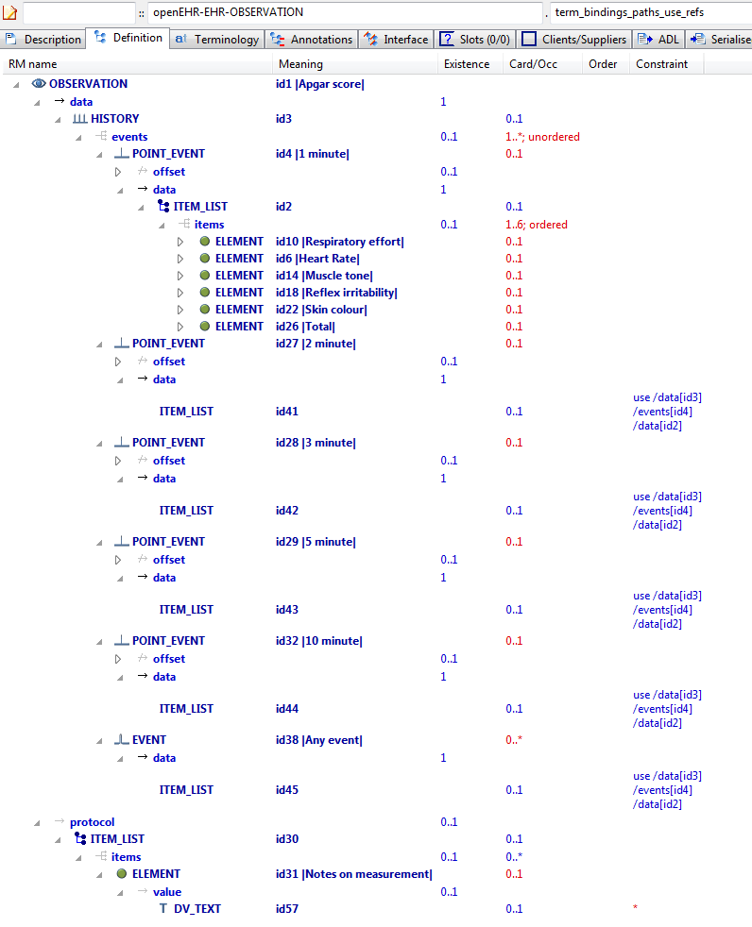

#### Term Bindings Paths Use Refs v1 AML Diagram

#### Term Bindings Paths Use Refs v1 AML Associations Diagram

### Value Set Binding v1 Example

Example of bindings to value sets (signified by ac codes) rather than individual codes.

#### Value Set Binding v1 ADL

archetype (adl_version=2.0.5; rm_release=1.0.2)

openEHR-EHR-OBSERVATION.value_set_binding.v1.0.0

language

original_language = <[ISO_639-1::en]>

description

custodian_namespace = <"org.openehr">

custodian_organisation = <"openEHR Foundation <http://www.openEHR.org>">

original_author = <

["name"] = <"Thomas Beale">

["email"] = <"thomas.beale@openEHR.org">

["organisation"] = <"openEHR Foundation <http://www.openEHR.org>">

["date"] = <"2012-10-21">

>

details = <

["en"] = <

language = <[ISO_639-1::en]>

purpose = <"Example of bindings to value sets (signified by ac codes) rather than individual codes.">

keywords = <"ADL", "test", "terminology bindings">

>

>

lifecycle_state = <"published">

other_details = <

["regression"] = <"PASS">

>

copyright = <"Copyright © 2012 openEHR Foundation <http://www.openEHR.org>">

licence = <"Creative Commons CC-BY-SA <https://creativecommons.org/licenses/by-sa/3.0/>">

definition

OBSERVATION[id1] matches { -- Cough - ZN

data matches {

HISTORY[id2] matches {

events cardinality matches {1..*; unordered} matches {

EVENT[id3] occurrences matches {0..1} matches { -- Any event

data matches {

ITEM_TREE[id4] matches {

items matches {

ELEMENT[id5] occurrences matches {0..1} matches { -- Character

value matches {

DV_CODED_TEXT[id6] matches {

defining_code matches {[ac2]} -- MZN-SIF-Dihanje-Kašelj

}

}

}

}

}

}

}

}

}

}

}

terminology

term_definitions = <

["en"] = <

["id1"] = <

text = <"Cough - ZN">

description = <"Documenting cough assessment as needed for nursing care">

>

["id3"] = <

text = <"Any event">

description = <"*">

>

["id5"] = <

text = <"Character">

description = <"The character of the cough.">

>

["ac2"] = <

text = <"MZN-SIF-Dihanje-Kašelj">

description = <"Link to ISPEK termset.">

>

>

>

term_bindings = <

["AIR93(1.0.0)"] = <

["ac2"] = <http://air93.org/MZN-SIF-Dihanje-Kašelj>

>

["AIR93"] = <

["ac2"] = <http://air93.org/MZN-SIF-Dihanje-Kašelj>

>

>

#### Value Set Binding v1 ADL Diagram

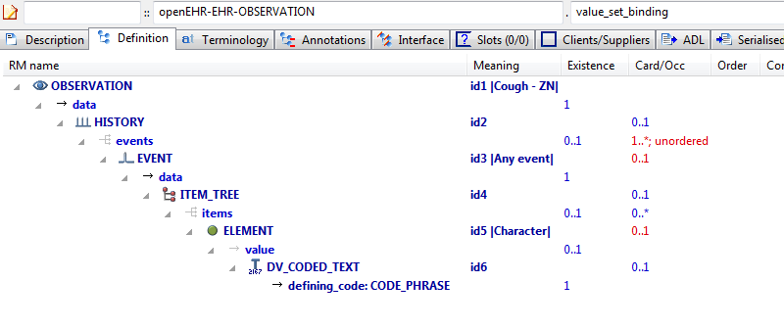

#### Value Set Binding v1 AML Diagram

#### Value Set Binding v1 AML Associations Diagram

### Value Set Binding Snomed v1 Example

Demonstrate constraint binding of individual terms to multiple terminologies, using URI references.

#### Value Set Binding Snomed v1 ADL

archetype (adl_version=2.0.5; rm_release=1.0.2)

openEHR-EHR-OBSERVATION.value_set_binding_snomed.v1.0.0

language

original_language = <[ISO_639-1::en]>

description

custodian_namespace = <"org.openehr">

custodian_organisation = <"openEHR Foundation <http://www.openEHR.org>">

original_author = <

["name"] = <"Thomas Beale">

["email"] = <"thomas.beale@openEHR.org">

["organisation"] = <"openEHR Foundation <http://www.openEHR.org>">

["date"] = <"2012-10-21">

>

details = <

["en"] = <

language = <[ISO_639-1::en]>

purpose = <"Demonstrate constraint binding of individual terms to multiple terminologies, using URI references.">

keywords = <"ADL", "test", "terminology bindings">

>

>

lifecycle_state = <"published">

other_details = <

["regression"] = <"PASS">

>

copyright = <"Copyright © 2012 openEHR Foundation <http://www.openEHR.org>">

licence = <"Creative Commons CC-BY-SA <https://creativecommons.org/licenses/by-sa/3.0/>">

definition

OBSERVATION[id1] matches { -- Pulse

data matches {

HISTORY[id3] matches {

events cardinality matches {1..*; unordered} matches {

EVENT[id4] occurrences matches {0..*} matches { -- Any event

data matches {

ITEM_TREE[id2] matches {

items matches {

ELEMENT[id1006] occurrences matches {0..1} matches { -- Pulse Presence

value matches {

DV_CODED_TEXT[id1039] matches {

defining_code matches {[ac1]} -- Pulse Presence (synthesised)

}

}

}

ELEMENT[id5] occurrences matches {0..1} matches { -- Rate

name matches {

DV_CODED_TEXT[id1040] matches {

defining_code matches {[ac2]} -- Rate (synthesised)

}

}

value matches {

DV_QUANTITY[id1041] matches {

property matches {[at1046]}

magnitude matches {|>=0.0|}

precision matches {0}

units matches {"/min"}

}

}

}

ELEMENT[id6] occurrences matches {0..1} matches { -- Regularity

value matches {

DV_CODED_TEXT[id1042] matches {

defining_code matches {[ac3]} -- Regularity (synthesised)

}

}

}

ELEMENT[id1031] occurrences matches {0..*} matches { -- Character

value matches {

DV_TEXT[id1043]

}

}

ELEMENT[id1023] occurrences matches {0..1} matches { -- Clinical Description

value matches {

DV_TEXT[id1044]

}

}

ELEMENT[id1024] occurrences matches {0..*} matches { -- Clinical Interpretation

value matches {

DV_TEXT[id1045]

}

}

}

}

}

state matches {

ITEM_TREE[id13] matches {

items matches {

ELEMENT[id14] occurrences matches {0..1} matches { -- Position

value matches {

DV_CODED_TEXT[id1046] matches {

defining_code matches {[ac4; at1002]} -- Position (synthesised)

}

}

}

ELEMENT[id1019] occurrences matches {0..1} matches { -- Confounding Factors

value matches {

DV_TEXT[id1047]

}

}

allow_archetype CLUSTER[id1018] occurrences matches {0..*} matches { -- Exertion

include

archetype_id/value matches {/openEHR-EHR-CLUSTER\.level_of_exertion(-a-zA-Z0-9_]+)*\.v1/}

}

}

}

}

}

INTERVAL_EVENT[id1037] occurrences matches {0..1} matches { -- Maximum

math_function matches {

DV_CODED_TEXT[id1048] matches {

defining_code matches {[at1047]}

}

}

data matches {

use_node ITEM_TREE[id1049] /data[id3]/events[id4]/data[id2] -- /data[id3]/events[Any event]/data[id2]

}

state matches {

use_node ITEM_TREE[id1050] /data[id3]/events[id4]/state[id13] -- /data[id3]/events[Any event]/state[id13]

}

}

}

}

}

}

terminology

term_definitions = <

["en"] = <

["id1"] = <

text = <"Pulse">

description = <"Measurement of the pulse rate, or heart rate, and description of associated characteristics.">

>

["id4"] = <

text = <"Any event">

description = <"Default, unspecified point in time or interval event which may be explicitly defined in a template or at run-time.">

>

["id5"] = <

text = <"Rate">

description = <"The rate, measured in beats per minute.">

>

["id6"] = <

text = <"Regularity">

description = <"The observed regularity of the pulse or heart beat.">

>

["id14"] = <

text = <"Position">

description = <"The body position of the subject during the observation.">

>

["at7"] = <

text = <"Regular">

description = <"The rhythm is regular.">

>

["at8"] = <

text = <"Regularly Irregular">

description = <"The rhythm is regularly irregular.">

>

["at9"] = <

text = <"Irregularly Irregular">

description = <"The rhythm is irregular in a chaotic manner.">

>

["id1006"] = <

text = <"Pulse Presence">

description = <"Identification of a pulse or heart beat.">

>

["id1014"] = <

text = <"Device">

description = <"Details about the device used to observe the pulse or heart beat.">

>

["id1018"] = <

text = <"Exertion">

description = <"Details about physical exertion being undertaken during the examination.">

>

["id1019"] = <

text = <"Confounding Factors">

description = <"Narrative description about any incidental factors that may be affect interpretation of the physical findings.">

>

["id1023"] = <

text = <"Clinical Description">

description = <"Narrative description about the findings.">

>

["id1024"] = <

text = <"Clinical Interpretation">

description = <"Single word, phrase or brief description represents the clinical meaning and significance of the pulse or heart beat findings.">

>

["at1001"] = <

text = <"Lying">

description = <"The subject was lying flat.">

>

["at1002"] = <

text = <"Sitting">

description = <"The subject was sitting (for example on bed or chair).">

>

["at1003"] = <

text = <"Reclining">

description = <"The subject was reclining.">

>

["at1004"] = <

text = <"Standing">

description = <"The subject was standing.">

>

["at1025"] = <

text = <"Present">

description = <"A pulse or heart beat can be detected.">

>

["at1026"] = <

text = <"Absent">

description = <"A pulse or heart beat cannot be detected.">

>

["at1027"] = <

text = <"Pulse Rate">

description = <"The pulse rate, measured in beats per minute.">

>

["at1028"] = <

text = <"Heart Rate">

description = <"The heart rate, measured in beats per minute.">

>

["at1029"] = <

text = <"Irregular">

description = <"The rhythm is irregular.">

>

["id1031"] = <

text = <"Character">

description = <"Description of the character of the pulse or heart beat.">

>

["id1037"] = <

text = <"Maximum">

description = <"Maximum rate of the pulse or heart beat observed during a period of exertion.">

>

["at1046"] = <

text = <"Frequency">

description = <"Frequency">

>

["at1047"] = <

text = <"maximum">

description = <"maximum">

>

["ac1"] = <

text = <"Pulse Presence (synthesised)">

description = <"Identification of a pulse or heart beat. (synthesised)">

>

["ac2"] = <

text = <"Rate (synthesised)">

description = <"The rate, measured in beats per minute. (synthesised)">

>

["ac3"] = <

text = <"Regularity (synthesised)">

description = <"The observed regularity of the pulse or heart beat. (synthesised)">

>

["ac4"] = <

text = <"Position (synthesised)">

description = <"The body position of the subject during the observation. (synthesised)">

>

>

>

term_bindings = <

["openehr"] = <

["at1046"] = <http://openehr.org/id/382>

["at1047"] = <http://openehr.org/id/144>

>

["snomedct"] = <

["ac2"] = <http://snomedct.info/id/12394009>

["ac3"] = <http://snomedct.info/id/12394015>

>

>

value_sets = <

["ac1"] = <

id = <"ac1">

members = <"at1025", "at1026">

>

["ac2"] = <

id = <"ac2">

members = <"at1027", "at1028">

>

["ac3"] = <

id = <"ac3">

members = <"at7", "at1029", "at8", "at9">

>

["ac4"] = <

id = <"ac4">

members = <"at1004", "at1002", "at1003", "at1001">

>

>

#### Value Set Binding Snomed v1 ADL Diagram

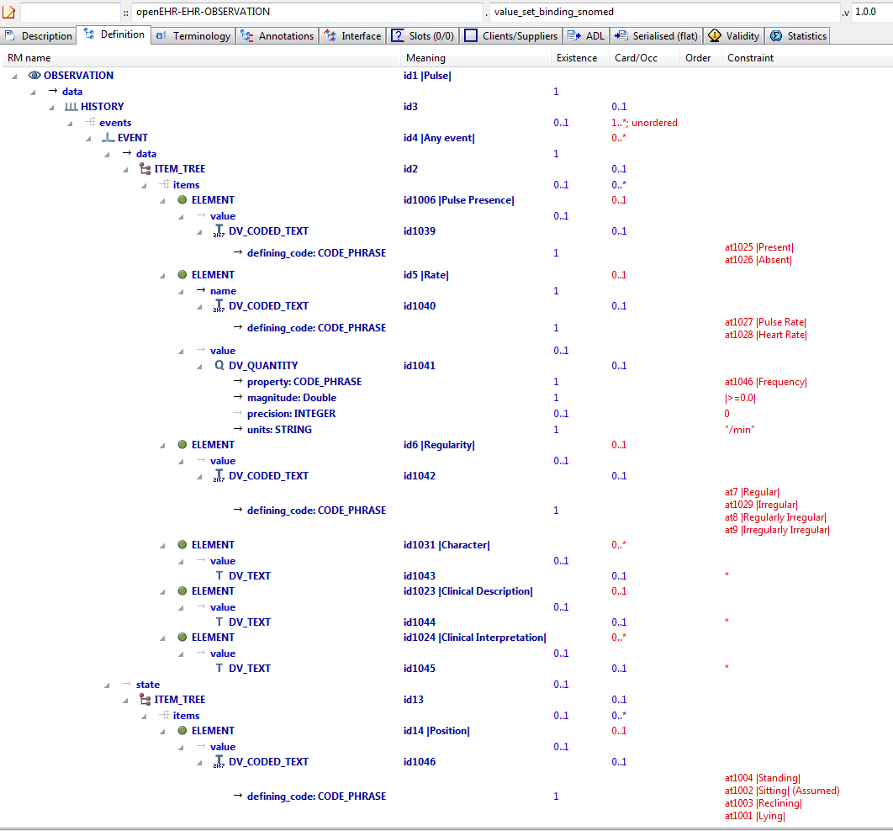

#### Value Set Binding Snomed v1 AML Diagram

#### Value Set Binding Snomed v1 AML Associations Diagram

## Terminology Value_sets Examples

### External Value Set v1 Example

Example of rewriting of external value set, designated by ac-code in an ADL 1.4 archetype, to an ADL 2.0 value set.

#### External Value Set v1 ADL

archetype (adl_version=2.0.5; rm_release=1.0.2)

openEHR-EHR-OBSERVATION.external_value_set.v1.0.0

language

original_language = <[ISO_639-1::en]>

description

custodian_namespace = <"org.openehr">

custodian_organisation = <"openEHR Foundation <http://www.openEHR.org>">

original_author = <

["name"] = <"Thomas Beale">

["email"] = <"thomas.beale@openEHR.org">

["organisation"] = <"openEHR Foundation <http://www.openEHR.org>">

["date"] = <"2014-02-01">

>

details = <

["en"] = <

language = <[ISO_639-1::en]>

purpose = <"Example of rewriting of external value set, designated by ac-code in an ADL 1.4 archetype, to an ADL 2.0 value set.">

keywords = <"ADL", "test", "value sets">

>

>

lifecycle_state = <"published">

other_details = <

["regression"] = <"PASS">

>

copyright = <"Copyright © 2014 openEHR Foundation <http://www.openEHR.org>">

licence = <"Creative Commons CC-BY-SA <https://creativecommons.org/licenses/by-sa/3.0/>">

definition

OBSERVATION[id1] matches { -- Test Obs

protocol matches {

ITEM_TREE[id2] matches {

items matches {

ELEMENT[id3] occurrences matches {0..1} matches { -- document state

value matches {

DV_CODED_TEXT[id4] matches {

defining_code matches {[ac1; at1]} -- document state

}

}

}

}

}

}

}

terminology

term_definitions = <

["en"] = <

["id1"] = <

text = <"Test Obs">

description = <"Test Obs">

>

["id3"] = <

text = <"document state">

description = <"document state">

>

["ac1"] = <

text = <"document state">

description = <"document state">

>

["at1"] = <

text = <"modification">

description = <"modification">

>

["at2"] = <

text = <"creation">

description = <"creation">

>

["at3"] = <

text = <"synthesis">

description = <"synthesis">

>

["at4"] = <

text = <"unknown">

description = <"unknown">

>

["at5"] = <

text = <"deleted">

description = <"deleted">

>

["at6"] = <

text = <"attestation">

description = <"attestation">

>

>

>

term_bindings = <

["openehr"] = <

["at1"] = <http://openehr.org/id/251>

["at2"] = <http://openehr.org/id/249>

["at3"] = <http://openehr.org/id/252>

["at4"] = <http://openehr.org/id/253>

["at5"] = <http://openehr.org/id/523>

["at6"] = <http://openehr.org/id/666>

>

>

value_sets = <

["ac1"] = <

id = <"ac1">

members = <"at2", "at1", "at3", "at4", "at5", "at6">

>

>

#### External Value Set v1 ADL Diagram

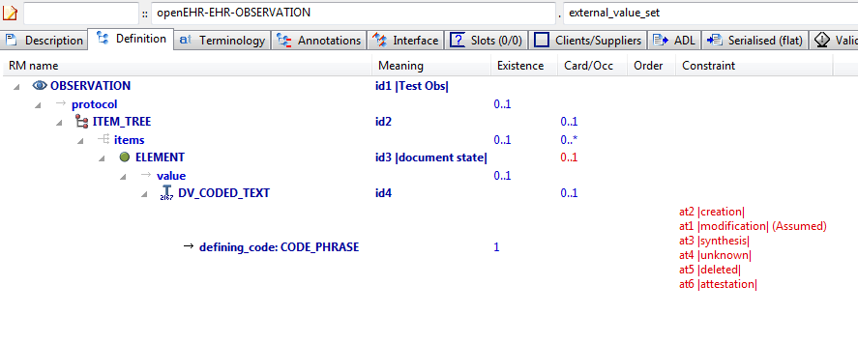

#### External Value Set v1 AML Diagram

#### External Value Set v1 AML Associations Diagram

### Internal Value Set v1 Example

Example of rewriting of internal value set, designated by a series of at-codes in an ADL 1.4 archetype, to an ADL 2.0 value set.

#### Internal Value Set v1 ADL

archetype (adl_version=2.0.5; rm_release=1.0.2)

openEHR-EHR-OBSERVATION.internal_value_set.v1.0.0

language

original_language = <[ISO_639-1::en]>

description

custodian_namespace = <"org.openehr">

custodian_organisation = <"openEHR Foundation <http://www.openEHR.org>">

original_author = <

["name"] = <"Thomas Beale">

["email"] = <"thomas.beale@openEHR.org">

["organisation"] = <"openEHR Foundation <http://www.openEHR.org>">

["date"] = <"2014-02-01">

>

details = <

["en"] = <

language = <[ISO_639-1::en]>

purpose = <"Example of rewriting of internal value set, designated by a series of at-codes in an ADL 1.4 archetype, to an ADL 2.0 value set.">

keywords = <"ADL", "test", "value sets">

>

>

lifecycle_state = <"published">

other_details = <

["regression"] = <"PASS">

>

copyright = <"Copyright © 2014 openEHR Foundation <http://www.openEHR.org>">

licence = <"Creative Commons CC-BY-SA <https://creativecommons.org/licenses/by-sa/3.0/>">

definition

OBSERVATION[id1] matches { -- Blood Pressure

data matches {

HISTORY[id2] matches { -- history

events cardinality matches {1..*; unordered} matches {

EVENT[id7] occurrences matches {0..*} matches { -- any event

state matches {

ITEM_TREE[id8] matches {

items matches {

ELEMENT[id9] occurrences matches {0..1} matches { -- Position

value matches {

DV_CODED_TEXT[id1045] matches {

defining_code matches {[ac1; at1002]} -- Position

}

}

}

ELEMENT[id1044] occurrences matches {0..1} matches { -- Sleep status

value matches {

DV_CODED_TEXT[id1046] matches {

defining_code matches {[ac2; at1045]} -- Sleep status

}

}

}

}

}

}

}

}

}

}

protocol matches {

ITEM_TREE[id12] matches { -- list structure

items matches {

ELEMENT[id14] occurrences matches {0..1} matches { -- Cuff size

value matches {

DV_CODED_TEXT[id1047] matches {

defining_code matches {[ac3]} -- Cuff size

}

}

}

CLUSTER[id1034] occurrences matches {0..1} matches { -- Location

items matches {

ELEMENT[id15] occurrences matches {0..1} matches { -- Location of measurement

value matches {

DV_CODED_TEXT[id1048] matches {

defining_code matches {[ac4]} -- Location of measurement

}

}

}

ELEMENT[id1035] occurrences matches {0..1} matches { -- Specific location

value matches {

DV_TEXT[id1049]

}

}

}

}

ELEMENT[id1036] occurrences matches {0..1} matches { -- Method

value matches {

DV_CODED_TEXT[id1050] matches {

defining_code matches {[ac5]} -- Method

}

}

}

ELEMENT[id1039] occurrences matches {0..1} matches { -- Mean Arterial Pressure Formula

value matches {

DV_TEXT[id1051]

}

}

ELEMENT[id1011] occurrences matches {0..1} matches { -- Diastolic endpoint

value matches {

DV_CODED_TEXT[id1052] matches {

defining_code matches {[ac6]} -- Diastolic endpoint

}

}

}

}

}

}

}

terminology

term_definitions = <

["en"] = <

["id1"] = <

text = <"Blood Pressure">

description = <"The local measurement of arterial blood pressure which is a surrogate for arterial. pressure in the systemic circulation. Most commonly, use of the term 'blood pressure' refers to measurement of brachial artery pressure in the upper arm.">

>

["id2"] = <

text = <"history">

description = <"history Structural node">

>

["at4"] = <

text = <"blood pressure">

description = <"@ internal @">

>

["at5"] = <

text = <"Systolic">

description = <"Peak systemic arterial blood pressure - measured in systolic or contraction phase of the heart cycle.">

>

["at6"] = <

text = <"Diastolic">

description = <"Minimum systemic arterial blood pressure - measured in the diastolic or relaxation phase of the heart cycle.">

>

["id7"] = <

text = <"any event">

description = <"Default event">

>

["id9"] = <

text = <"Position">

description = <"The position of the subject at the time of measurement.">

>

["id12"] = <

text = <"list structure">

description = <"list structure">

>

["id14"] = <

text = <"Cuff size">

description = <"The size of the cuff used for blood pressure measurement. ">

>

["id15"] = <

text = <"Location of measurement">

description = <"Common body sites where blood pressure is recorded.">

>

["at16"] = <

text = <"Adult Thigh">

description = <"A cuff used for an adult thigh - bladder approx 20cm x 42cm.">

>

["at17"] = <

text = <"Large Adult">

description = <"A cuff for adults with larger arms - bladder approx 16cm x 38cm.">

>

["at18"] = <

text = <"Adult">

description = <"A cuff that is standard for an adult - bladder approx 13cm x 30cm.">

>

["at26"] = <

text = <"Right arm">

description = <"The right arm of the person.">

>

["at27"] = <

text = <"Left arm">

description = <"The left arm of the person.">

>

["at28"] = <

text = <"Right thigh">

description = <"The right thigh of the person.">

>

["at29"] = <

text = <"Left thigh">

description = <"The left thigh of the person.">

>

["at34"] = <

text = <"Comment">

description = <"Comment on blood pressure measurement.">

>

["at1001"] = <

text = <"Standing">

description = <"Standing at the time of blood pressure measurement.">

>

["at1002"] = <

text = <"Sitting">

description = <"Sitting (for example on bed or chair) at the time of blood pressure measurement.">

>

["at1003"] = <

text = <"Reclining">

description = <"Reclining at the time of blood pressure measurement.">

>

["at1004"] = <

text = <"Lying">

description = <"Lying flat at the time of blood pressure measurement.">

>

["at1006"] = <

text = <"Tilt">

description = <"The craniocaudal tilt of the surface on which the person is lying at the time of measurement.">

>

["at1007"] = <

text = <"Mean Arterial Pressure">

description = <"The average arterial pressure that occurs over the entire course of the heart contraction and relaxation cycle.">

>

["at1008"] = <

text = <"Pulse Pressure">

description = <"The difference between the systolic and diastolic pressure.">

>

["at1009"] = <

text = <"Small Adult">

description = <"A cuff used for a small adult - bladder approx 10cm x 24cm.">

>

["at1010"] = <

text = <"Paediatric/Child">

description = <"A cuff that is appropriate for a child or adult with a thin arm - bladder approx 8cm x 21cm.">

>

["id1011"] = <

text = <"Diastolic endpoint">

description = <"Record which Korotkoff sound is used for determining diastolic pressure using auscultative method.">

>

["at1012"] = <

text = <"Phase IV">

description = <"The fourth Korotkoff sound is identified as an abrupt muffling of sounds.">

>

["at1013"] = <

text = <"Phase V">

description = <"The fifth Korotkoff sound is identified by absence of sounds as the cuff pressure drops below the diastolic blood pressure.">

>

["at1015"] = <

text = <"Lying with tilt to left">

description = <"Lying flat with some lateral tilt, usually angled towards the left side. Commonly required in the last trimester of pregnancy to relieve aortocaval compression.">

>

["at1019"] = <

text = <"Infant">

description = <"A cuff used for infants - bladder approx 5cm x 15cm.">

>

["at1020"] = <

text = <"Neonatal">

description = <"A cuff used for a neonate, assuming cuff is the appropriate size for maturity and birthweight of the neonate.">

>

["at1021"] = <

text = <"Right wrist">

description = <"The right wrist of the subject.">

>

["at1022"] = <

text = <"Left wrist">

description = <"The left wrist of the subject.">

>

["at1026"] = <

text = <"Device">

description = <"Details about sphygmomanometer or other device used to measure the blood pressure.">

>

["at1027"] = <

text = <"Right ankle">

description = <"The right ankle of the subject.">

>

["at1031"] = <

text = <"Exertion ">

description = <"Details about physical activity undertaken at the time of blood pressure.measurement.">

>

["at1032"] = <

text = <"Left ankle">

description = <"The left ankle of the subject.">

>

["at1033"] = <

text = <"Finger">

description = <"A finger of the subject. Identification of the finger can be recorded in 'Specific Location' data element, if required.">

>

["id1034"] = <

text = <"Location">

description = <"Body location where blood pressure is measured. Use 'Location of measurement' to select from common sites. Use 'Specific location' to record more specific details or a site that is not in the common set or to refer to an external terminology.">

>

["id1035"] = <

text = <"Specific location">

description = <"Specific details about the body site where blood pressure is recorded.">

>

["id1036"] = <

text = <"Method">

description = <"Method of measurement of blood pressure.">

>

["at1037"] = <

text = <"Auscultation">

description = <"Method of measuring blood pressure externally, using a stethoscope and Korotkoff sounds.">

>

["at1038"] = <

text = <"Palpation">

description = <"Method of measuring blood pressure externally, using palpation (usually of the brachial or radial arteries).">

>

["id1039"] = <

text = <"Mean Arterial Pressure Formula">

description = <"Formula used to calculate the MAP (if recorded in data).">

>

["at1040"] = <

text = <"Machine">

description = <"Method of measuring blood pressure externally, using a blood pressure machine.">

>

["at1041"] = <

text = <"Invasive">

description = <"Method of measuring blood pressure internally ie involving penetration of the skin and measuring inside blood vessels.">

>

["at1043"] = <

text = <"24 hour average ">

description = <"Estimate of the average blood pressure over a 24 hour period.">

>

["id1044"] = <

text = <"Sleep status">

description = <"Sleep status - supports interpretation of 24 hour ambulatory blood pressure records. ">

>

["at1045"] = <

text = <"Alert & awake">

description = <"Subject is fully conscious.">

>

["at1046"] = <

text = <"Sleeping">

description = <"Subject is in the natural state of bodily rest.">

>

["at1052"] = <

text = <"Toe">

description = <"A toe of the subject. Identification of the toe can be recorded in 'Specific Location' data element, if required.">

>

["at1053"] = <

text = <"Confounding factors">

description = <"Comment on and record other incidental factors that may be contributing to the blood pressure measurement. For example, level of anxiety or 'white coat syndrome'; pain or fever; changes in atmospheric pressure etc.">

>

["at1054"] = <

text = <"Intra-arterial">

description = <"Invasive measurement via transducer access line within an artery. Location of the transducer can be recorded in 'Specific Location' data element, if required.">

>

["ac1"] = <

text = <"Position">

description = <"The position of the subject at the time of measurement.">

>

["ac2"] = <

text = <"Sleep status">

description = <"Sleep status - supports interpretation of 24 hour ambulatory blood pressure records. ">

>

["ac3"] = <

text = <"Cuff size">

description = <"The size of the cuff used for blood pressure measurement. ">

>

["ac4"] = <

text = <"Location of measurement">

description = <"Common body sites where blood pressure is recorded.">

>

["ac5"] = <

text = <"Method">

description = <"Method of measurement of blood pressure.">

>

["ac6"] = <

text = <"Diastolic endpoint">

description = <"Record which Korotkoff sound is used for determining diastolic pressure using auscultative method.">

>

>

>

term_bindings = <

["SNOMED-CT"] = <

["id1"] = <http://SNOMED-CT.info/id/163020007>

["at5"] = <http://SNOMED-CT.info/id/163030003>

["at6"] = <http://SNOMED-CT.info/id/163031004>

["id14"] = <http://SNOMED-CT.info/id/246153002>

>

>

value_sets = <

["ac1"] = <

id = <"ac1">

members = <"at1001", "at1002", "at1003", "at1004", "at1015">

>

["ac2"] = <

id = <"ac2">

members = <"at1045", "at1046">

>

["ac3"] = <

id = <"ac3">

members = <"at16", "at17", "at18", "at1009", "at1010", "at1019", "at1020">

>

["ac4"] = <

id = <"ac4">

members = <"at26", "at27", "at28", "at29", "at1021", "at1022", "at1027", "at1032", "at1033", "at1052", "at1054">

>

["ac5"] = <

id = <"ac5">

members = <"at1037", "at1038", "at1040", "at1041">

>

["ac6"] = <

id = <"ac6">

members = <"at1012", "at1013">

>

>

#### Internal Value Set v1 ADL Diagram

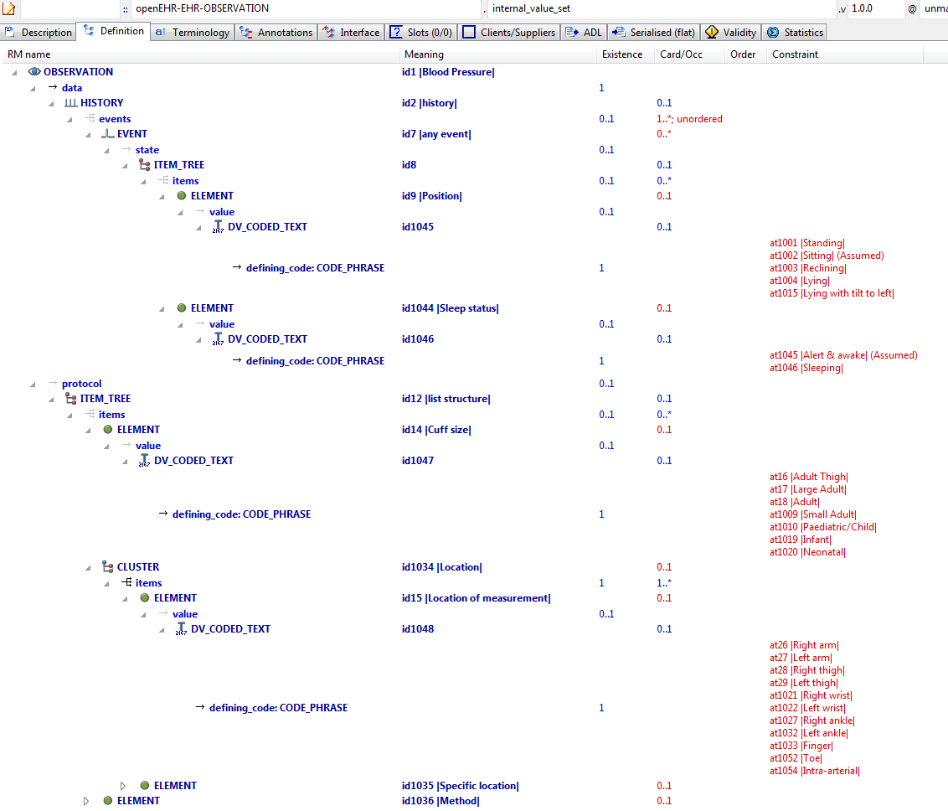

#### Internal Value Set v1 AML Diagram

#### Internal Value Set v1 AML Associations Diagram